**“DATABASE”**

1. **Establishing Connection To Database**

**1.2 Create Database**

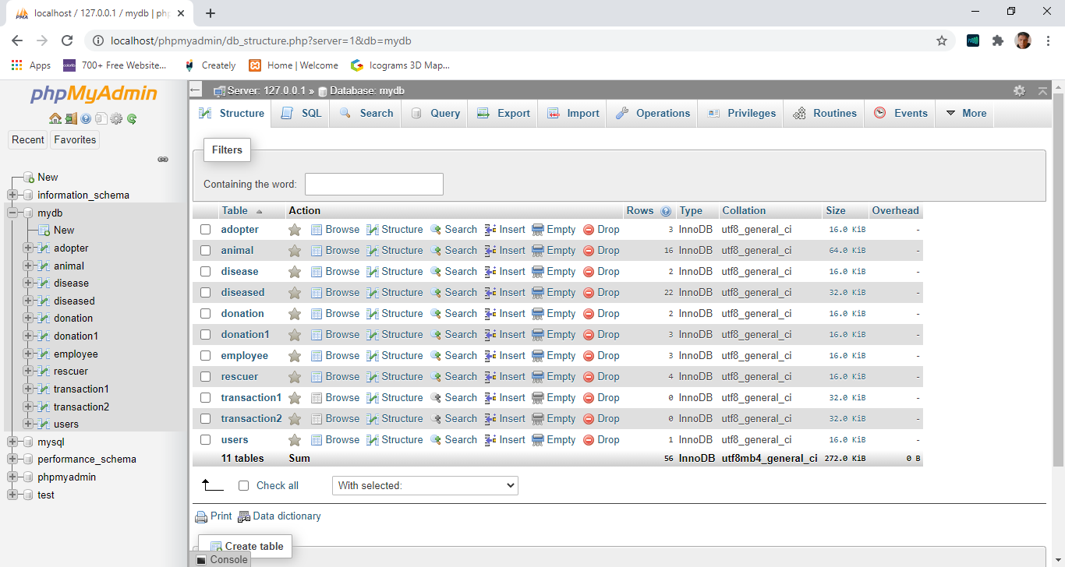

**1.3 Configure in PHP**

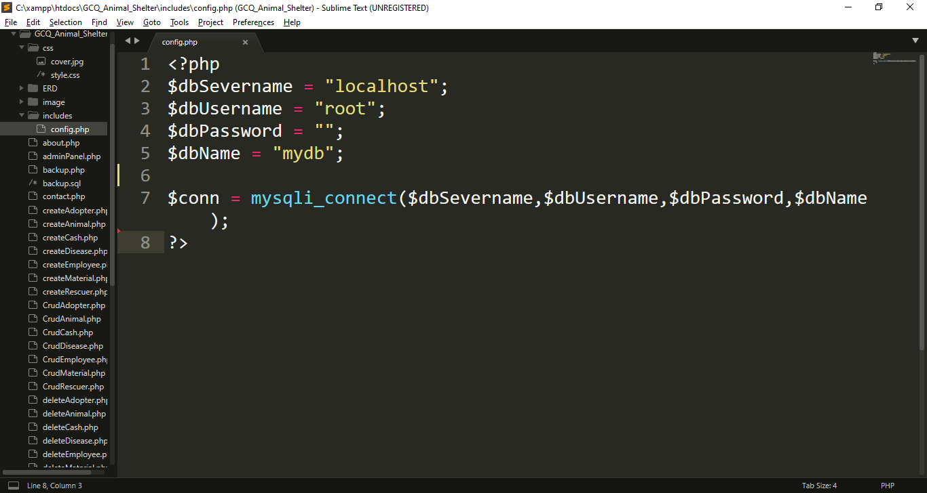

I create variable that will store the needed information to connect into my database, such as servername, username, password, and database name.

Is use variable called “$conn” to establish connection using mysqli_connect() function

**“Functional Requirements For The Web Application”**

1. **MP 1 CRUD script for dogs and cats**
   1. 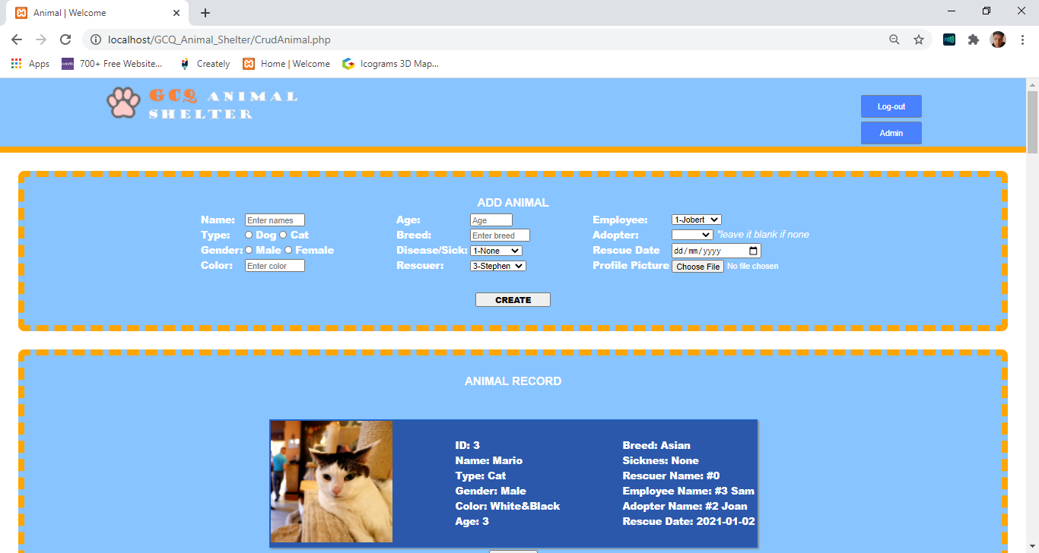**GUI FOR MP1**

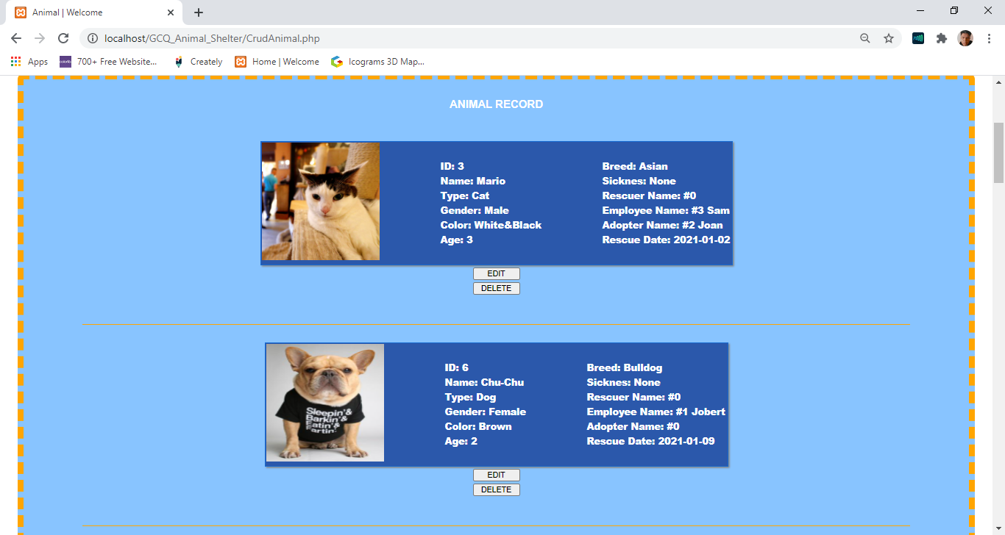

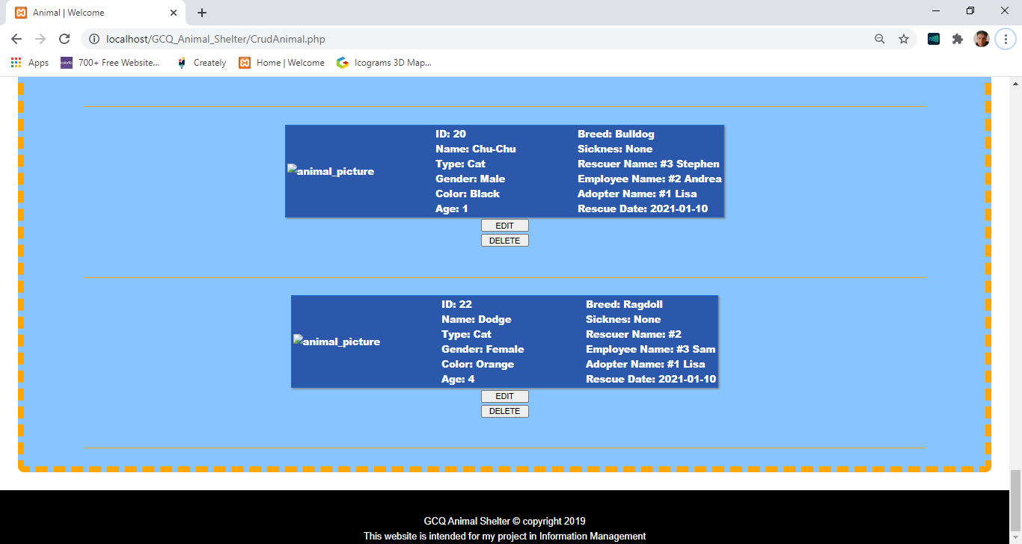

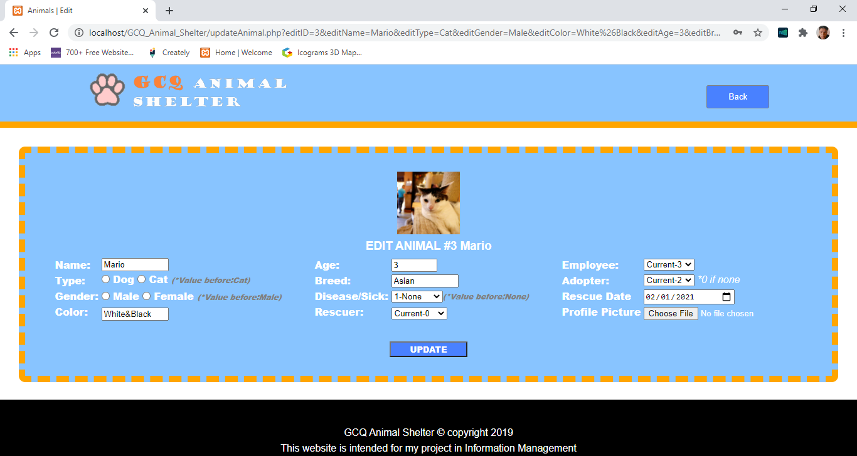

* 1. **CODE FOR MP1**

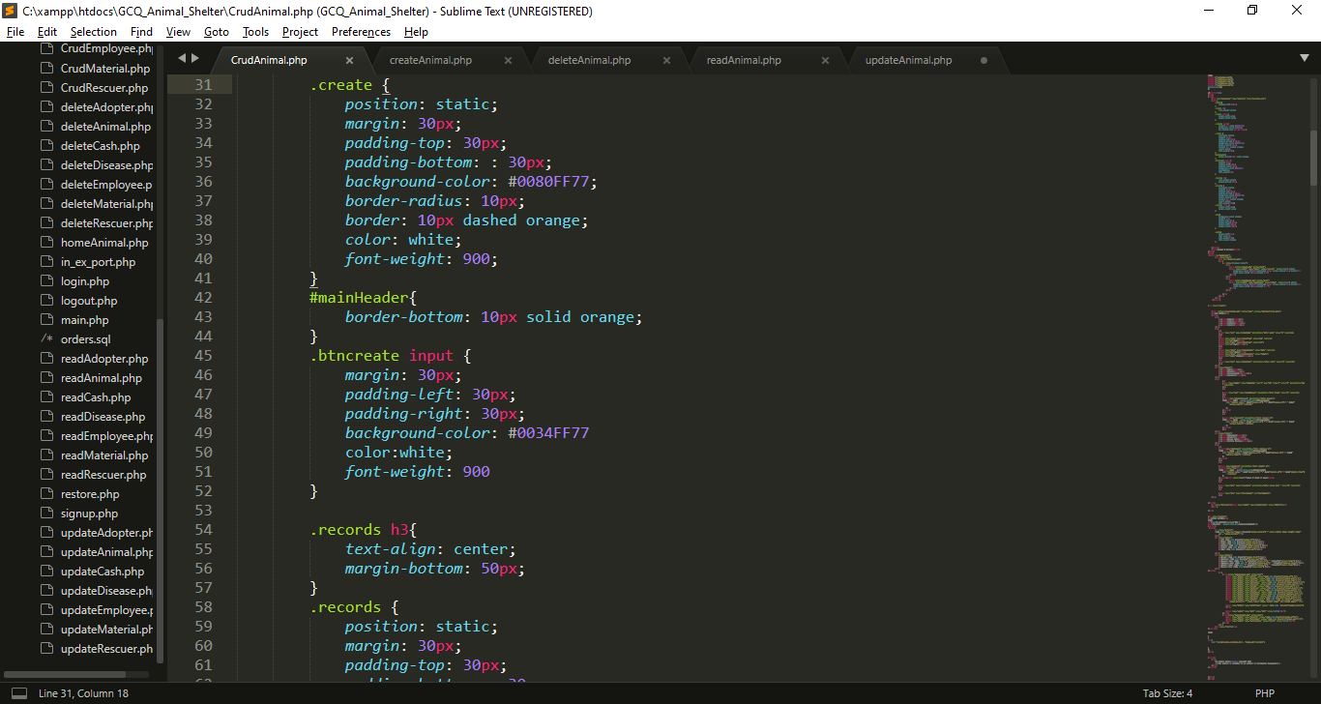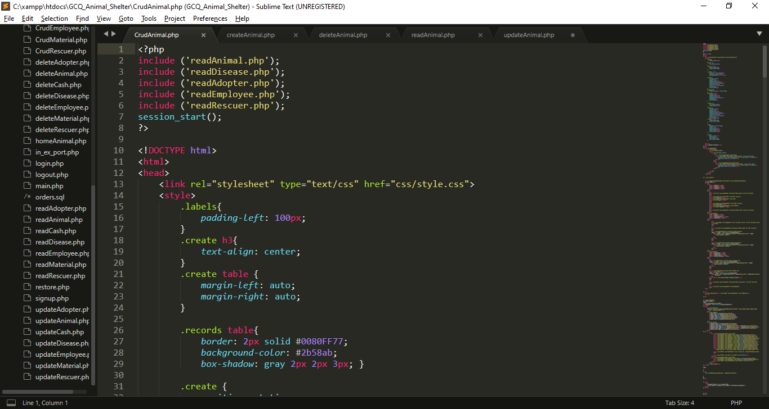

My External CSS

I import/include this reads file that I created for reference in my combo box in creation.

My Internal CSS

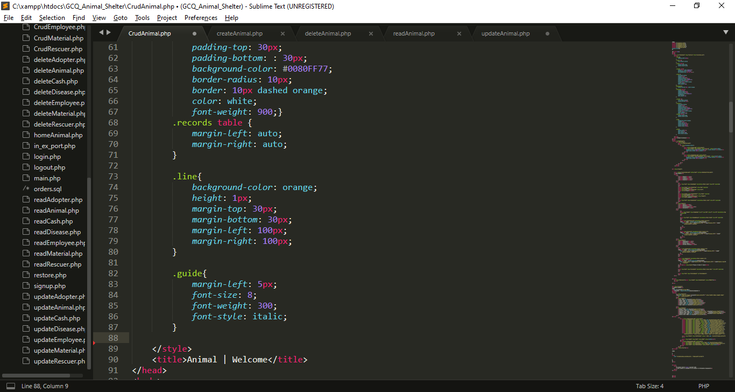

My Website Tab Title

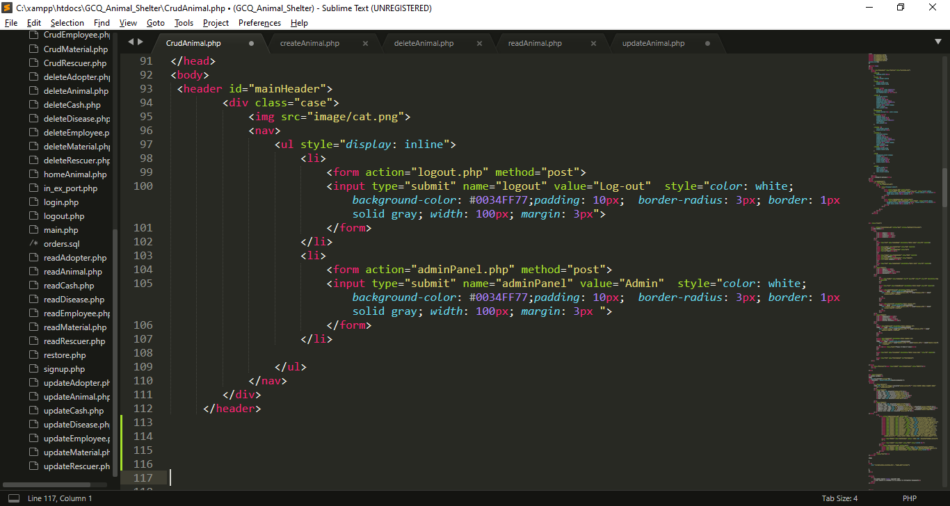

Log-out Button

My Website Logo

Admin Panel

I use post method as a server of all data which include in this form.

I set action equal to createAnimal.php which means if I click submit button, it will direct to that file.

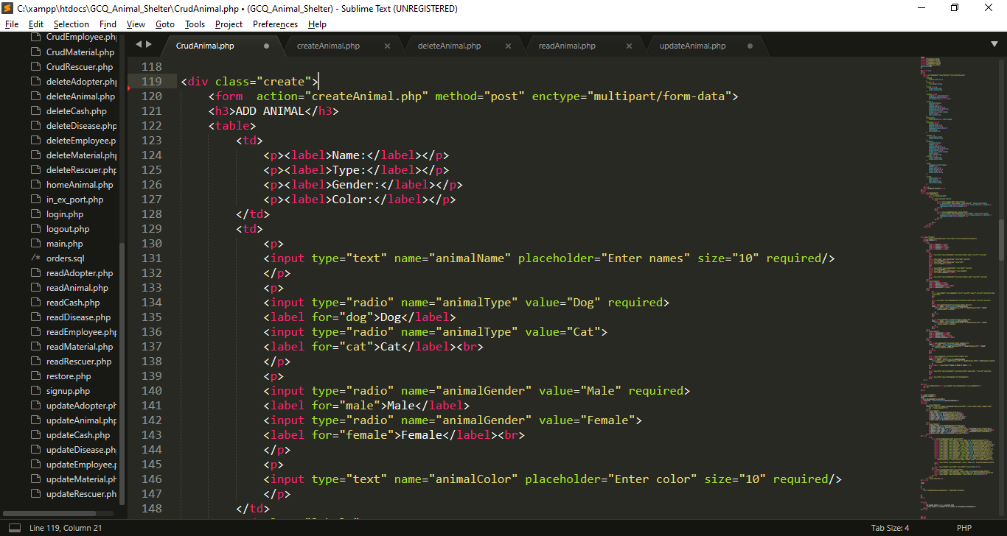

Labels for input boxes

I created inputs for the needed data, each input has name attribute which become a key for each value that users will input

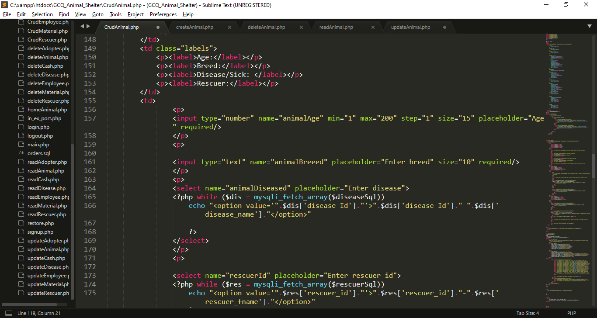

Labels for input boxes

**I get the $diseasesql from my import readDisease.php, this variable returns information from my disease table in my database. I use this sql to fill my combo box.**

I created inputs for the needed data, each input has name attribute which become a key for each value that users will input

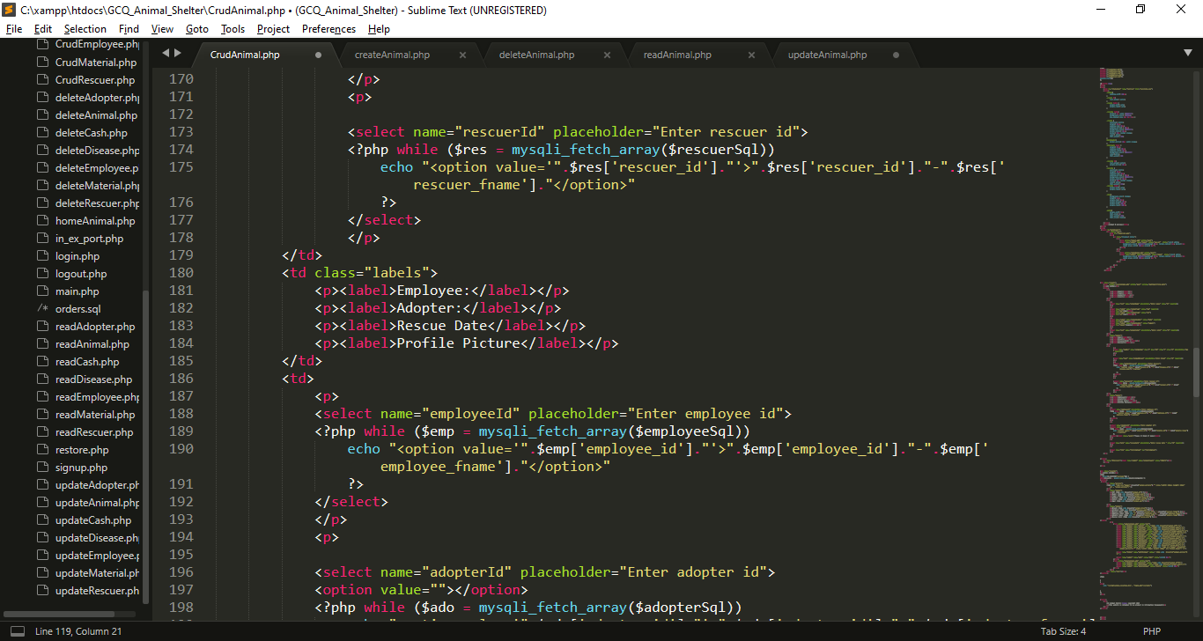

**I get the $rescuersql from my import readRescuer.php, this variable returns information from my rescuer table in my database. I use this sql to fill my combo box.**

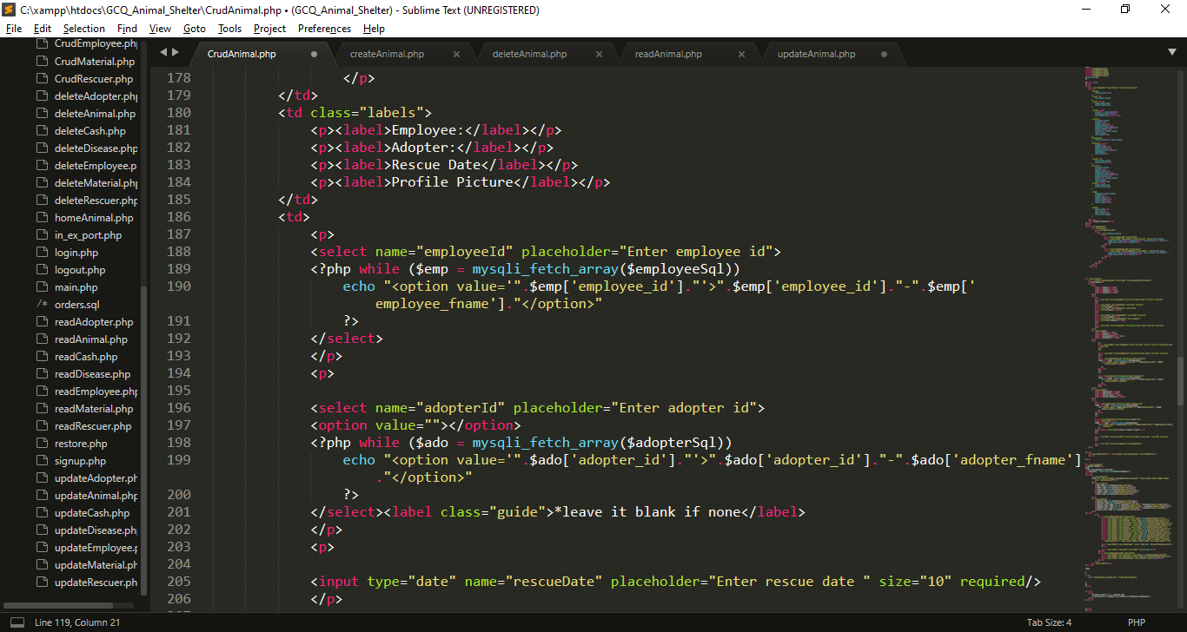

**I get the $employeesql from my import readEmployee.php, this variable returns information from my employee table in my database. I use this sql to fill my combo box.**

Labels for input boxes

I created inputs for the needed data, each input has name attribute which become a key for each value that users will input

**I get the $adoptersql from my import readAdopter.php, this variable returns information from my adopter table in my database. I use this sql to fill my combo box.**

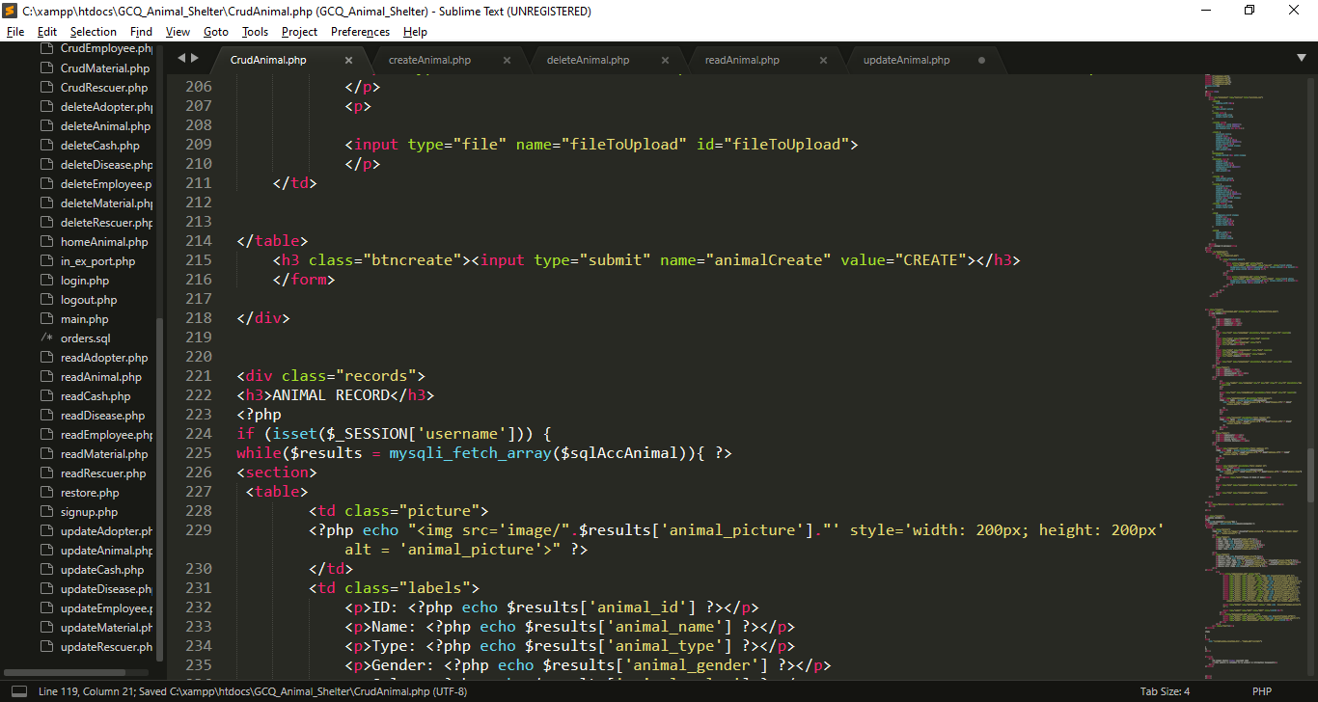

**This input allows users to access file manager to upload file.**

**If this submit input is click the name animalCreate will set in $_POST**

**I use while loop to fetch mysql array $sqlAccAnimal which contains result from readAnimal.php query , and each row of that will stored in $results for each loop.**

**I use If statement to check is the session username is already set.**

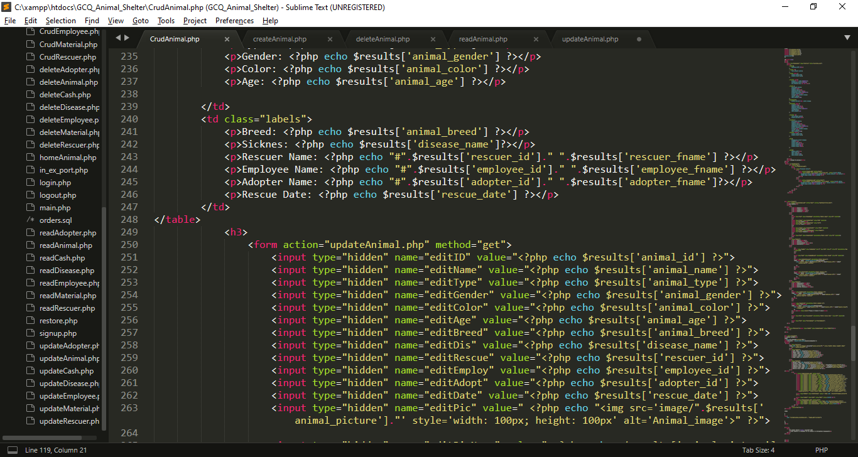

Now the $result contains a key value pair, (the key is the column name and the value is the data that store in the specific column)

I use hidden input type which get the result from results this data will use for update

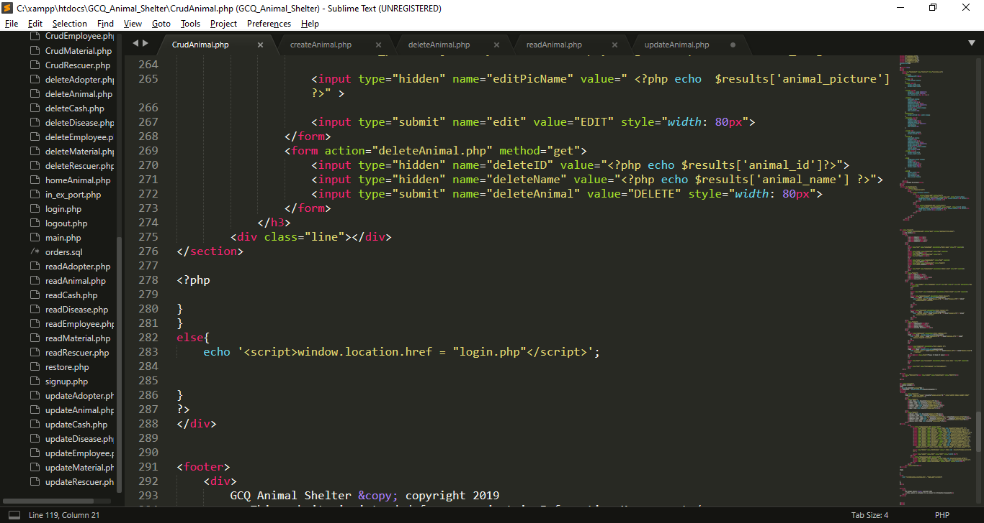

I use hidden input type which get the result from results this data will use for deletion

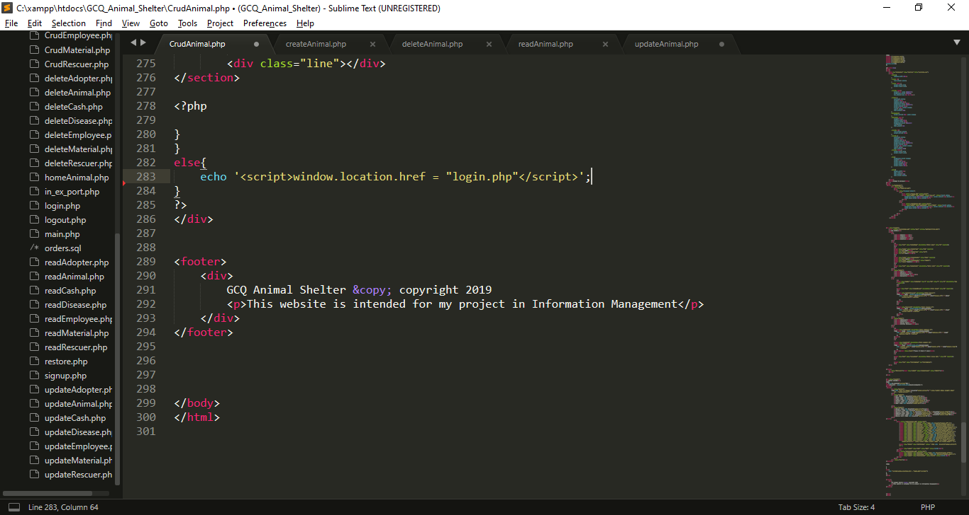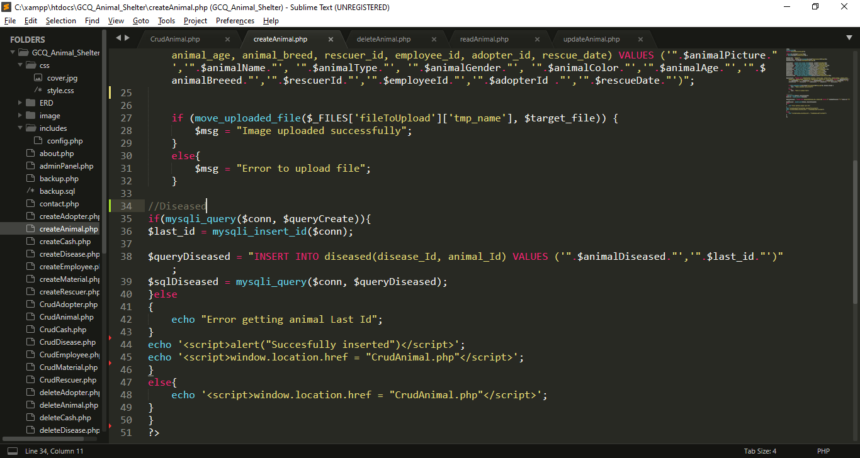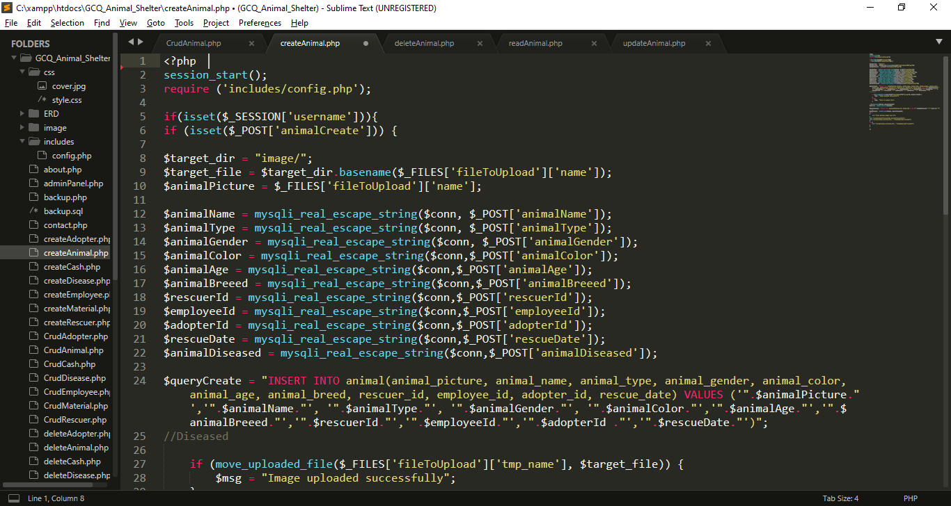

**Include config.php for database connection**

**If session username is not set you will redirect to login page**

**If the session username is not set insertion will not proceeded**

**Using java script Success message will pop-up after the insertion, then it will back to CrudAnimal.php**

**If the $queryCreate is execute, query for disease is execute**

**This variable contain string or query for insertion of values in anima table**

**I use $_FILES['file']['tmp_name'] to provide temporary storage of uploaded image**

I get all the data from post which set in previous page (CrudAnimal.php). And put it into variables, so that I can use for insertion query

I use basename() function, it  is an inbuilt function which is used to return the base name of a file if the path of the file is provided as a parameter to the basename().

**If animalCreate is set or click the insert process will begin**

**I create createAnimal.php for inserting data in database**

**I use If statement to check is the session username is already set.**

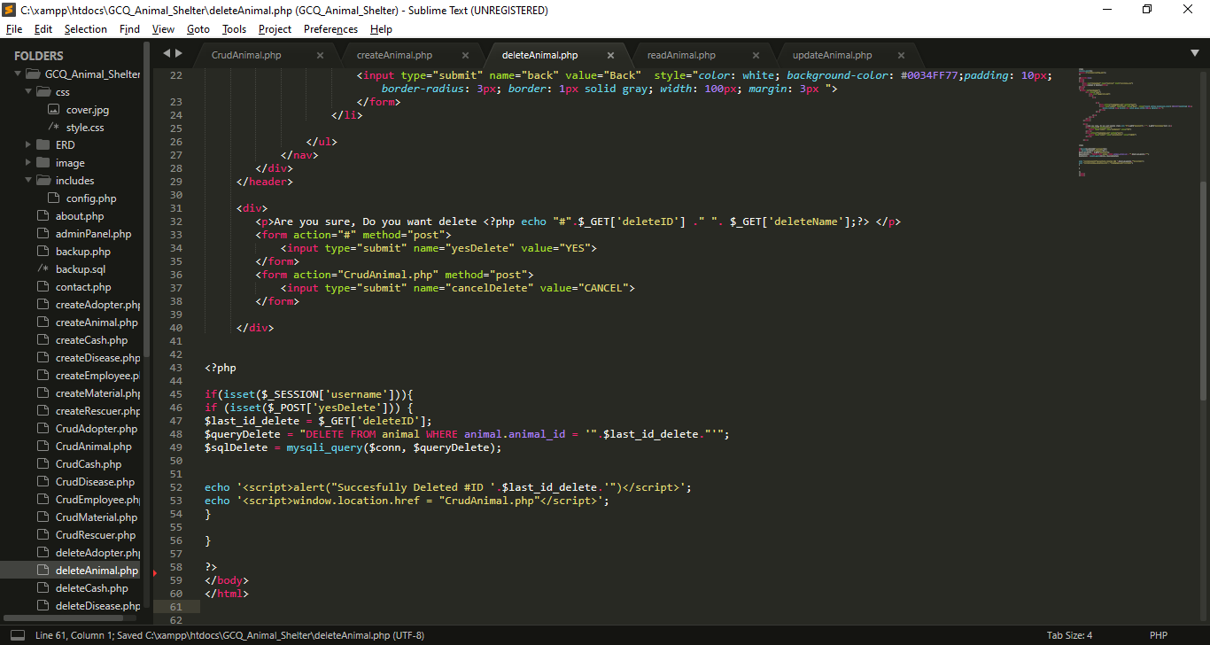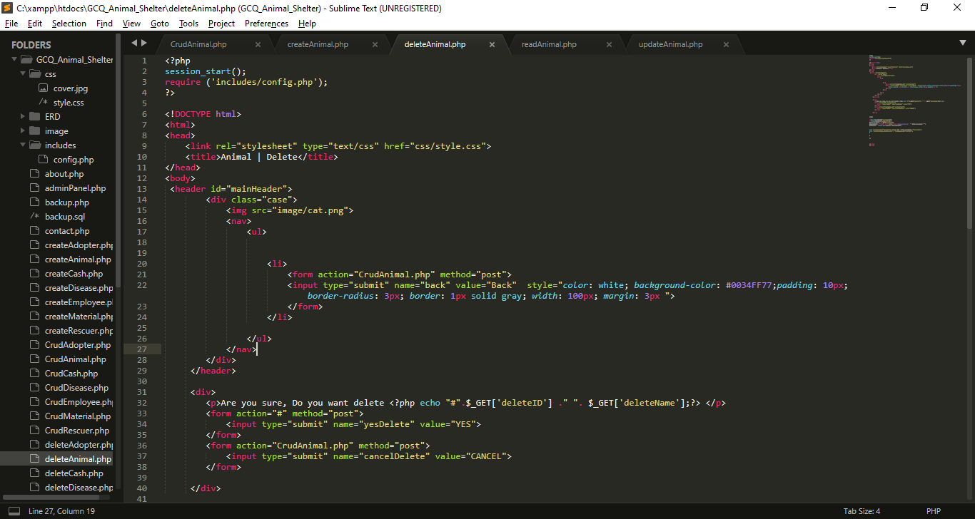

**If this submit input is click the name it will back in CrudAnimal.php**

**If this submit input is click the name yesDelete will set in $_POST**

**I create deleteAnimal.php for deleting data in database**

**Include config.php for database connection**

If yesDelete is set query will execute for deletion

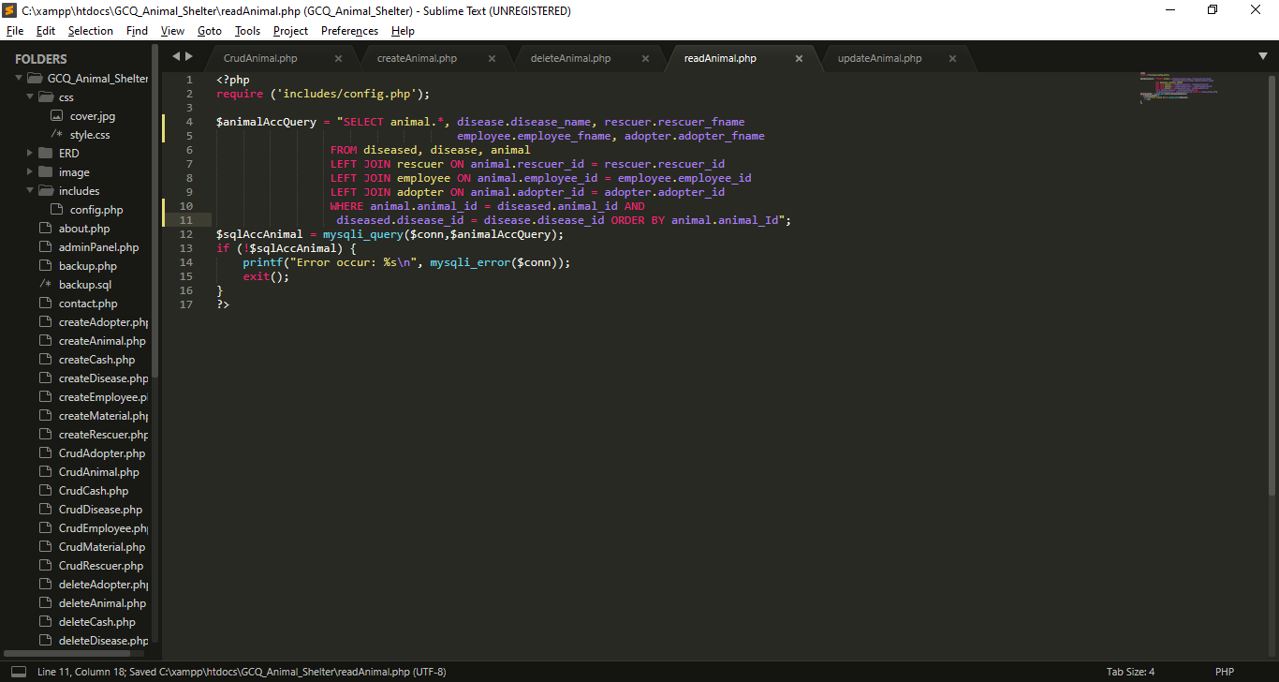

I create query for selecting all the data from animal table and to its realated table, after that, I execute that query using mysqli_query() function, that has 2 parameter which is the connection and the query

**I create readAnimal.php for reading data in database**

**Include config.php for database connection**

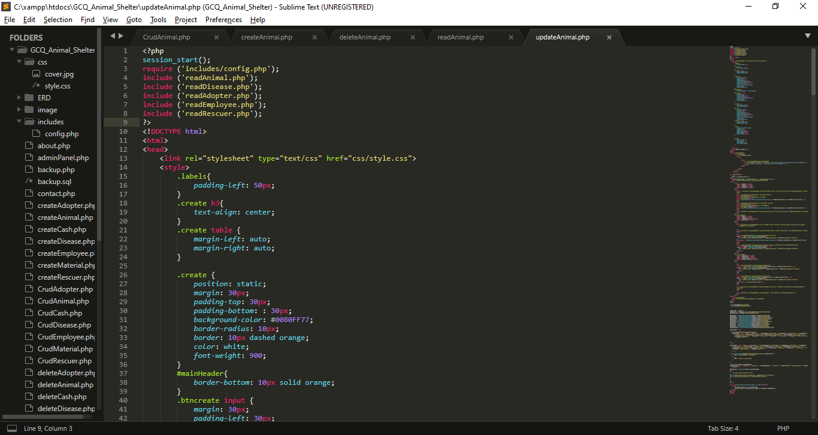

**I create updateAnimal.php for updating data in database**

I import/include this reads file that I created for reference in my combo box in creation.

My External CSS

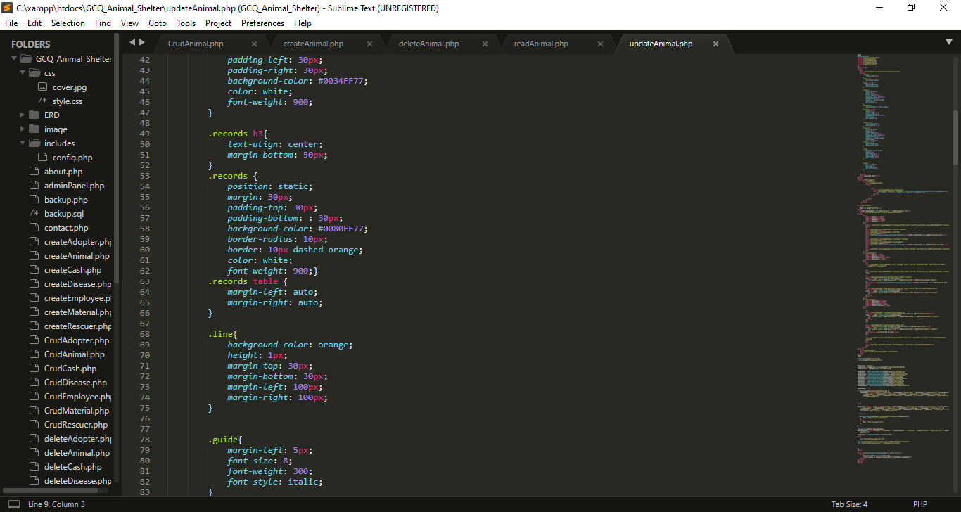

My Internal CSS

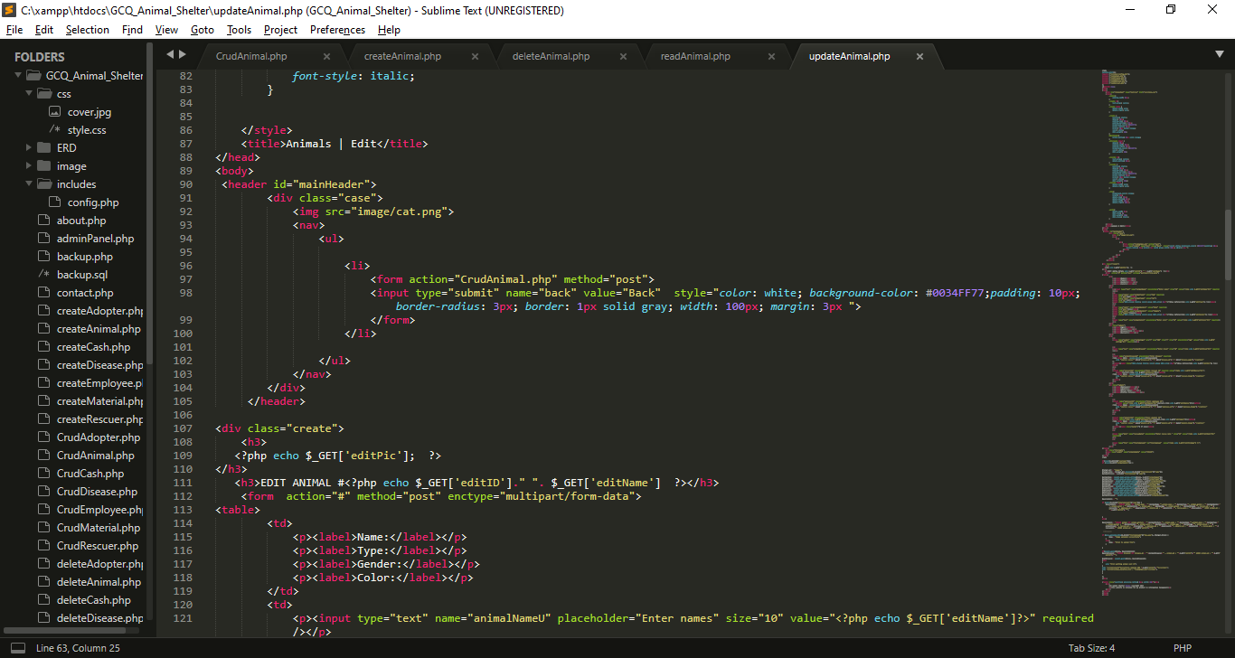

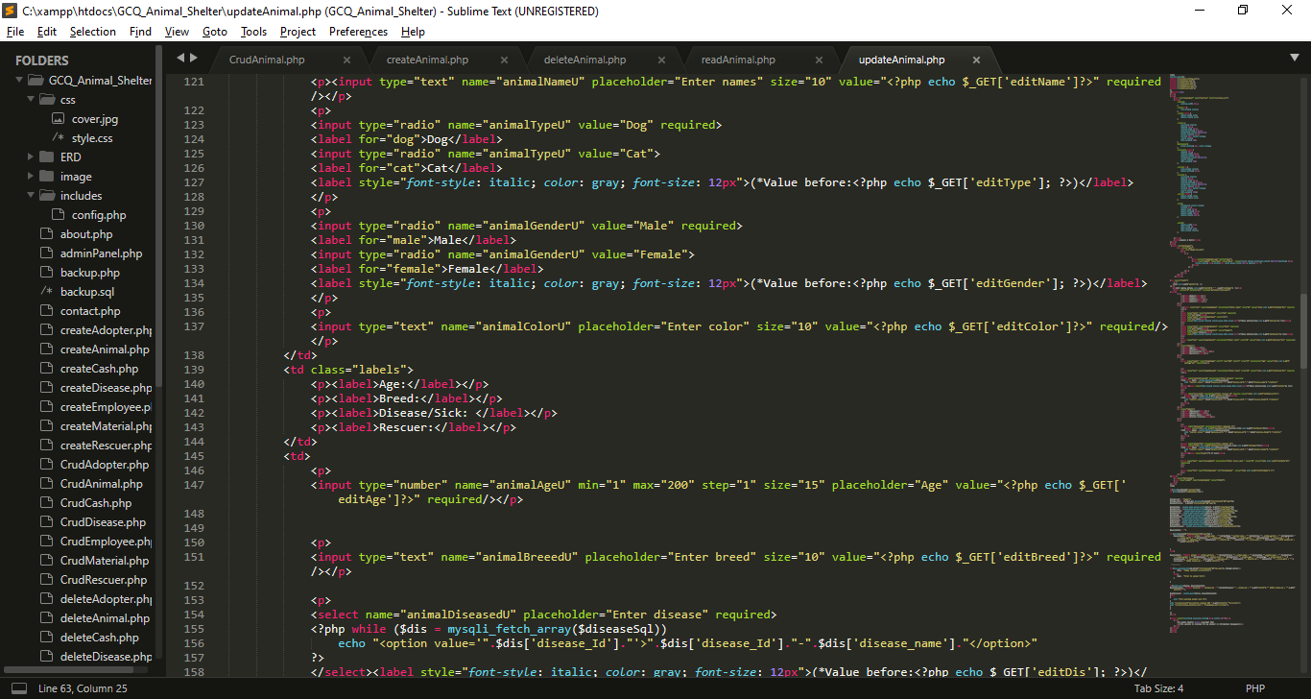

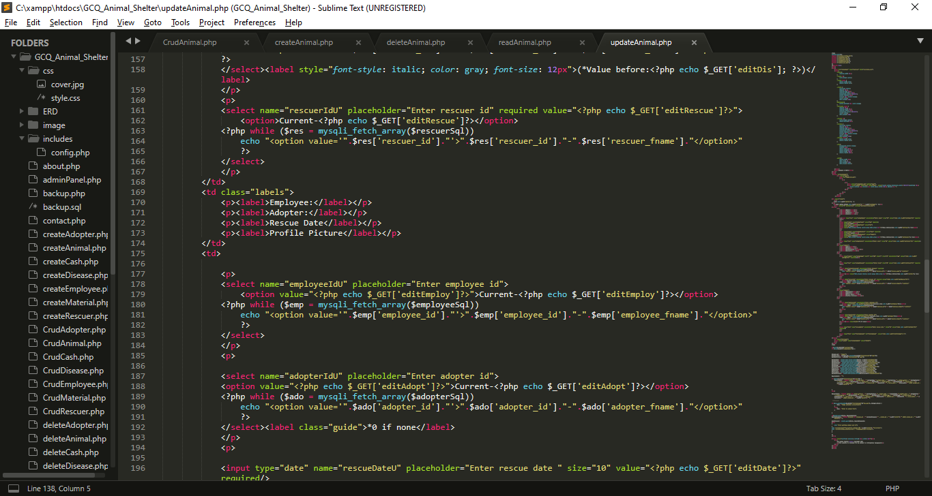

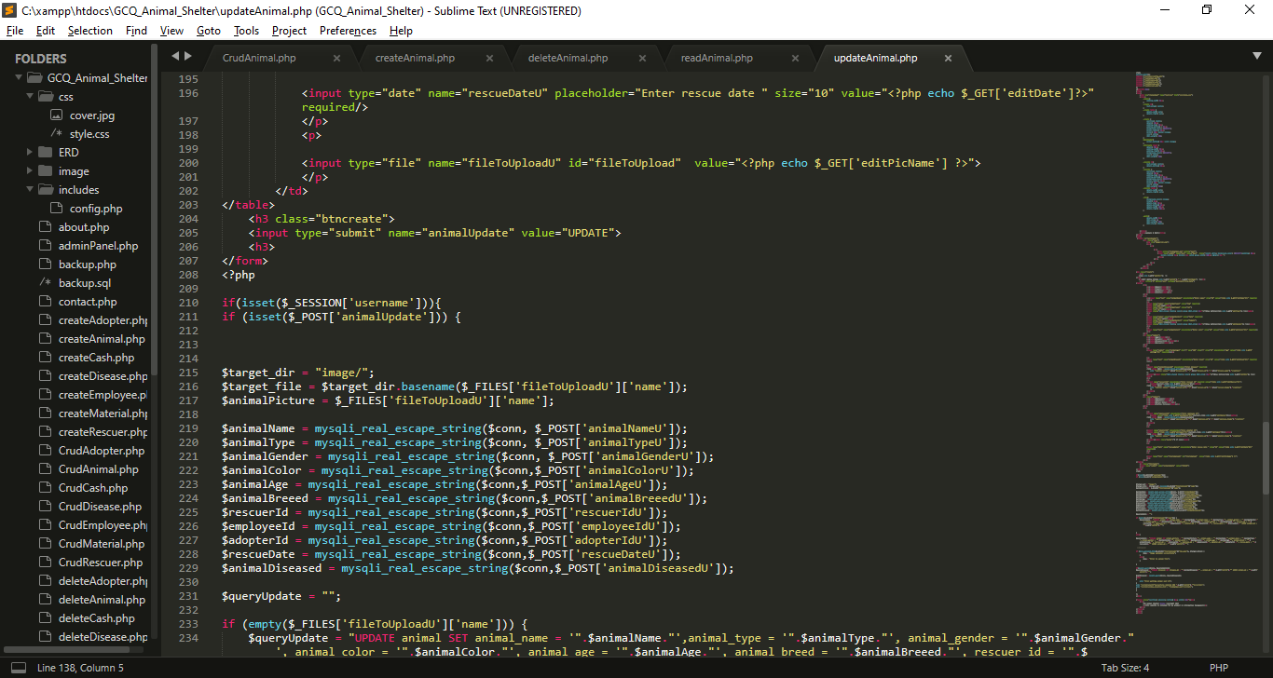

* I created inputs for the needed data, each input has name attribute which become a key for each value that users will input for update, I also get all the data from get method from CrudAnimal to show the current value while editing.

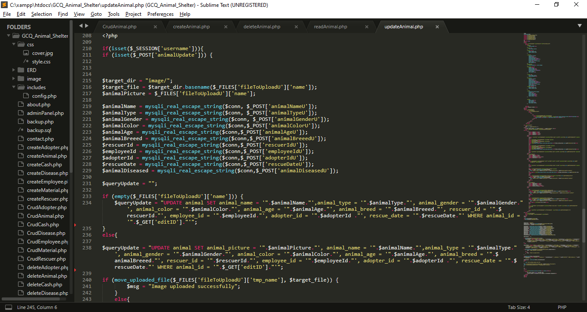

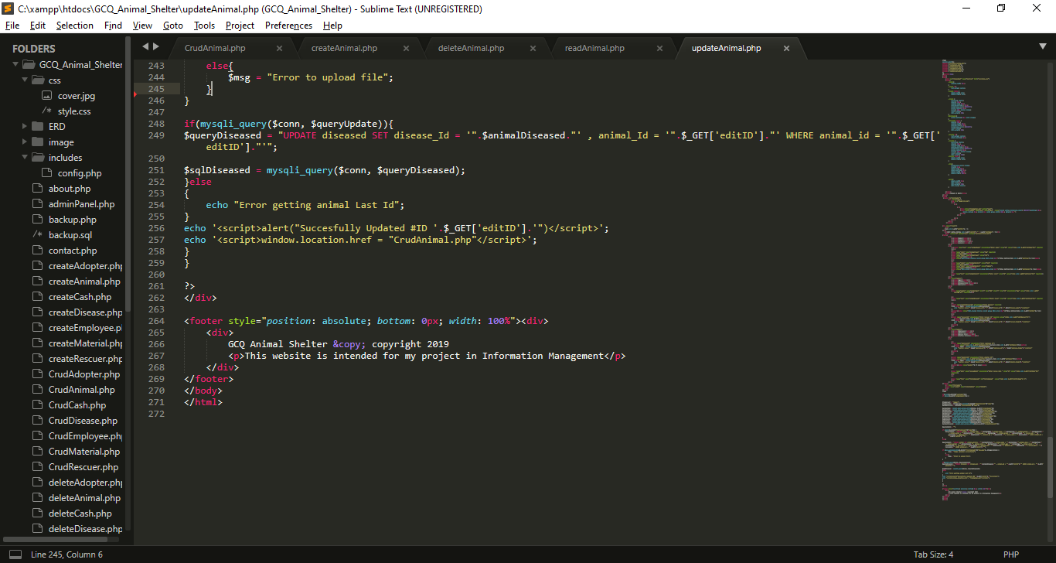

* I get all the data from post which set in from the top of this file, I put it into variables, so that I can use for updating query.
* Then I create two queries, one is for updating with picture and one is without picture
* Diseased table are also updated
* After that , all query will be executed, if the updating is success alert will pop-up

1. **MP 2 CRUD Script For The Rescuers**
   1. **GUI For MP2**

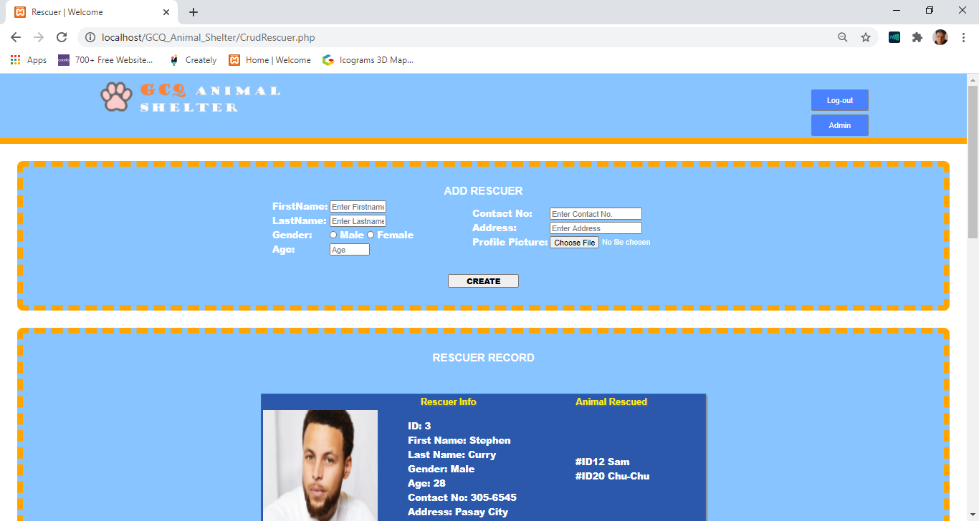

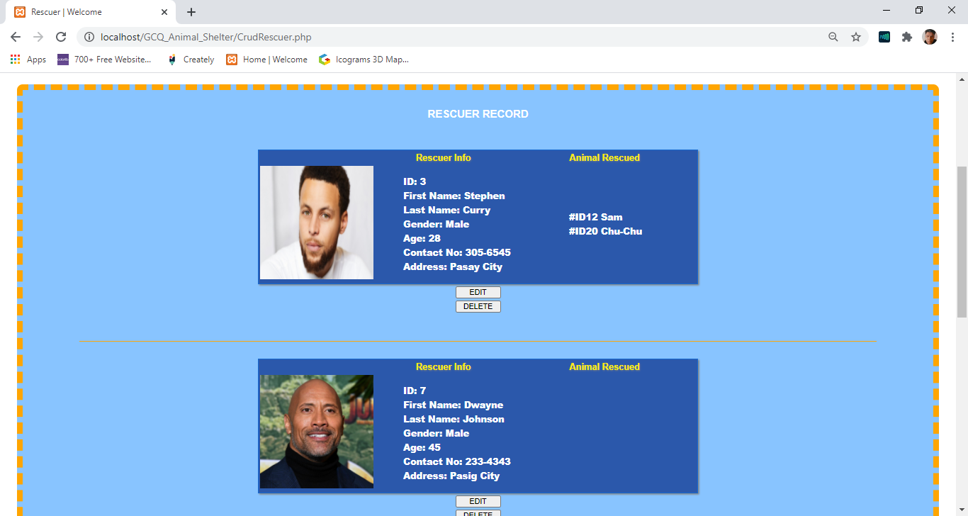

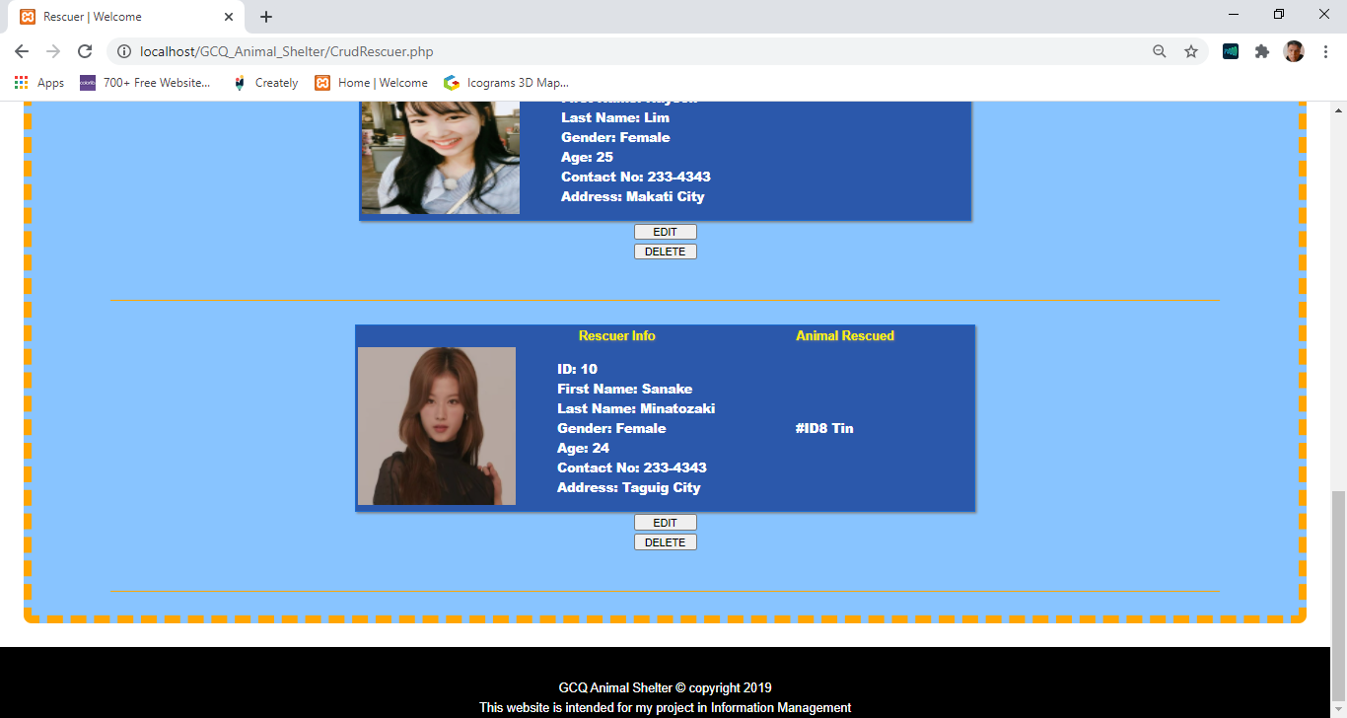

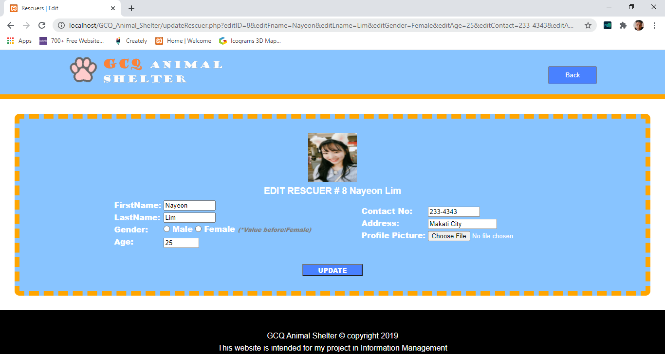

* 1. **CODE FOR MP2**

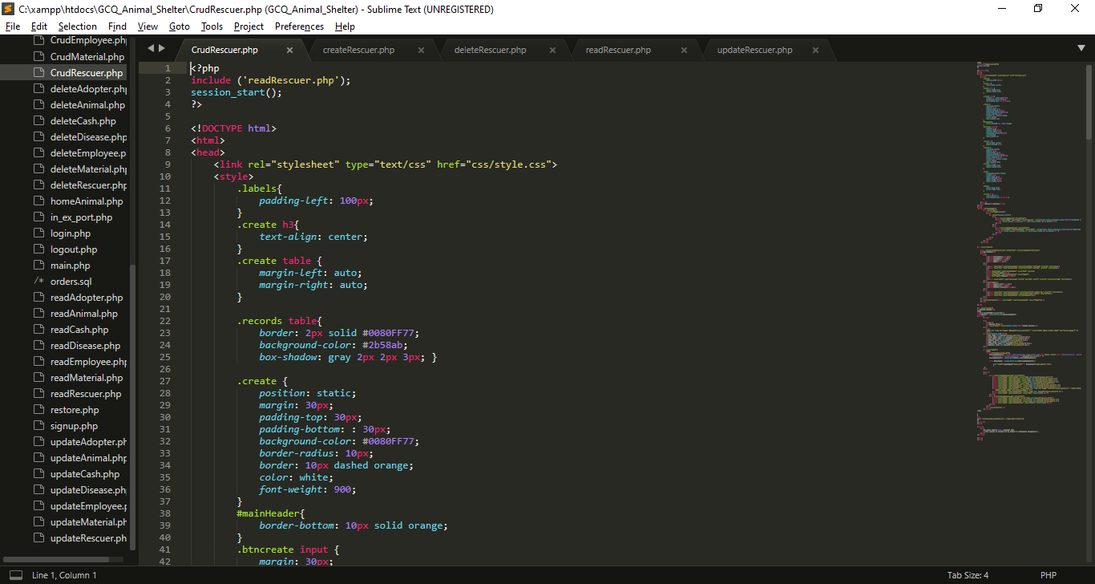

I import/include this reads file for displaying purpose

My External CSS

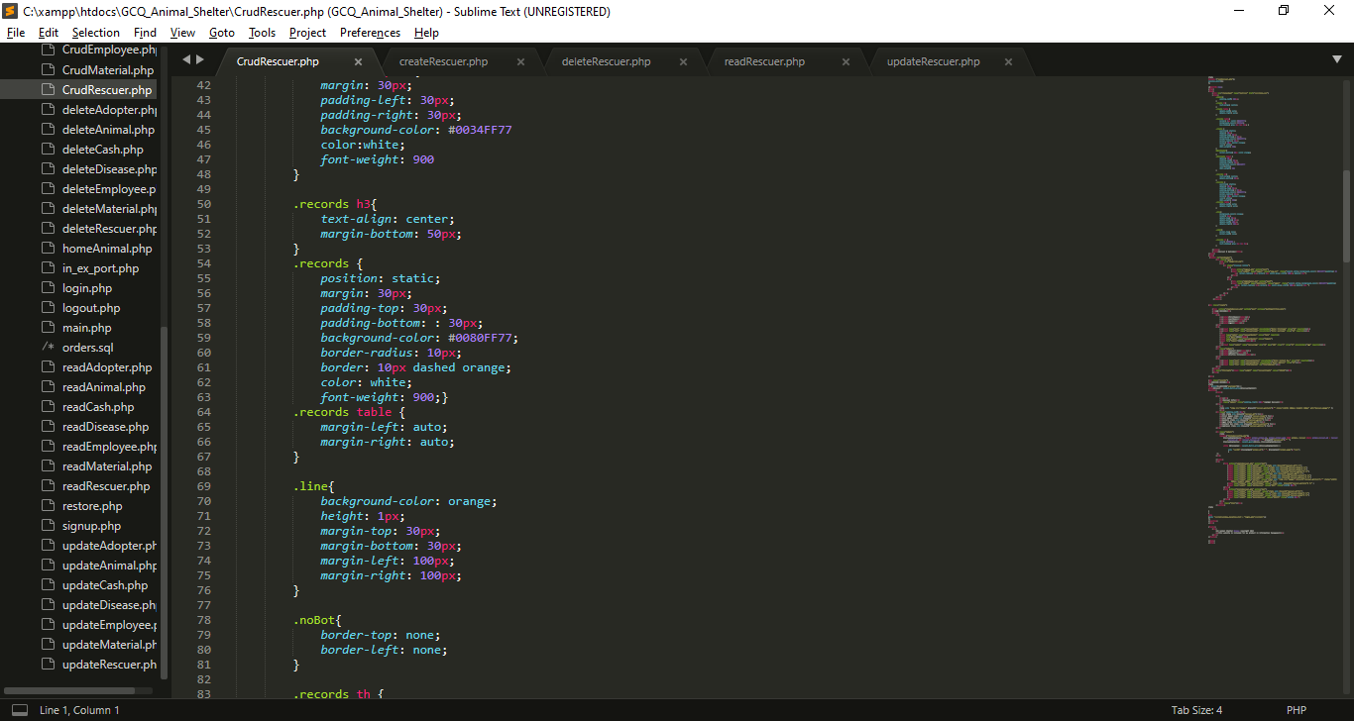

My Internal CSS

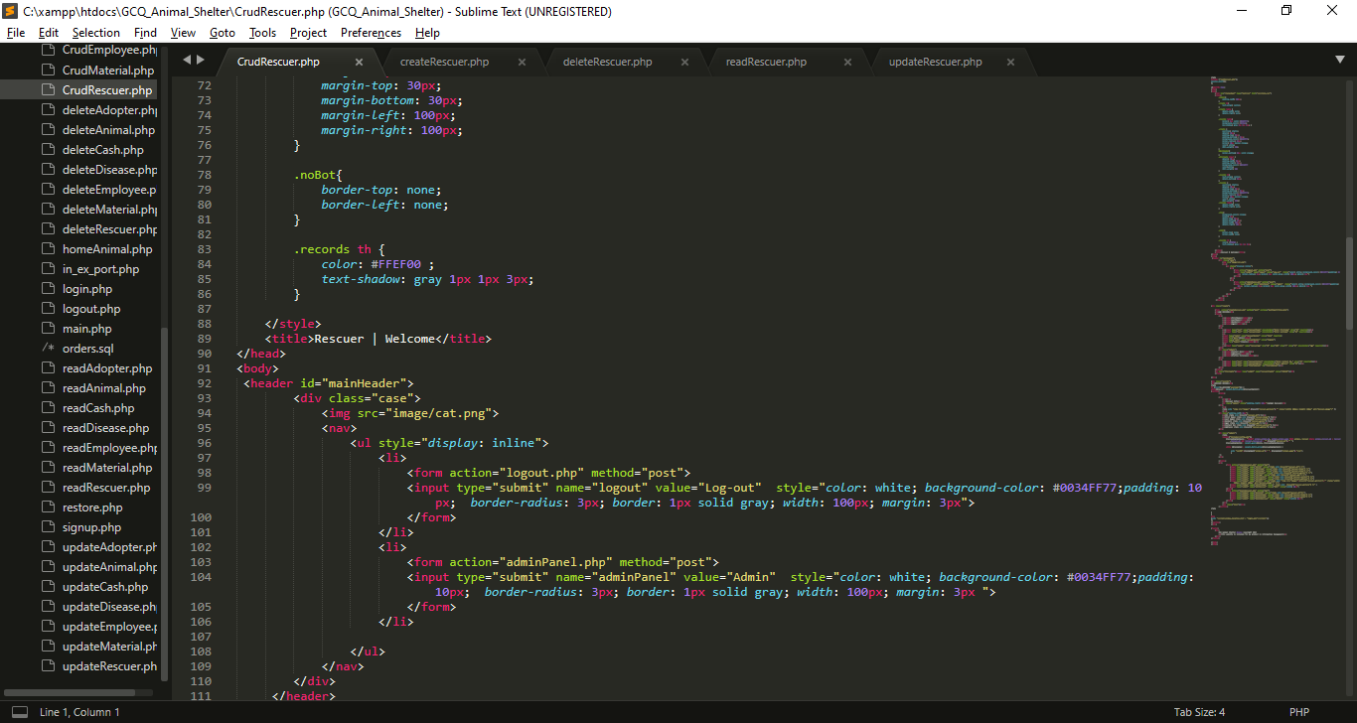

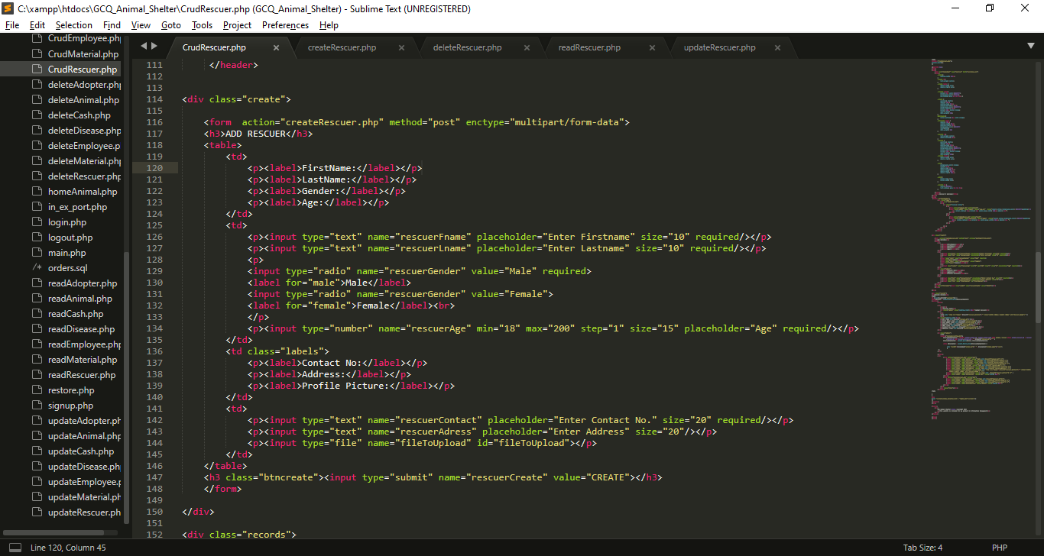

* I created a form inputs for the needed data, each input has name attribute which become a key for each value that users will input that will direct to createRescuer.php and it has a post method.
* I also added radio button named rescuerGender, which is use for selecting gender.
* At the end of the form I create submit button that has name attribute of rescuerCreate.

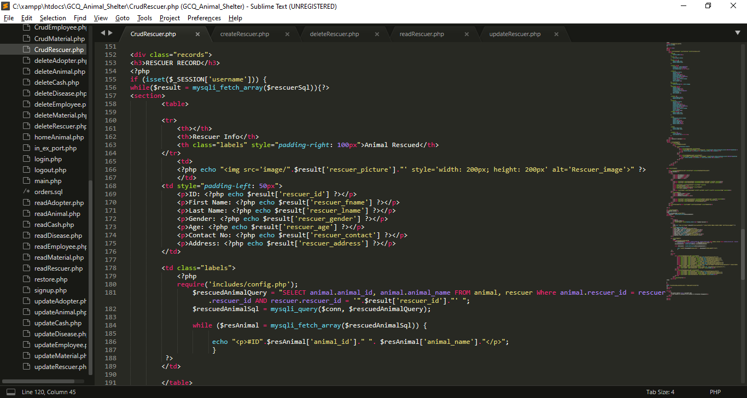

* I use If statement to check is the session username is already set.
* I use while loop to fetch all the data from $rescuersql which imported from readRescuer.php, each row will stored in $result that contains rescuer information, (the key is the column name and the value is the data that store in the specific column).
* I use while loop to fetch all the data from $rescuedAnimalSql which came from $rescuerAnimalQuery that has been executed, each row will stored in $resAnimal that contains animal id and name that the rescuer rescued.

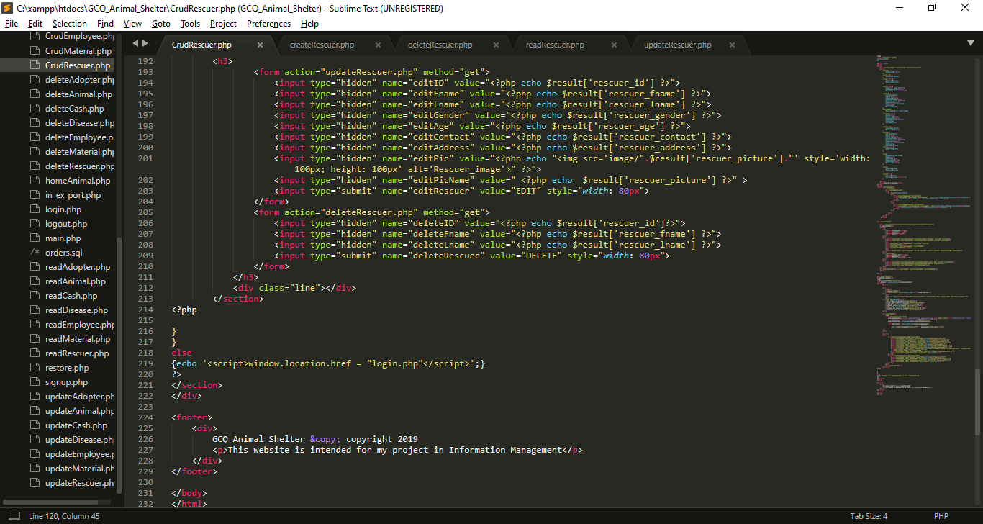

* I use hidden input type which get the result from results, this data will use for update
* I use hidden input type which get the result from results, this data will use for deletion

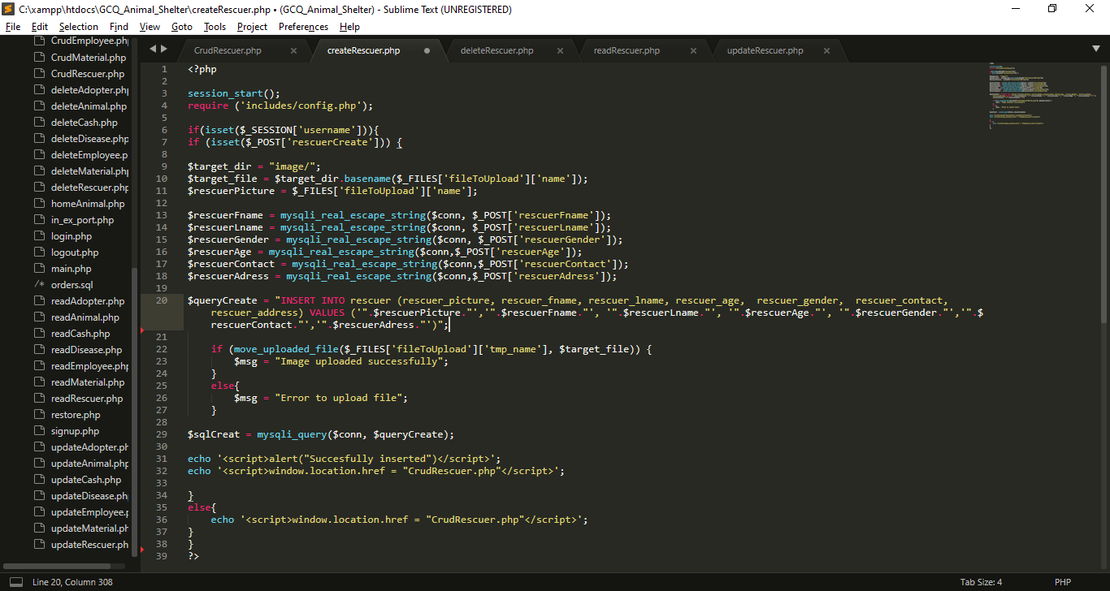

**I create createRescuer.php for inserting data in database**

* I import includes/config.php for database connection.
* use If statement to check is the session username is already set.
* If rescuerCreate is set or click the insert process will begin
* I use basename () function, it is an inbuilt function which is used to return the base name of a file if the path of the file is provided as a parameter to the basename ().
* I get all the data from post which set in previous page (CrudRescuer.php). And put it into variables, so that I can use for insertion query
* $queryCreate variable contain string or query for insertion of values in rescuer table
* I use $_FILES['file']['tmp_name'] to provide temporary storage of uploaded image
* Using java script Success message will pop-up after the insertion, then it will back to CrudRescuer.php
* If the session username is not set insertion will not proceed.

**I create deleteRescuer.php for deleting data in database**

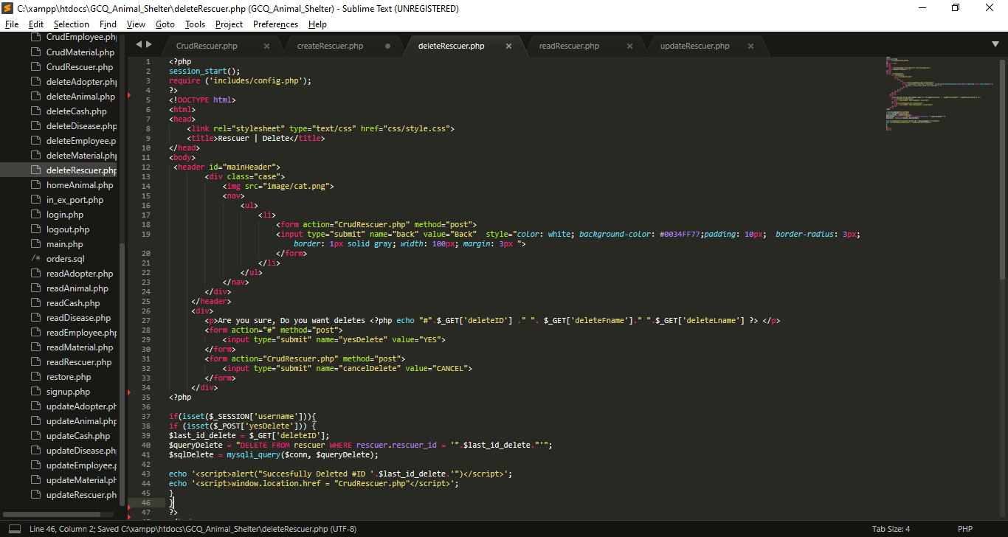

* I Include config.php for database connection
* If input submit named yesDelete is click the name yesDelete will set in $_POST, If this submit input named cancelDelete is click it will back in CrudRescuer.php
* If yesDelete is set query will execute for deletion

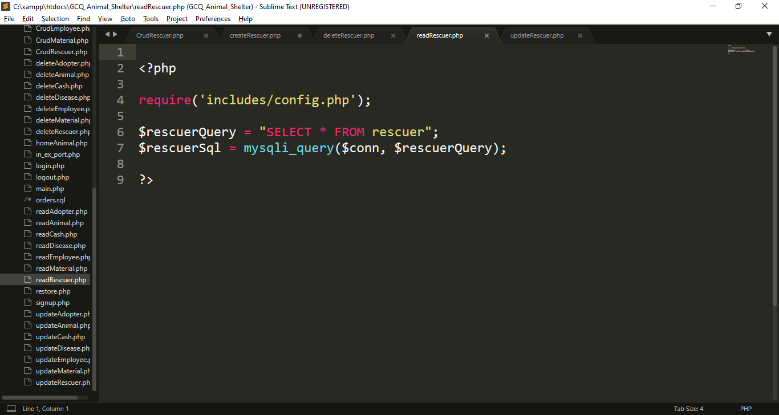

**I create readRescuer.php for reading data in database**

* Include config.php for database connection
* I create query called $rescuerQuery for selecting all the data from rescuer , after that, I execute that query using mysqli_query() function, that has 2 parameter which is the connection and the query

**I create updateRescuer.php for update data in database**

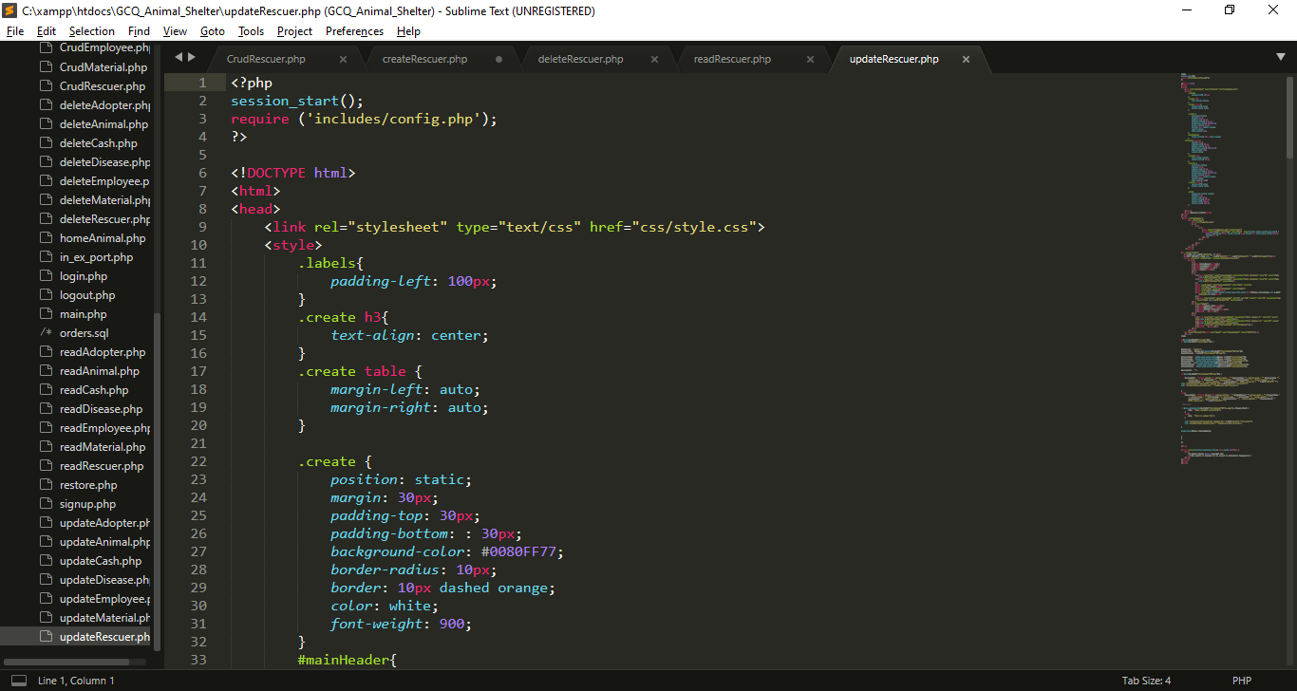

My External CSS

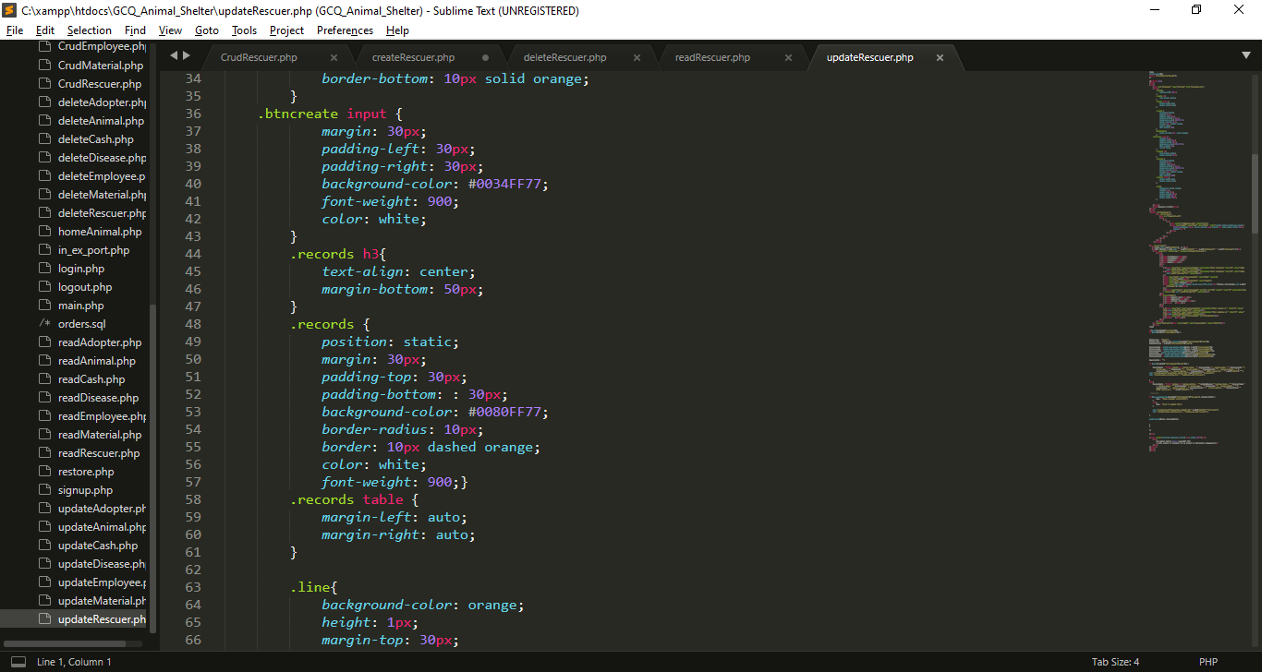

My Internal CSS

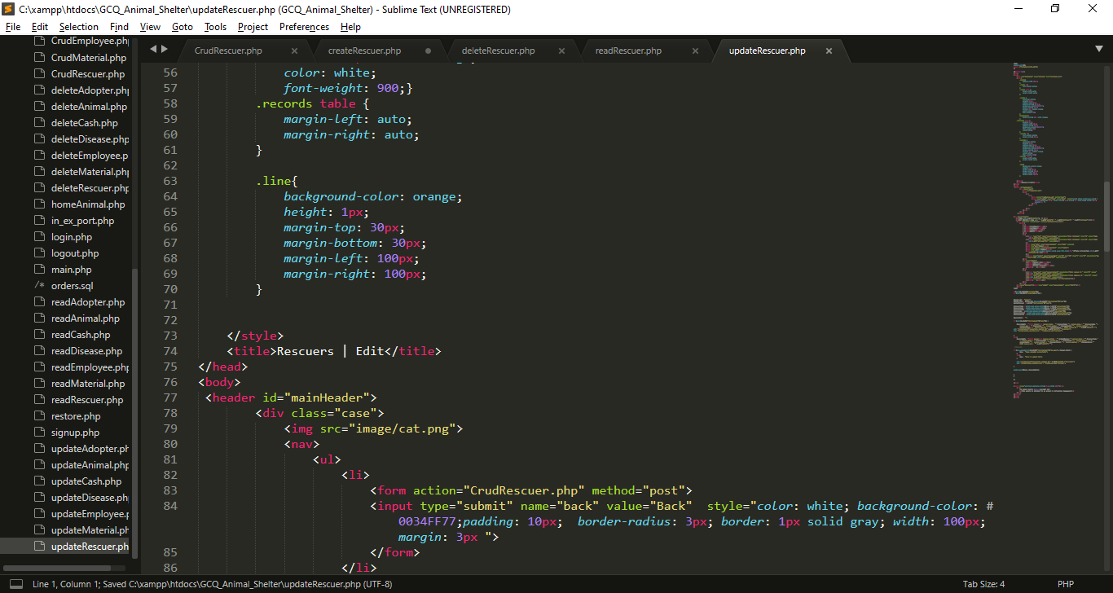

My Internal CSS

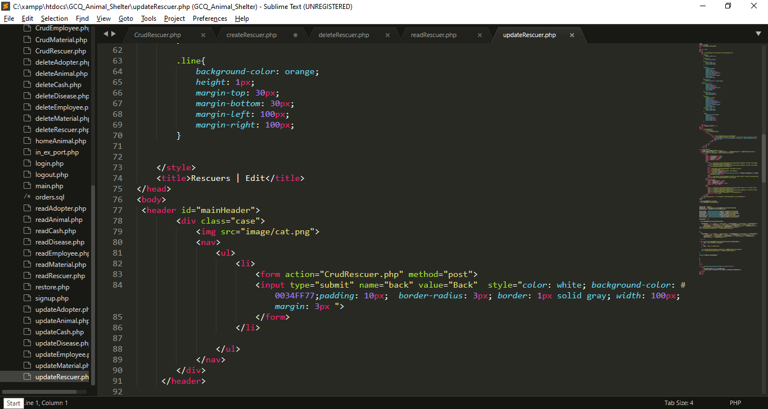

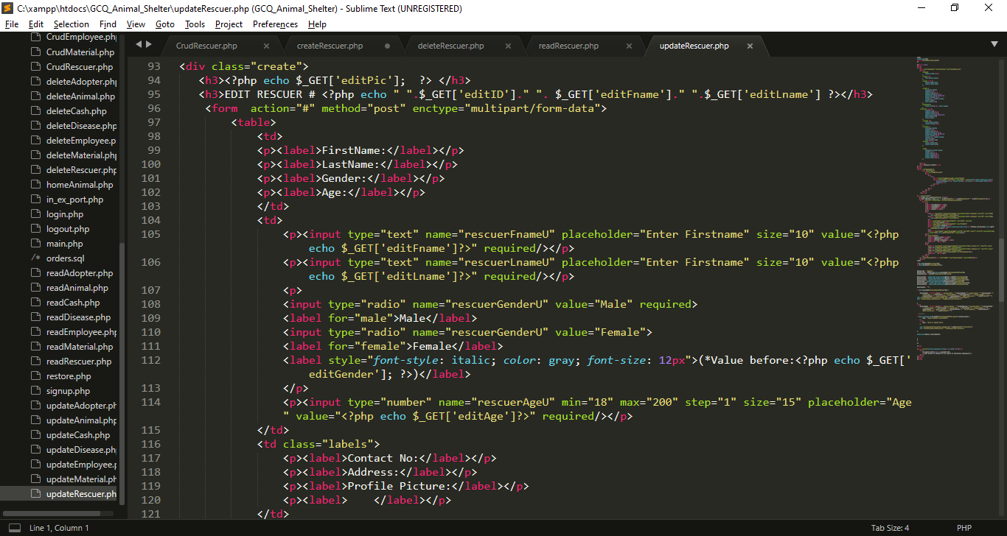

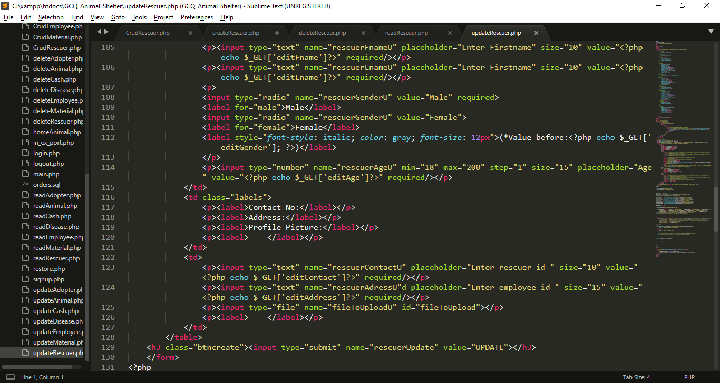

* I created inputs for the needed data, each input has name attribute which become a key for each value that users will input for update, I also get all the data from get method from CrudRescuer.php to show the current value while editing.

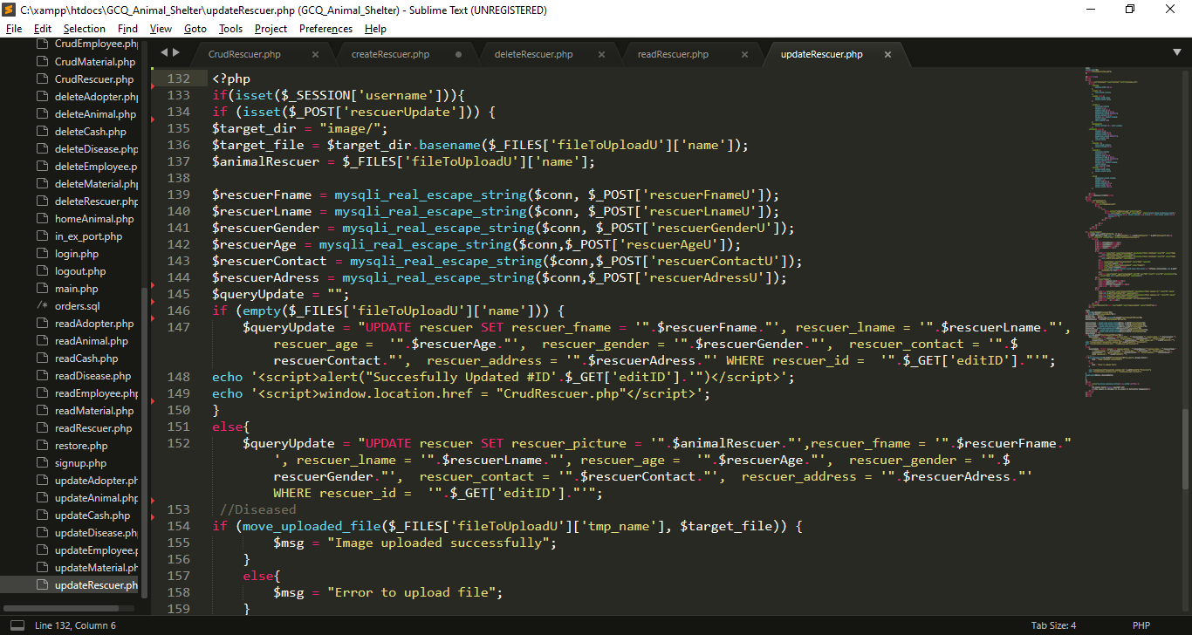

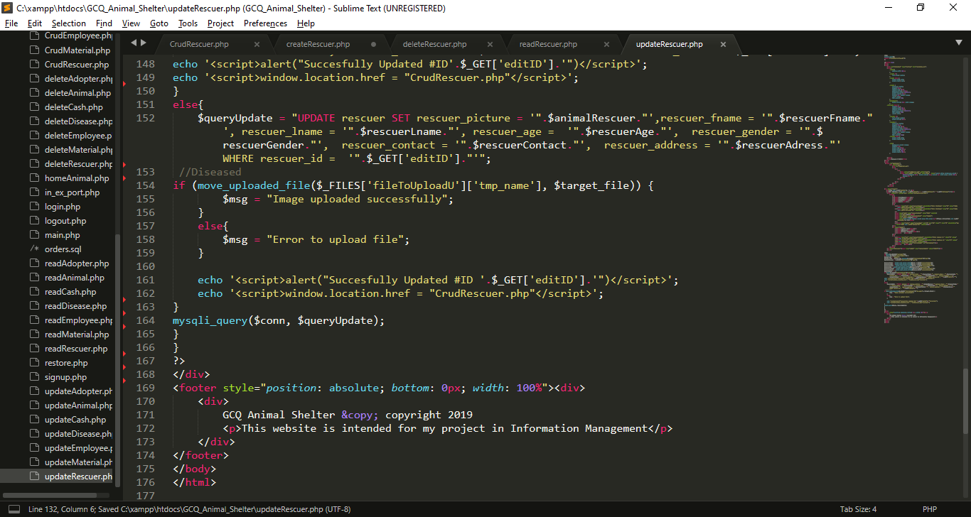

* I get all the data from post which set in from the top of this file, I put it into variables, so that I can use for updating query.
* Then I create two queries, one is for updating with picture and one is without picture
* After that , all query will be executed, if the updating is success alert will pop-up

1. **MP 3 CRUD Script For The Employees**
   1. **GUI For MP3**

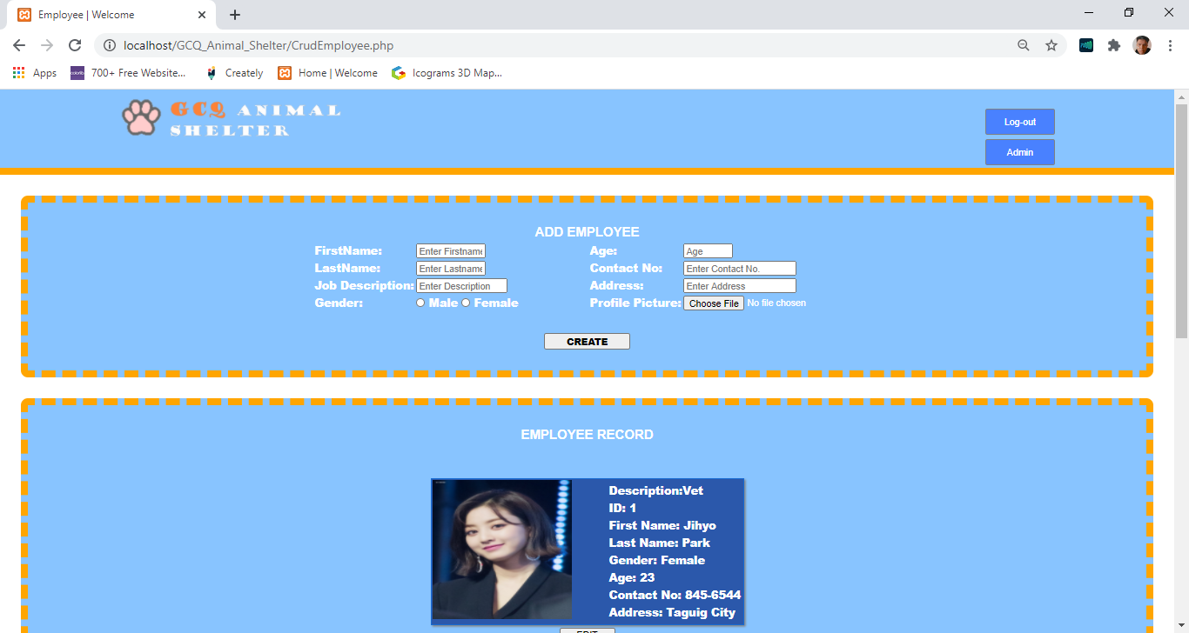

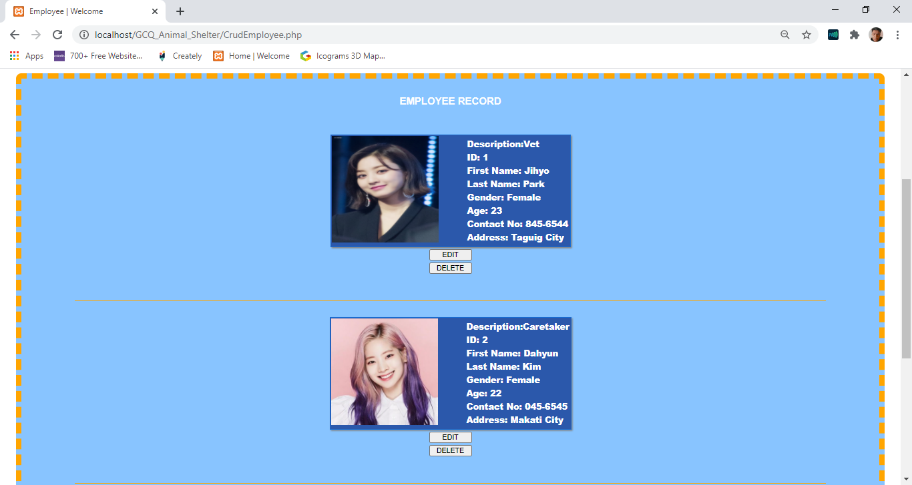

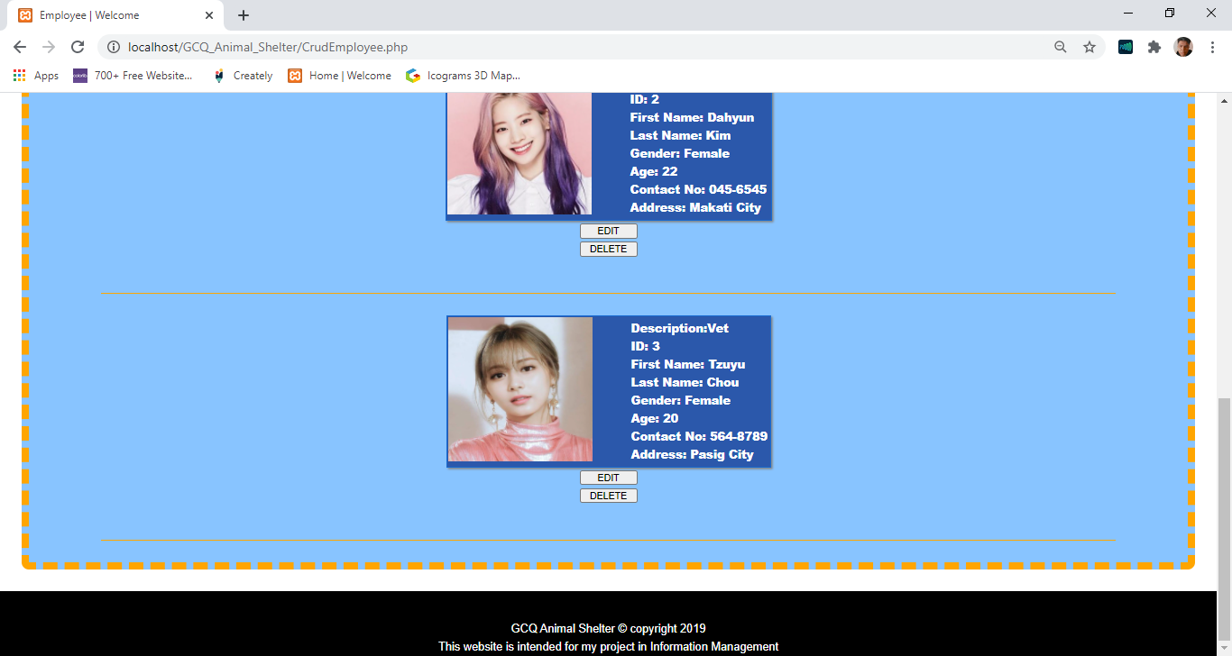

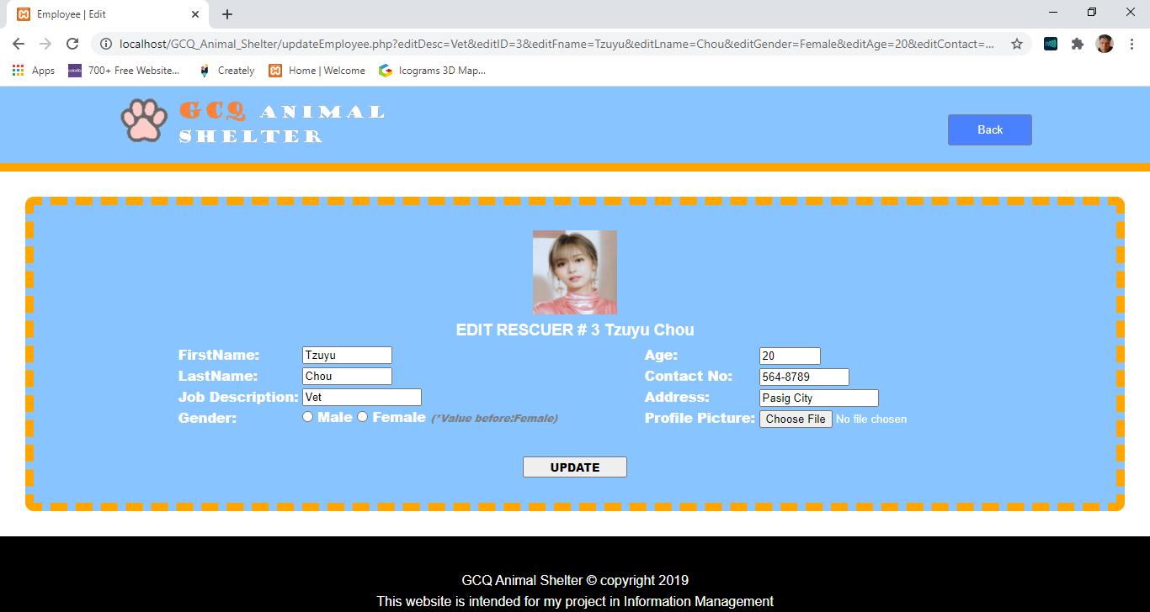

* 1. **Codes For MP3**

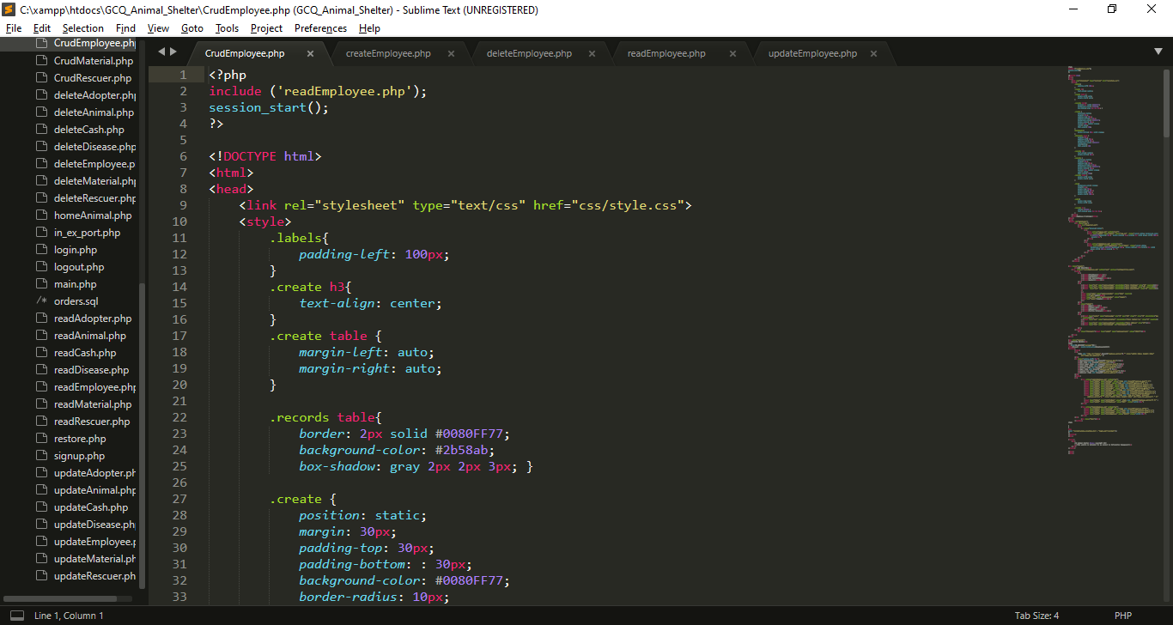

I import/include this reads file for displaying purpose

My External CSS

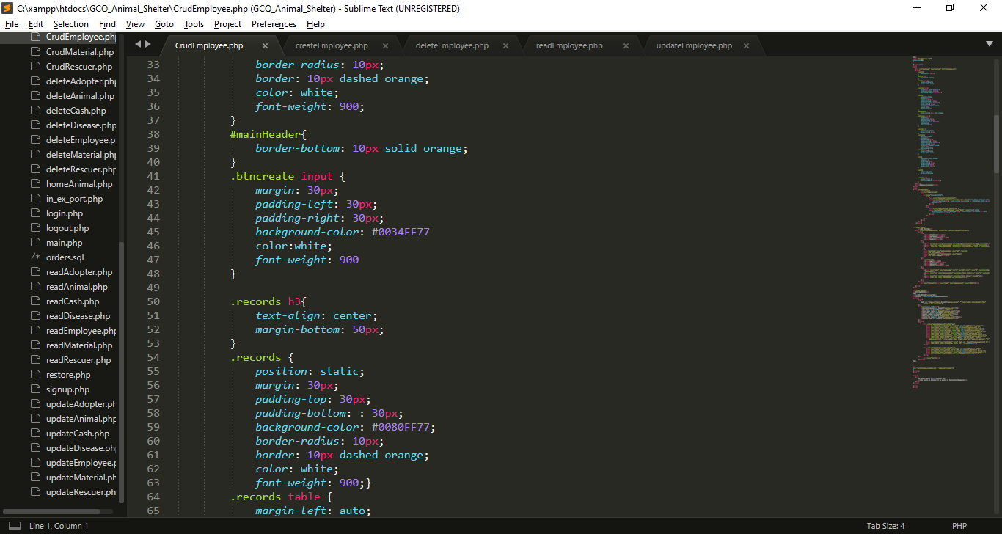

My Internal CSS

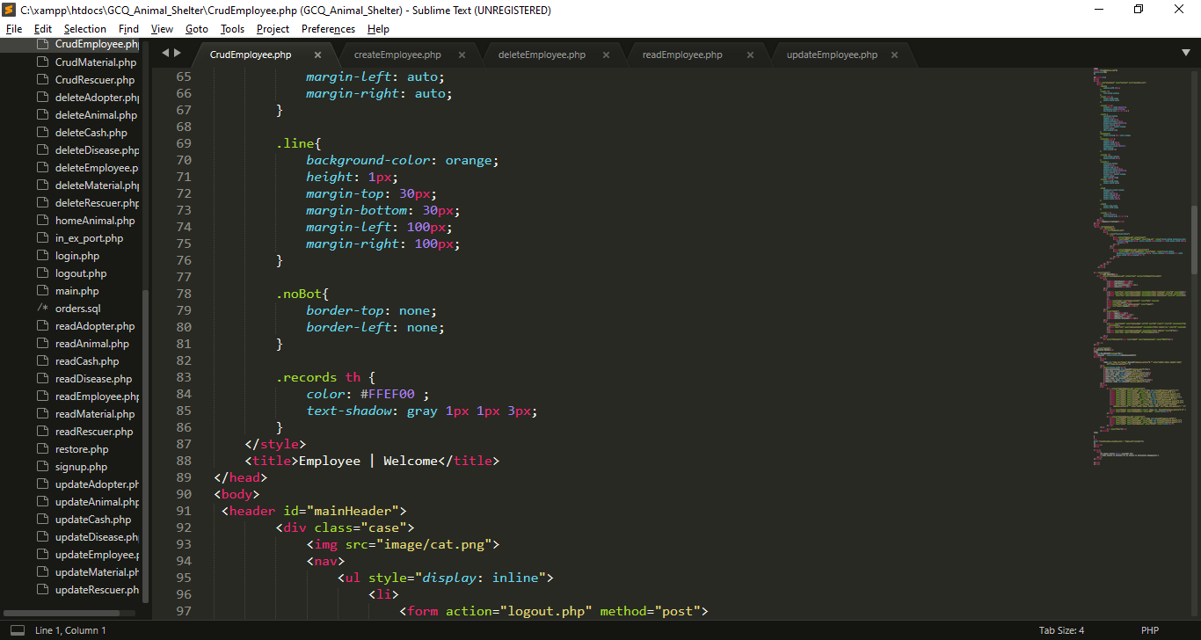

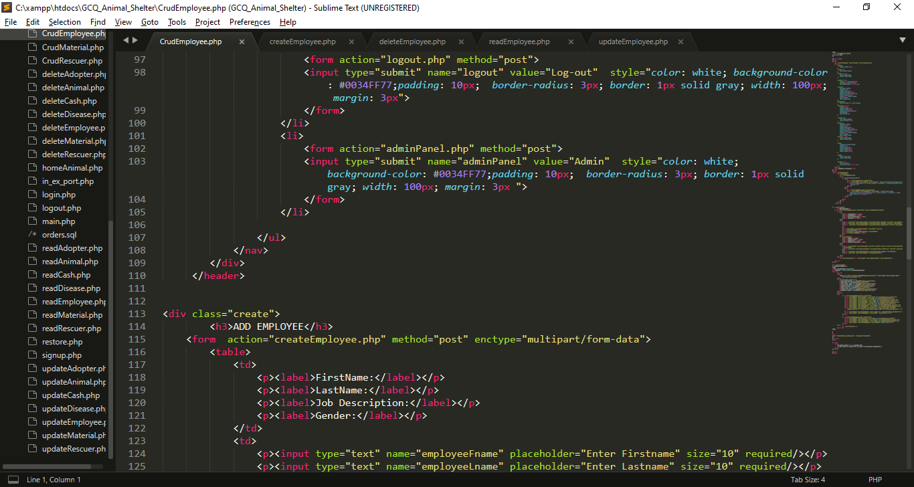

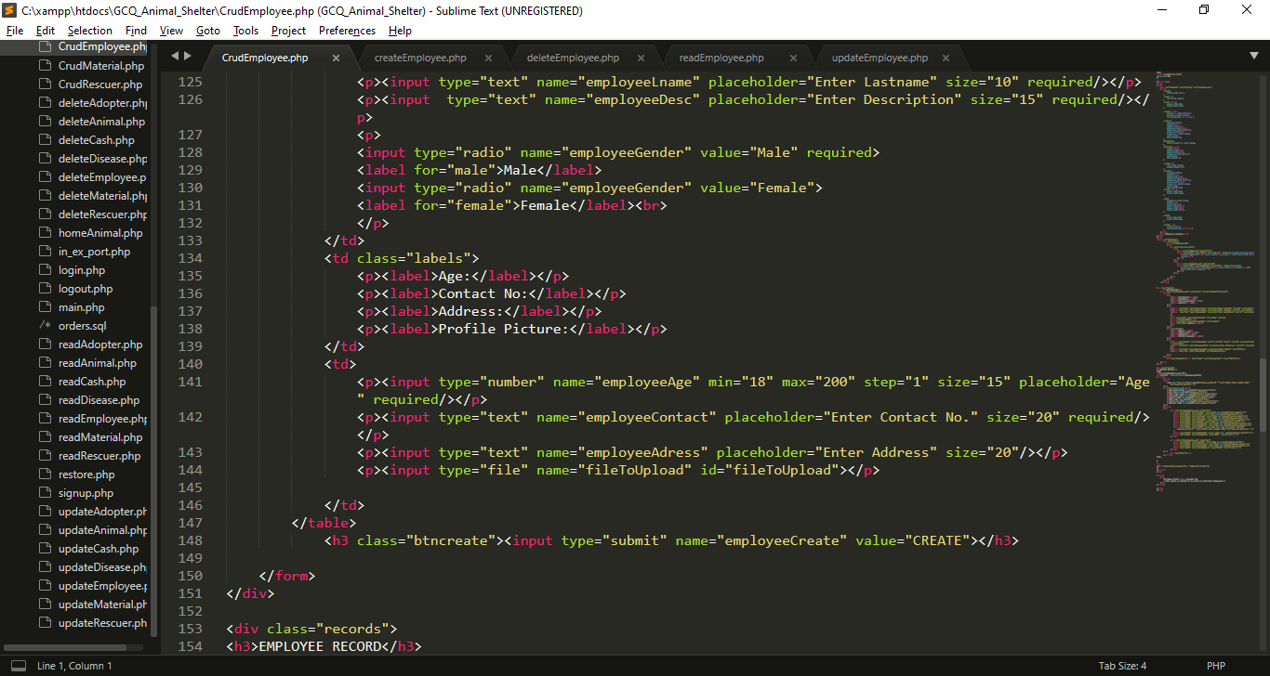

* I created a form inputs for the needed data, each input has name attribute which become a key for each value that users will input that will direct to createEmployee.php and it has a post method.
* I also added radio button named employeeGender, which is use for selecting gender.
* At the end of the form I create submit button that has name attribute of employeeCreate.

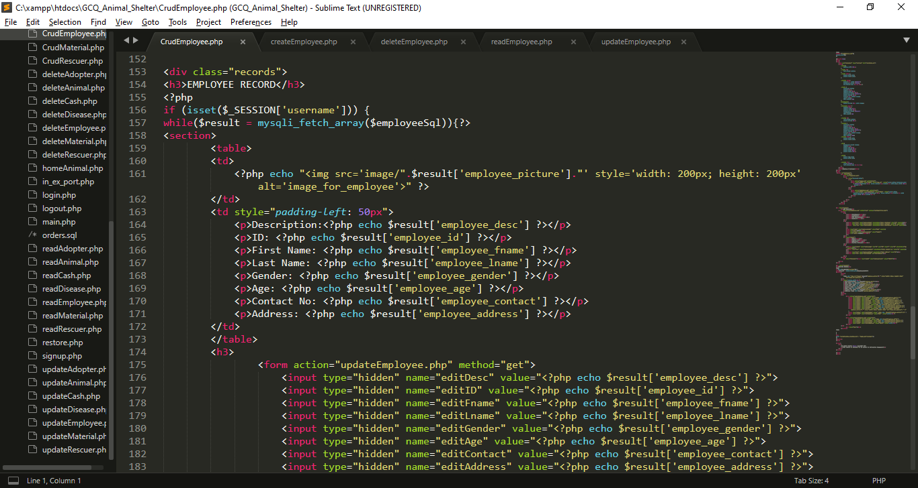

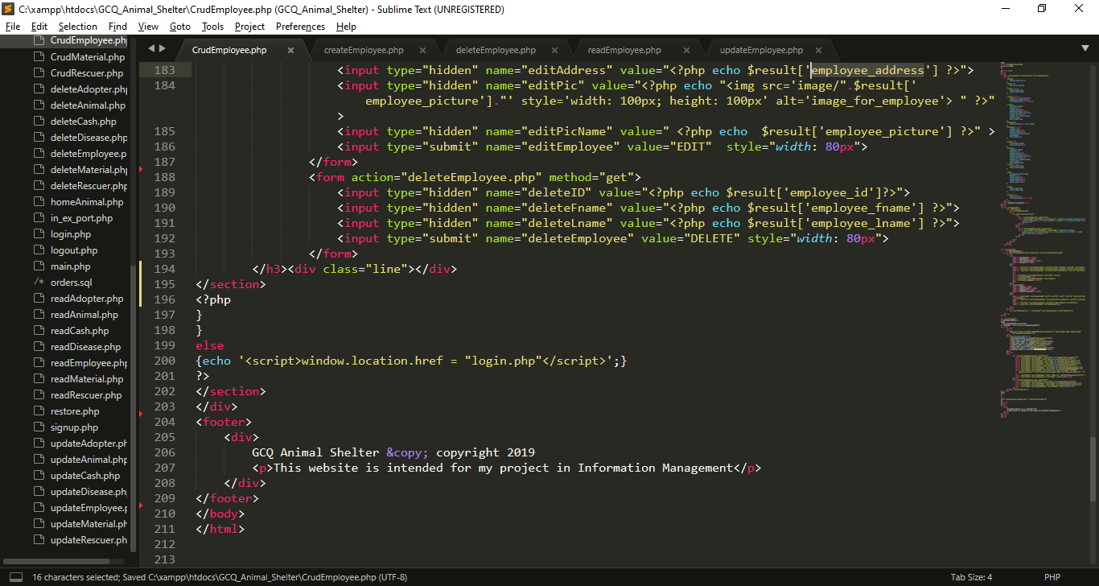

* I use If statement to check is the session username is already set.
* I use while loop to fetch all the data from $employeeSql which imported from readEmployee.php, each row will stored in $result that contains employee information, (the key is the column name and the value is the data that store in the specific column).
* I use hidden input type which get the result from results, this data will use for update
* I use hidden input type which get the result from results, this data will use for deletion

**I create createEmployee.php for inserting data in database**

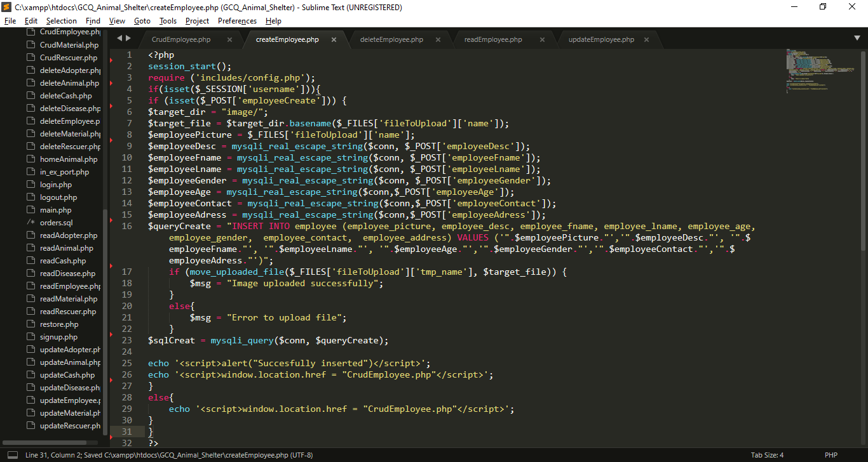

* I import includes/config.php for database connection.
* I use If statement to check is the session username is already set.
* If employeeCreate is set or click the insert process will begin
* I use basename () function, it is an inbuilt function which is used to return the base name of a file if the path of the file is provided as a parameter to the basename ().
* I get all the data from post which set in previous page (CrudEmployee.php). And put it into variables, so that I can use for insertion query
* $queryCreate variable contain string or query for insertion of values in employee table
* I use $_FILES['file']['tmp_name'] to provide temporary storage of uploaded image
* Using java script Success message will pop-up after the insertion, then it will back to CrudEmployee.php
* If the session username is not set insertion will not proceed.

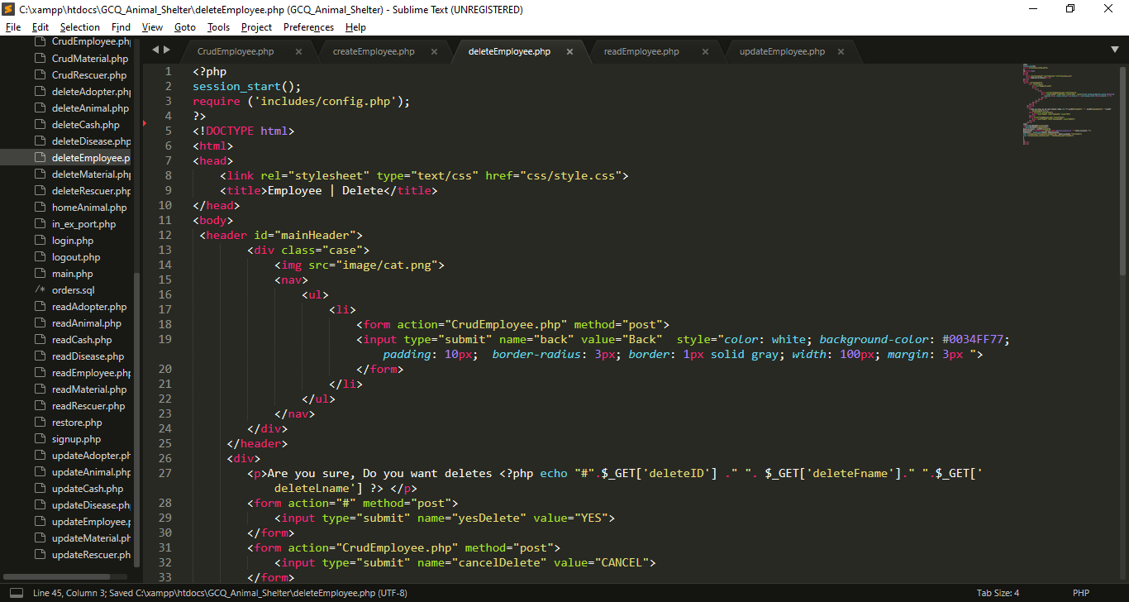

**I create deleteEmployee.php for deleting data in database**

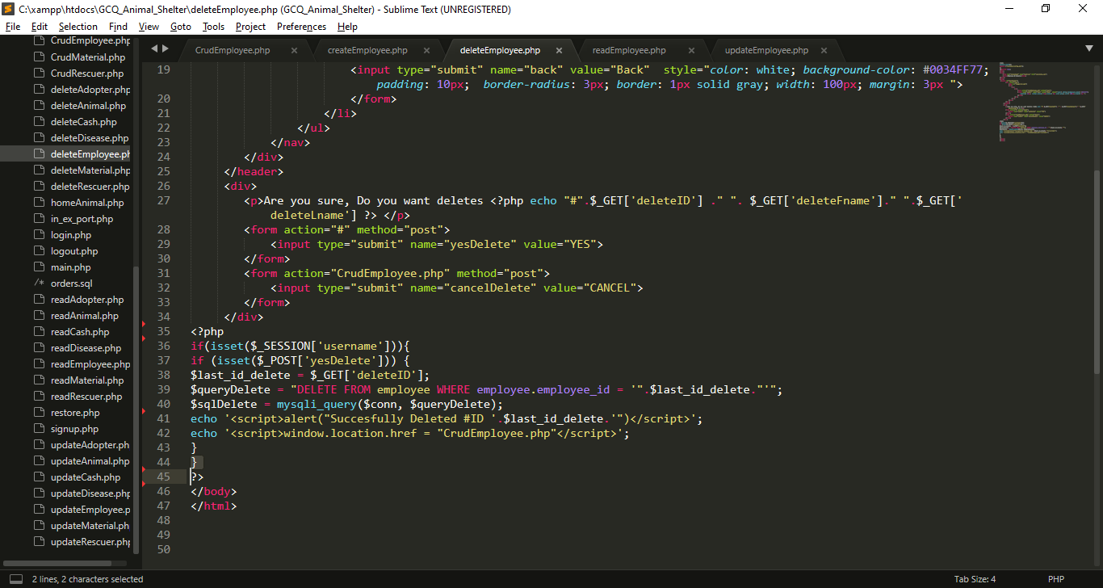

* I Include config.php for database connection
* If input submit named yesDelete is click the name yesDelete will set in $_POST, If this submit input named cancelDelete is click it will back in CrudEmployee.php
* If yesDelete is set query will execute for deletion

**I create readEmployee.php for reading data in database**

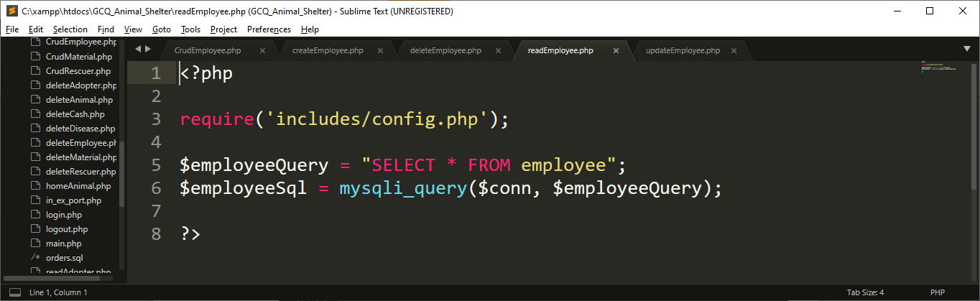

* Include config.php for database connection
* I create query called $employeeQuery for selecting all the data from employee , after that, I execute that query using mysqli_query() function, that has 2 parameter which is the connection and the query

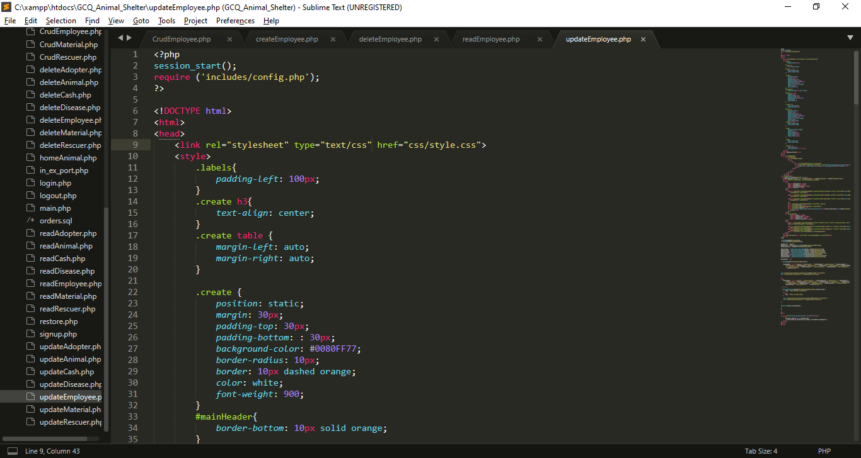

**I create updateEmployee.php for update data in database**

My External CSS

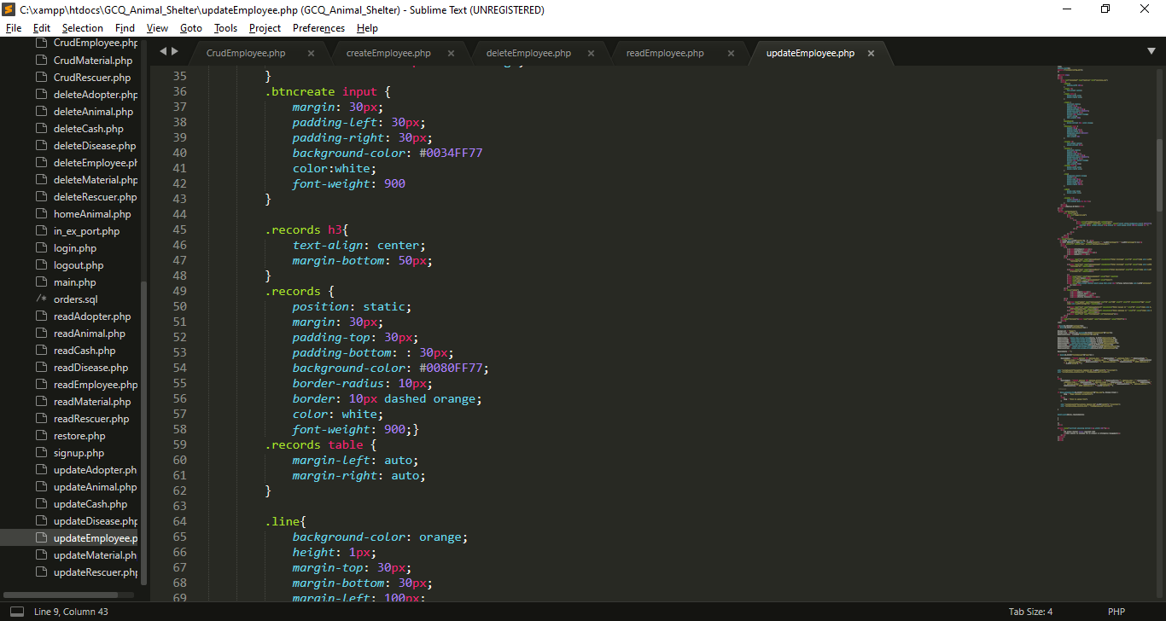

My Internal CSS

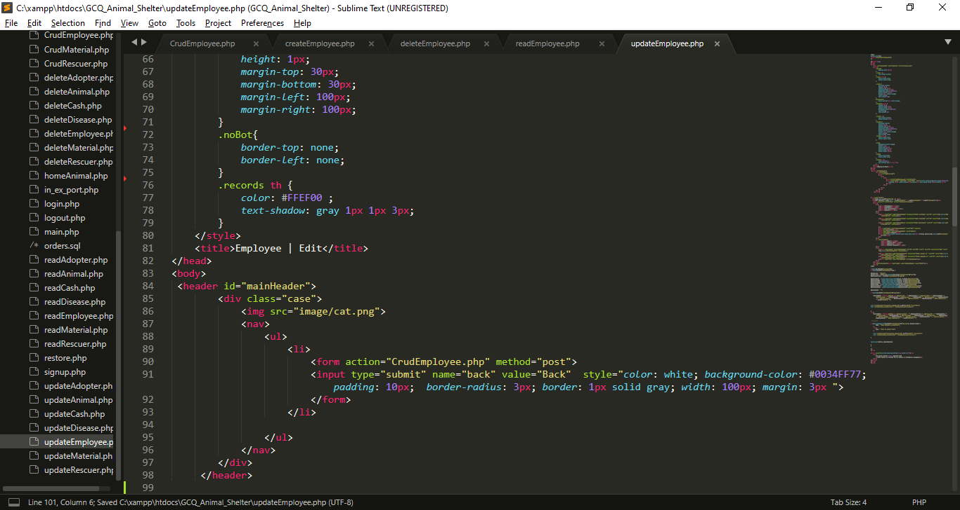

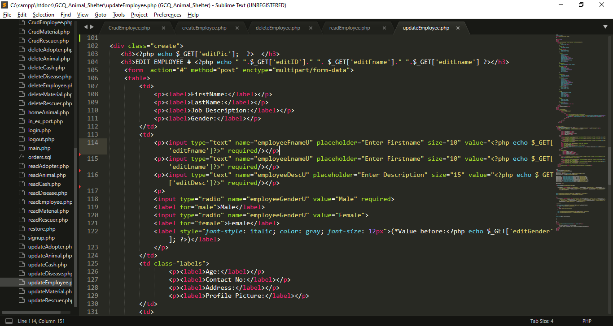

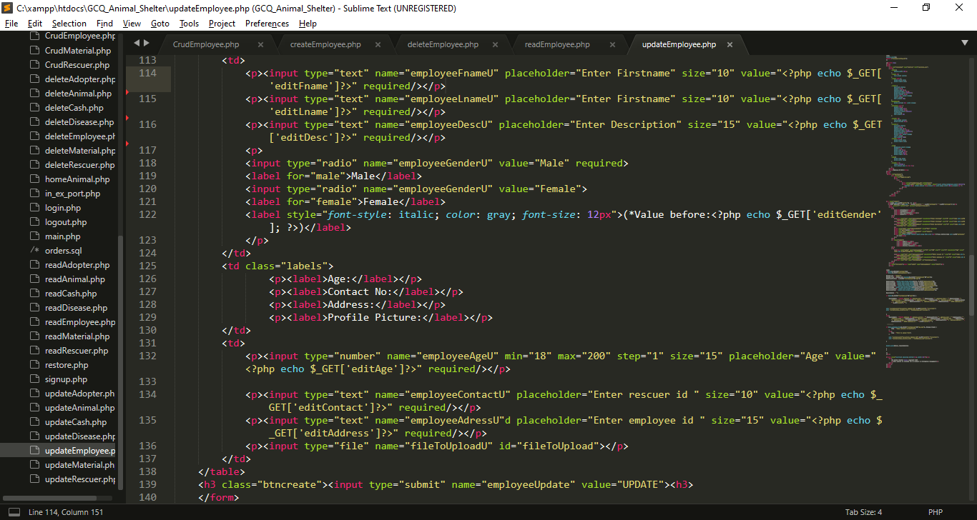

* I created inputs for the needed data, each input has name attribute which become a key for each value that users will input for update, I also get all the data from get method from CrudEmployee.php to show the current value while editing.

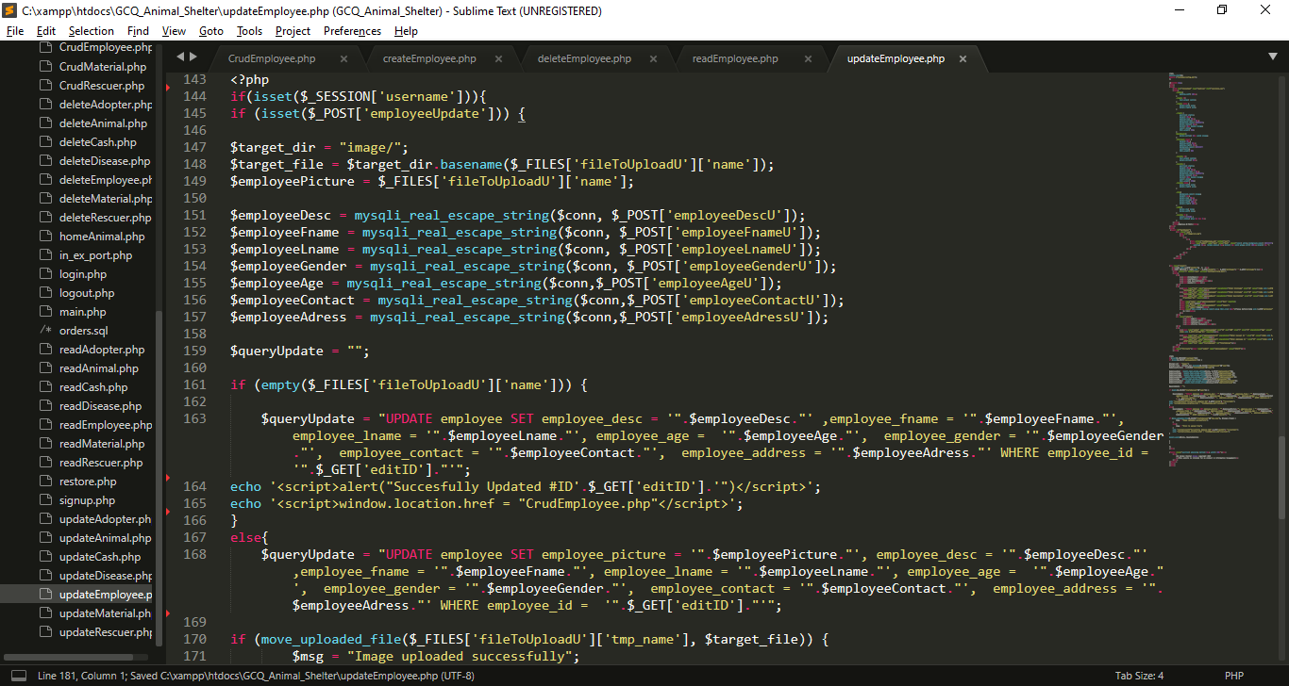

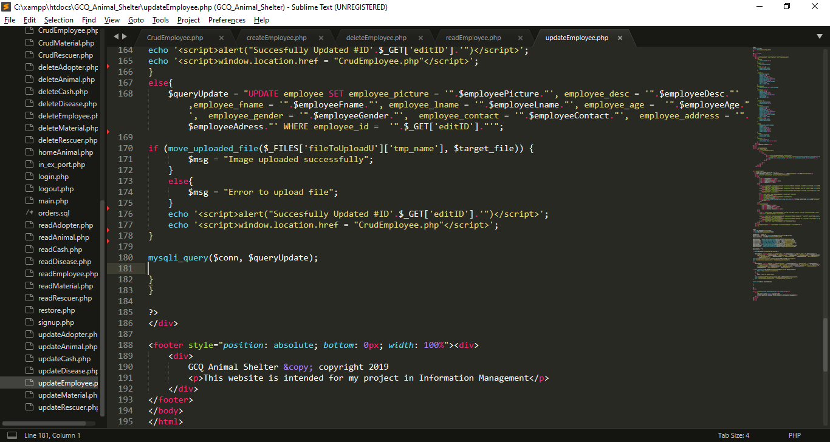

* I get all the data from post which set in from the top of this file, I put it into variables, so that I can use for updating query.
* Then I create two queries, one is for updating with picture and one is without picture
* After that , all query will be executed, if the updating is success alert will pop-up

1. **Quiz 1 CRUD Script For The Cash Donations**
   1. **GUI For Quiz 1**

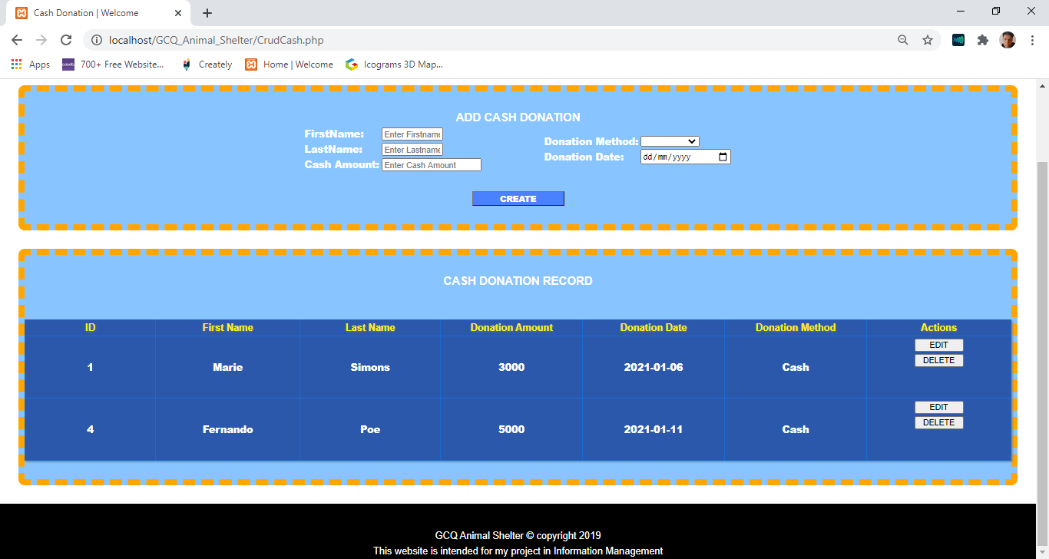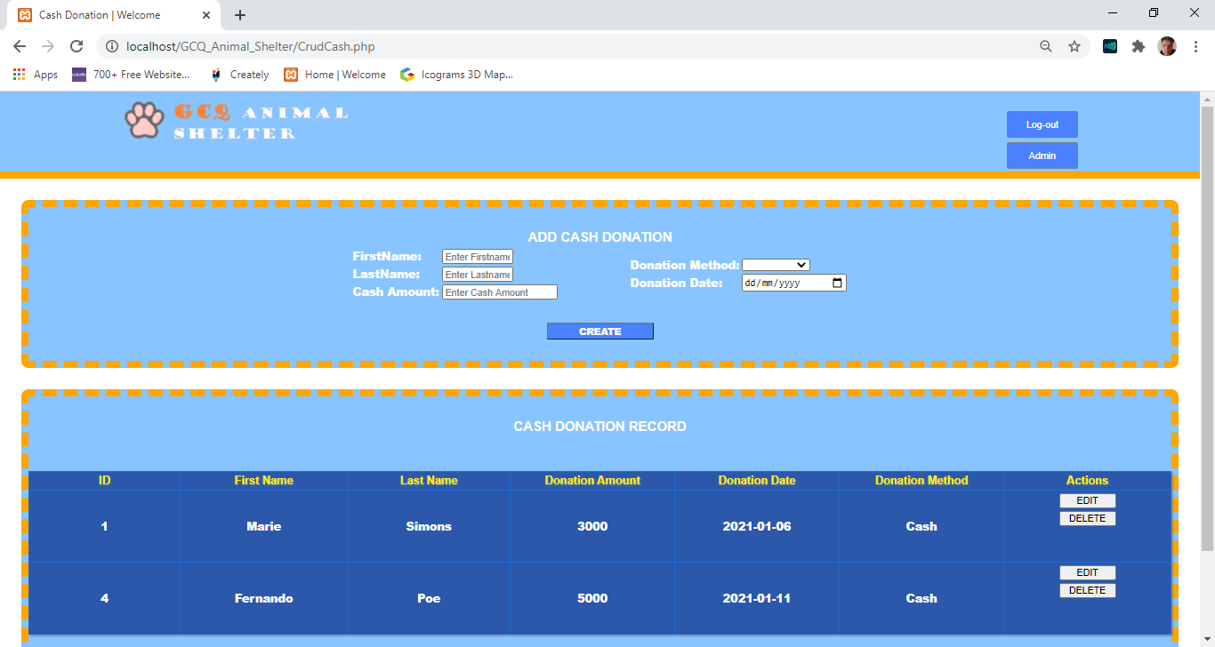

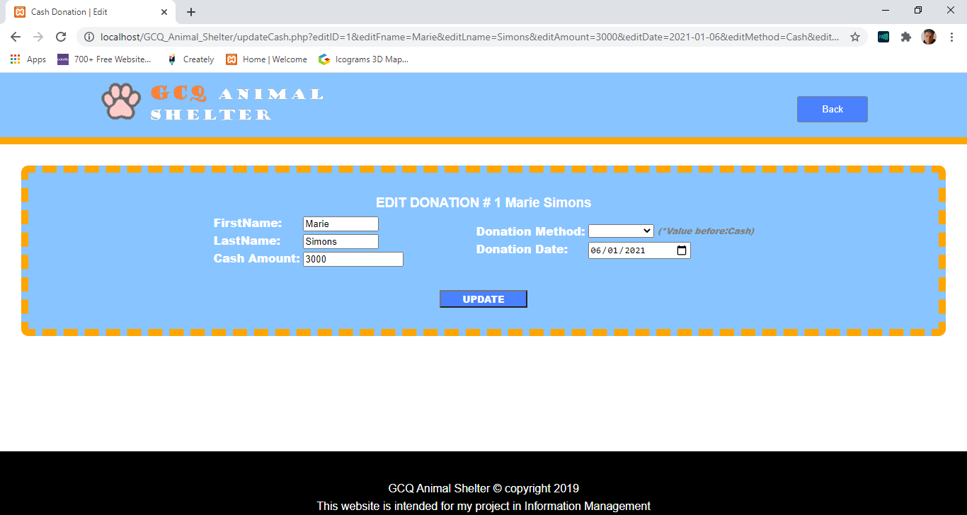

**4.2 Codes For Quiz 1**

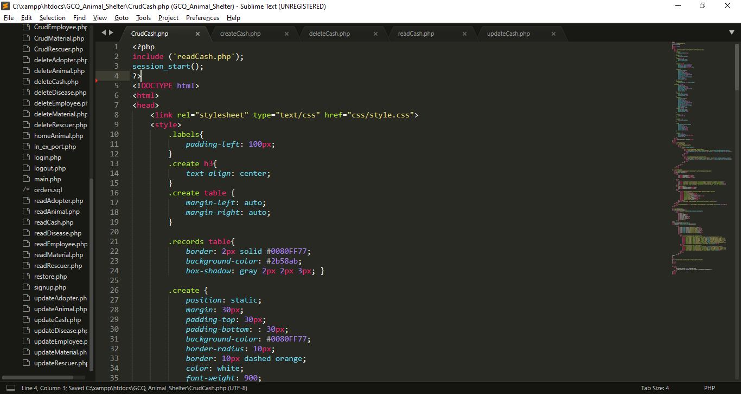

I import/include this reads file for displaying purpose

My External CSS

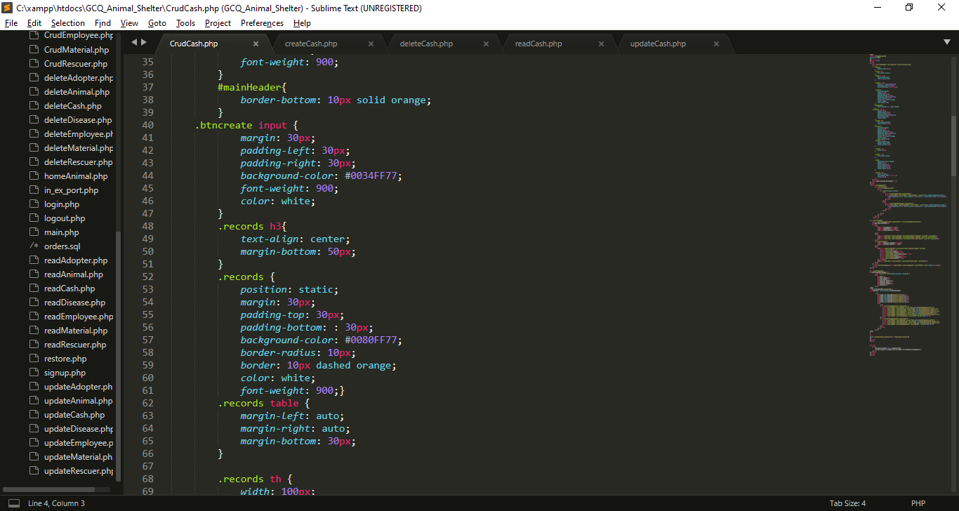

My Internal CSS

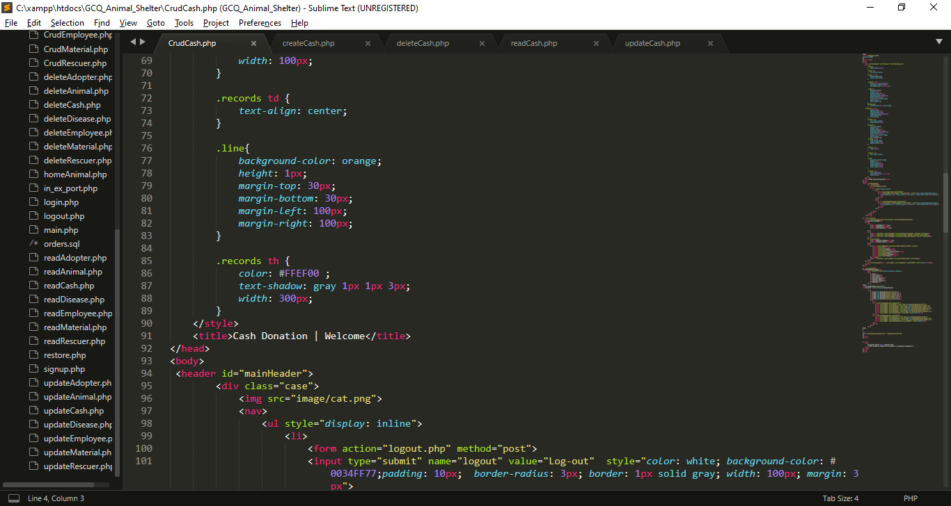

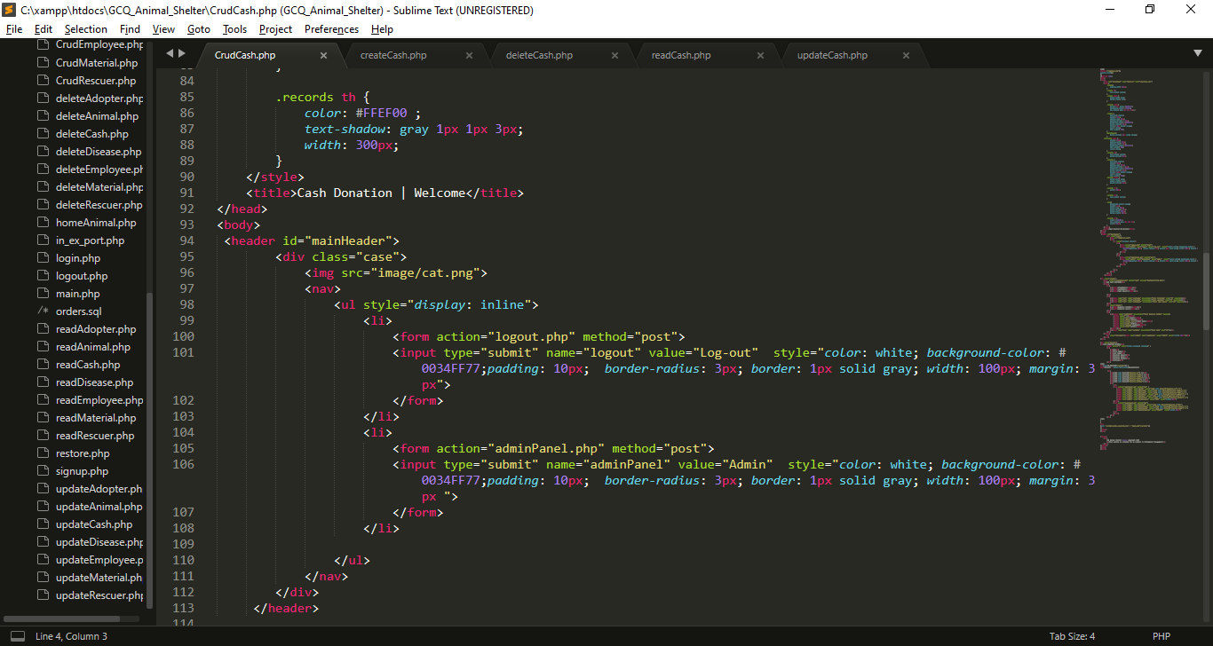

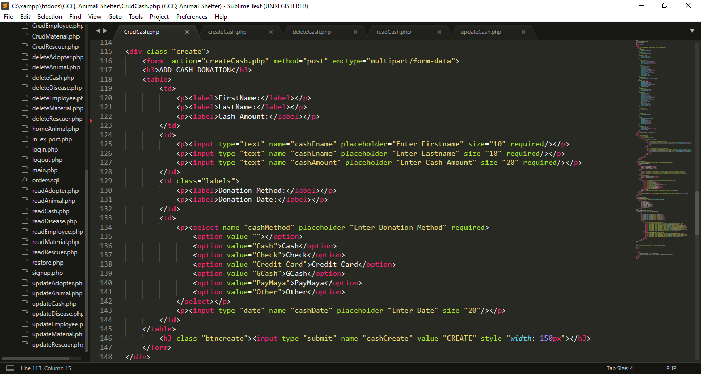

* I created a form inputs for the needed data, each input has name attribute which become a key for each value that users will input that will direct to createCash.php and it has a post method.
* At the end of the form I create submit button that has name attribute of cashCreate.

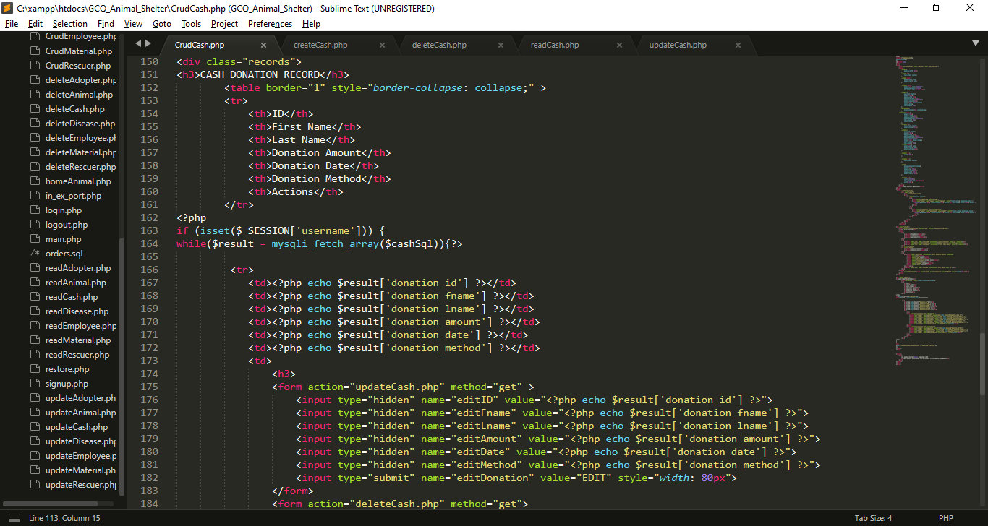

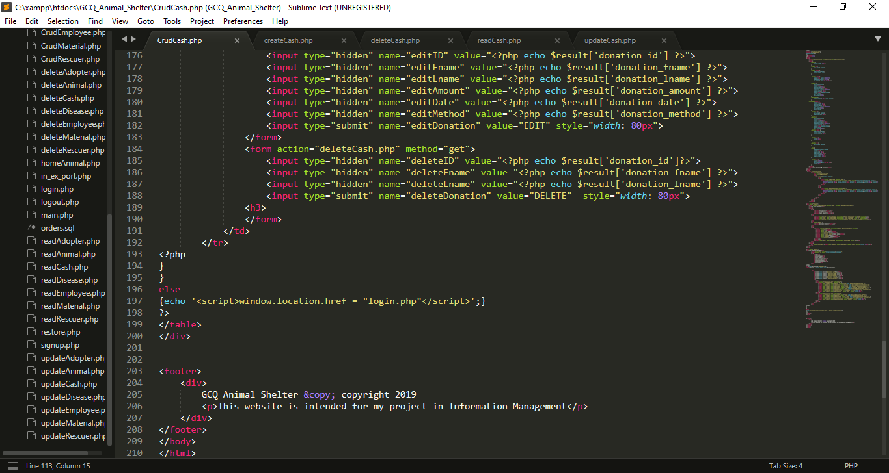

* I use If statement to check is the session username is already set.
* I use while loop to fetch all the data from $cashSql which imported from readCash.php, each row will stored in $result that contains cash information, (the key is the column name and the value is the data that store in the specific column).
* I use hidden input type which get the result from results, this data will use for update
* I use hidden input type which get the result from results, this data will use for deletion

**I create createCash.php for inserting data in database**

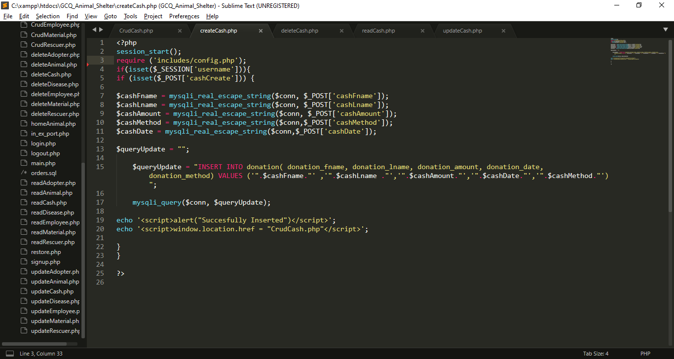

* I import includes/config.php for database connection.
* I use If statement to check is the session username is already set.
* If cashCreate is set or click the insert process will begin
* I get all the data from post which set in previous page (CrudCash.php). And put it into variables, so that I can use for insertion query
* $queryCreate variable contain string or query for insertion of values in cash table
* Using java script Success message will pop-up after the insertion, then it will back to CrudCash.php
* If the session username is not set insertion will not proceed.

**I create deleteCash.php for deleting data in database**

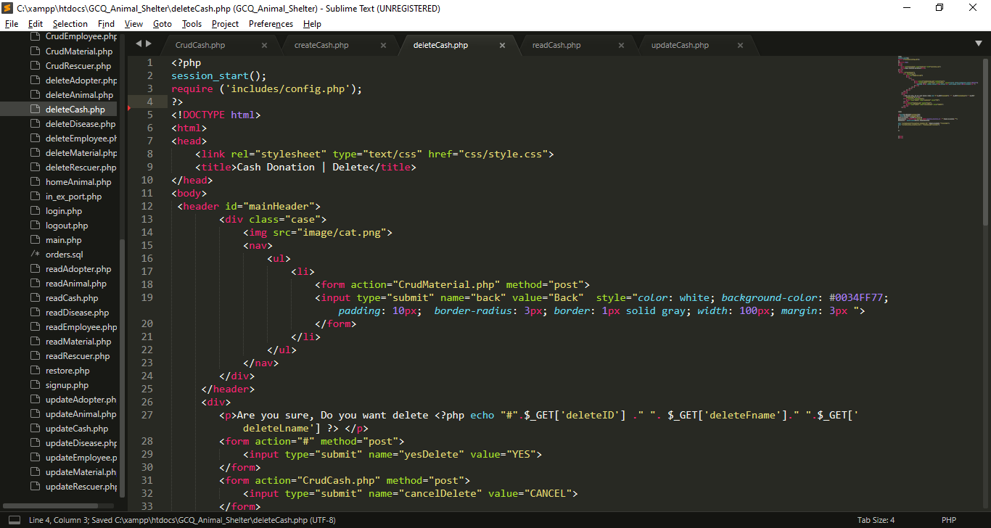

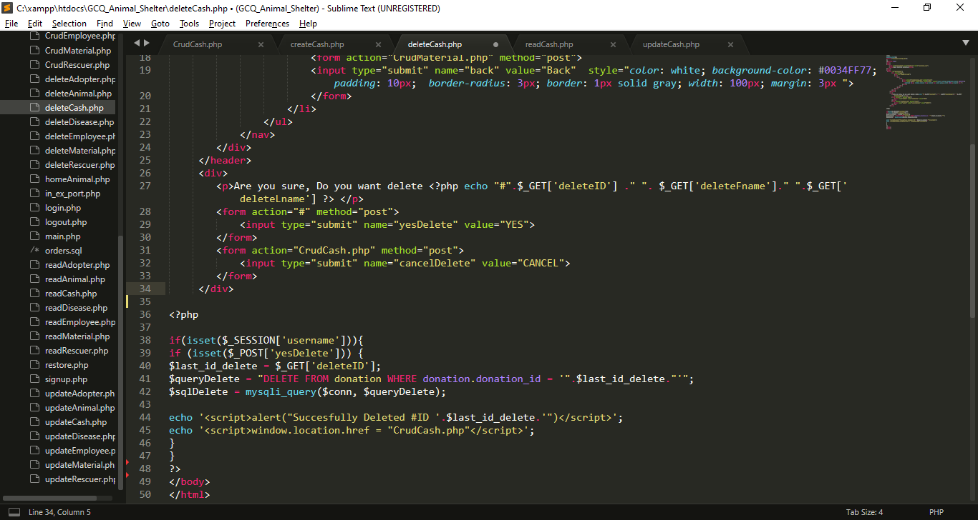

* I Include config.php for database connection
* If input submit named yesDelete is click the name yesDelete will set in $_POST, If this submit input named cancelDelete is click it will back in CrudCash.php
* If yesDelete is set query will execute for deletion

**I create readCash.php for reading data in database**

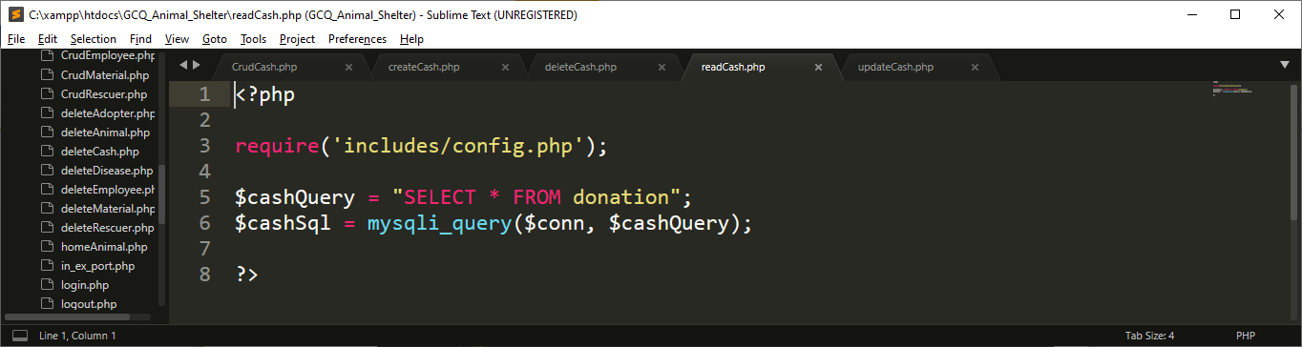

* Include config.php for database connection
* I create query called $cashQuery for selecting all the data from cash , after that, I execute that query using mysqli_query() function, that has 2 parameter which is the connection and the query

**I create updateCash.php for update data in database**

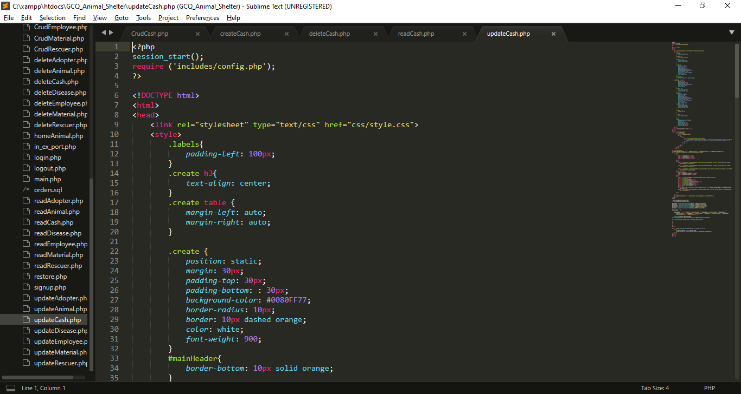

My External CSS

My Internal CSS

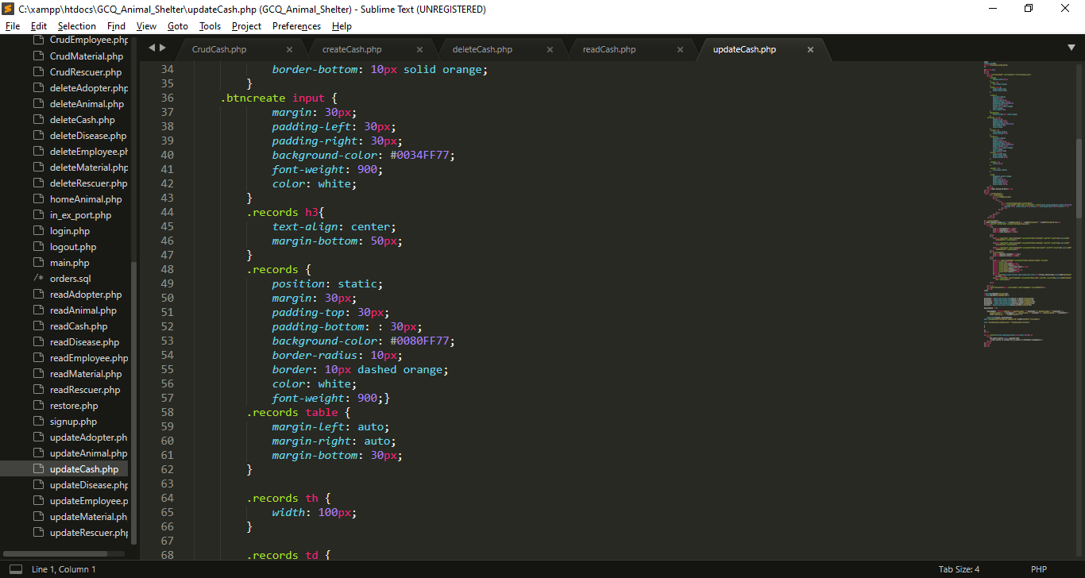

My Internal CSS

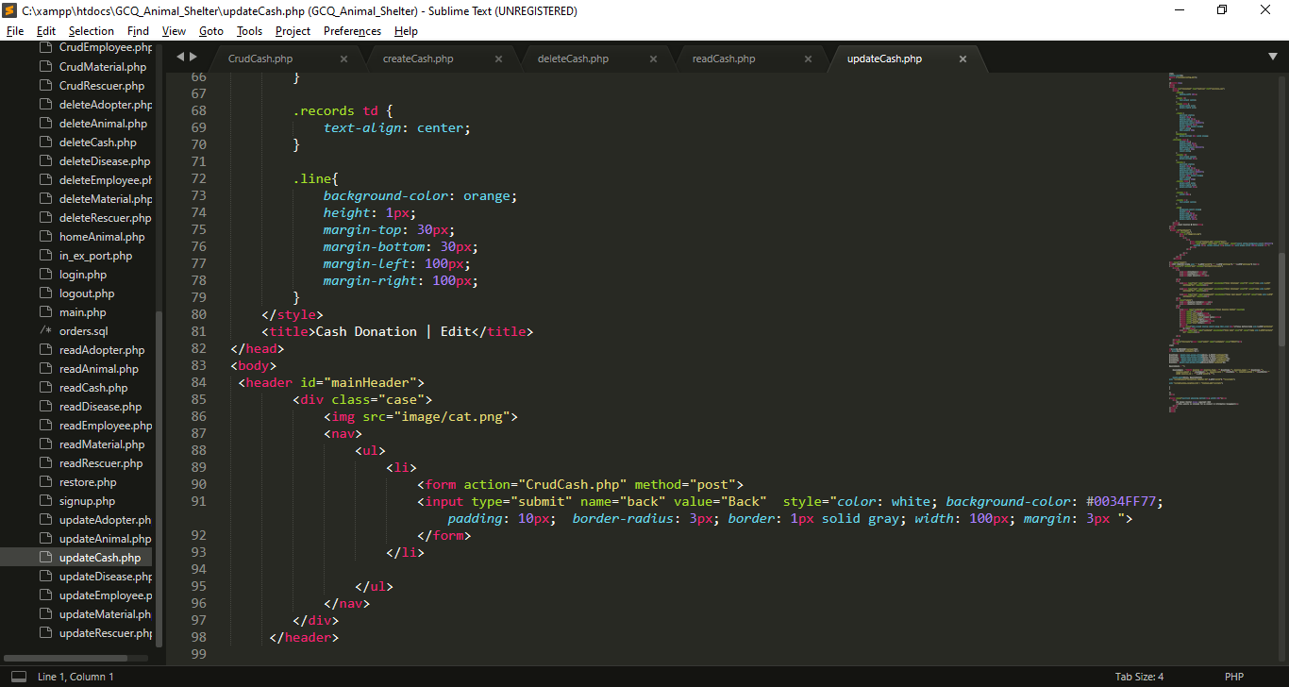

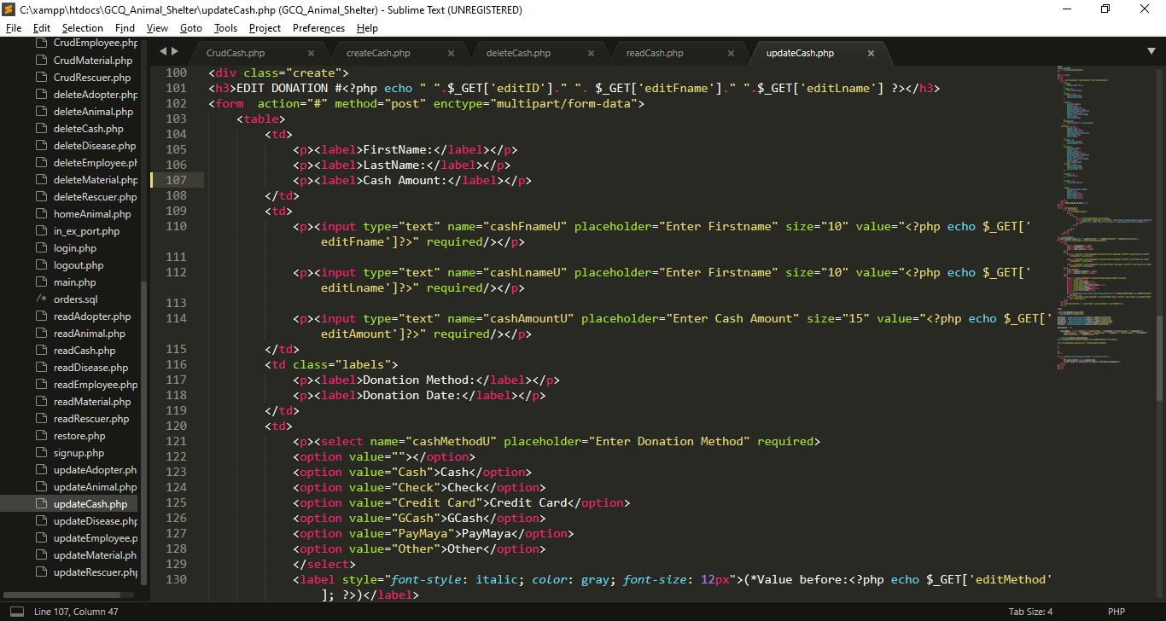

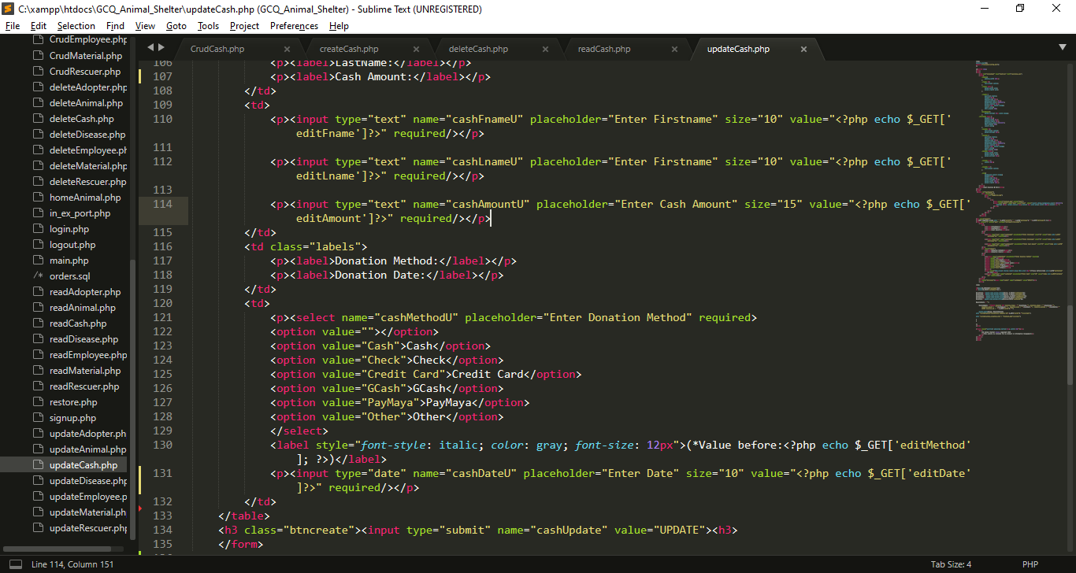

* I created inputs for the needed data, each input has name attribute which become a key for each value that users will input for update, I also get all the data from get method from CrudCash.php to show the current value while editing.

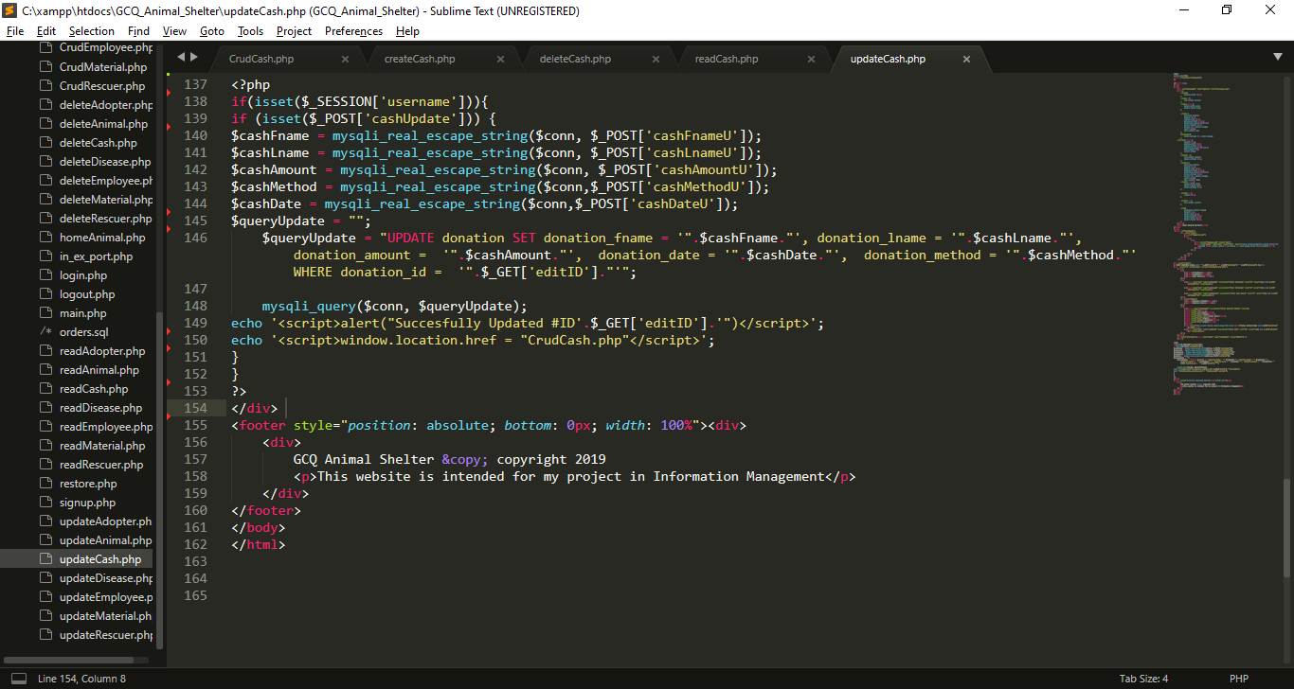

* I get all the data from post which set in from the top of this file, I put it into variables, so that I can use for updating query.
* After that , all query will be executed, if the updating is success alert will pop-up

**5. Quiz 2 CRUD Script For The Material Or In Kind Donations**

**5.1 GUI For Quiz 2**

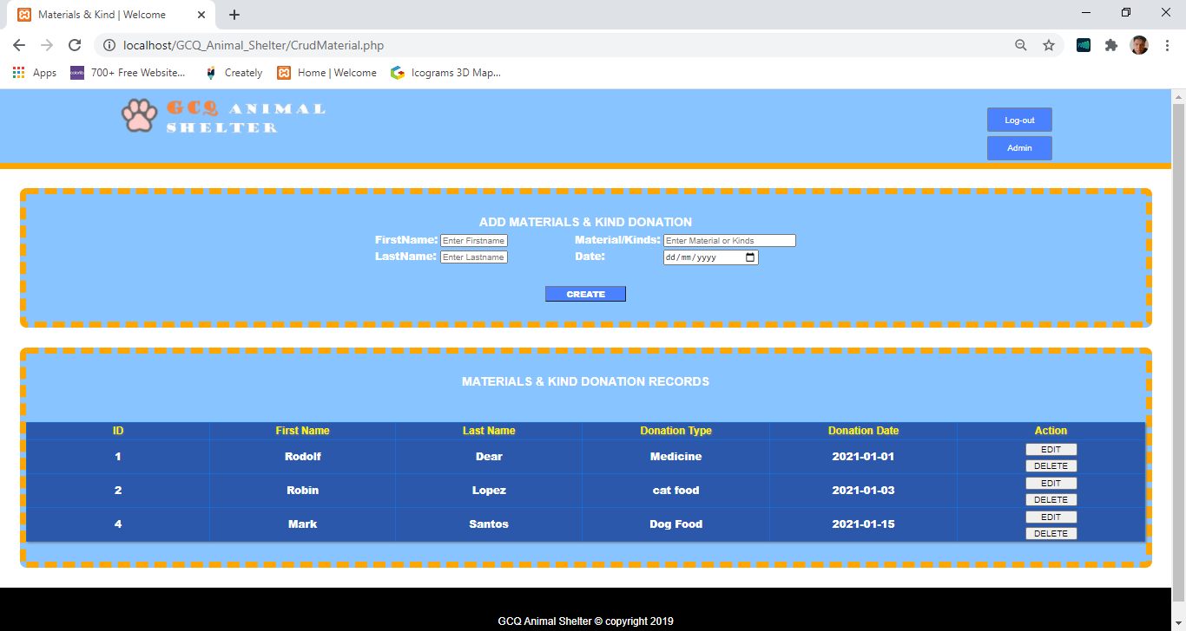

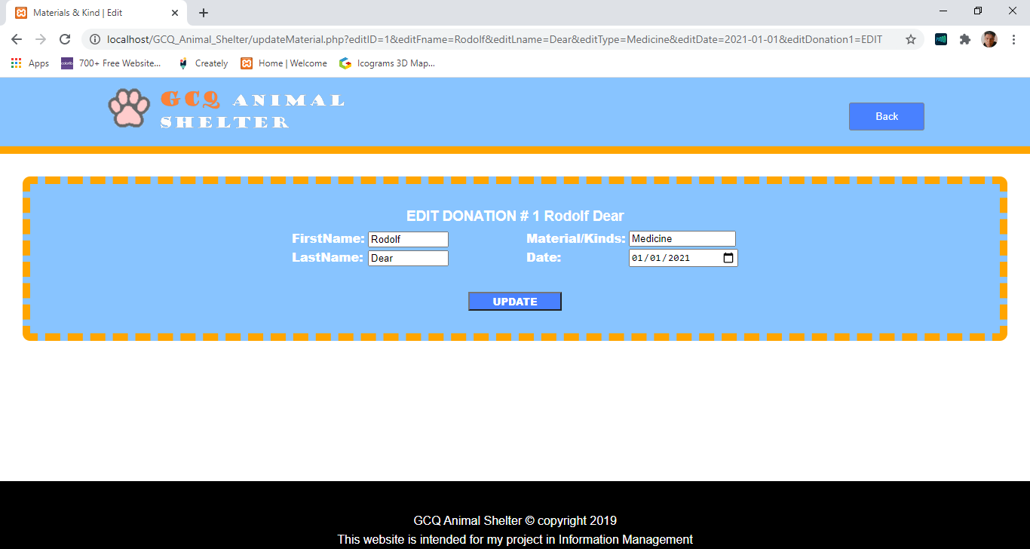

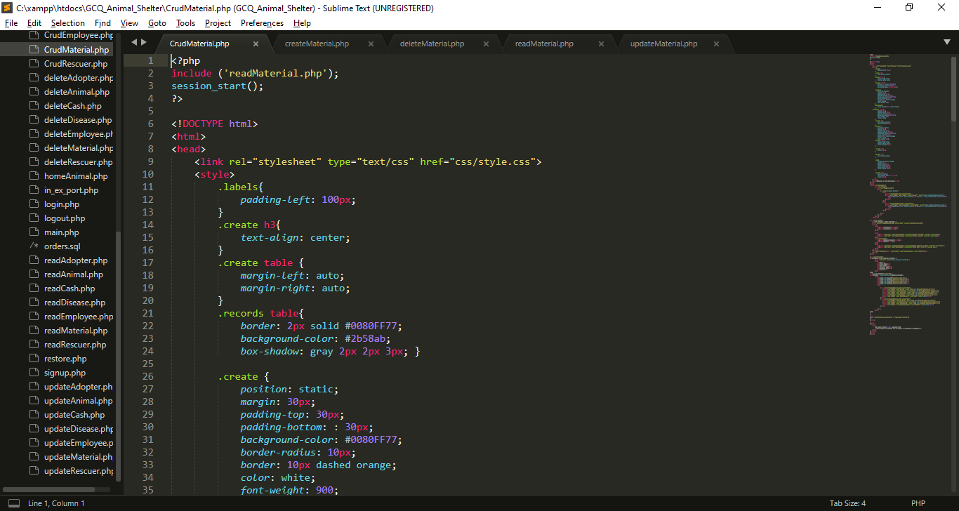 **5.2 Codes For Quiz 2**

I import/include this reads file for displaying purpose

My External CSS

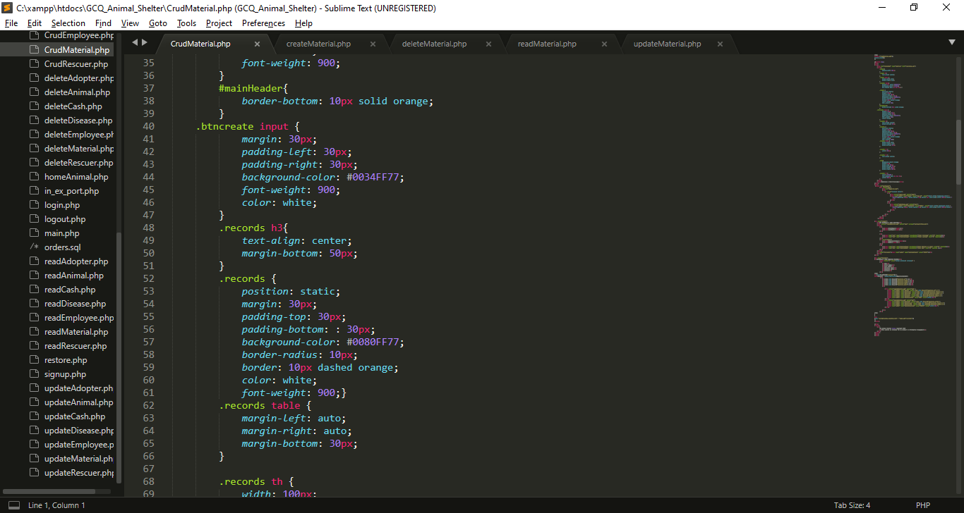

My Internal CSS

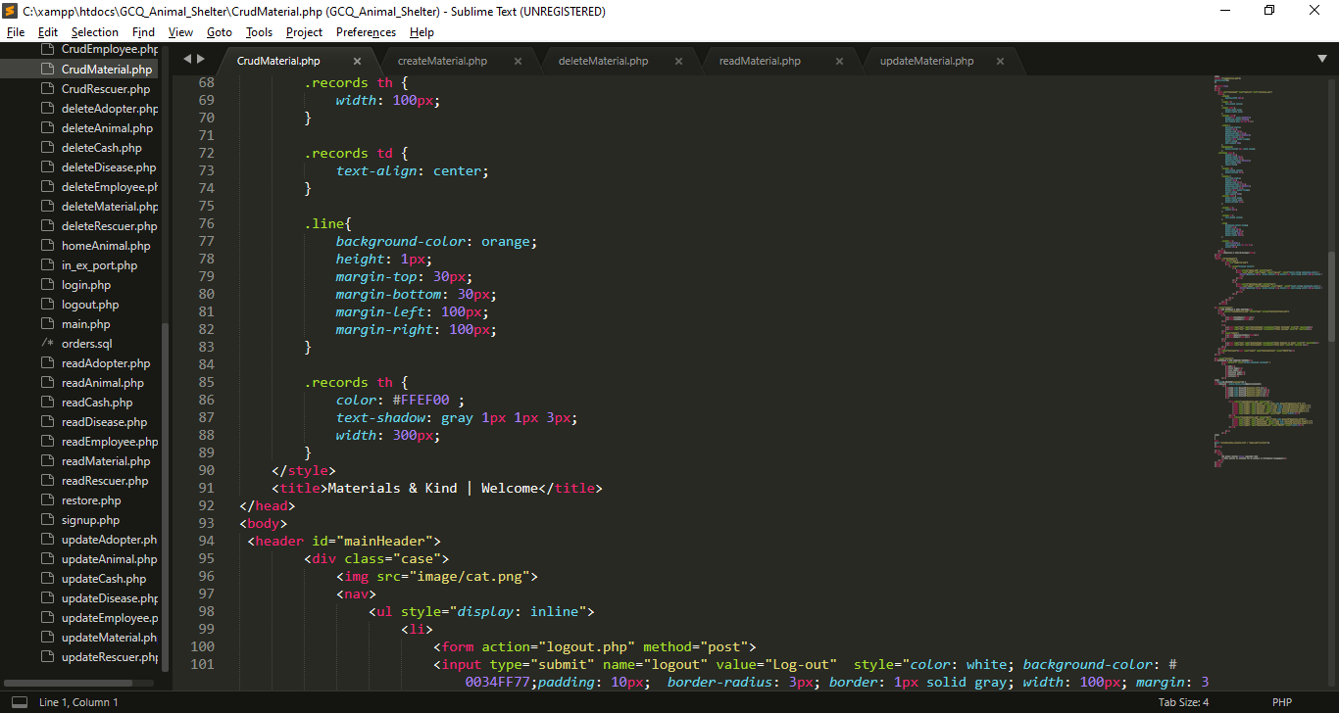

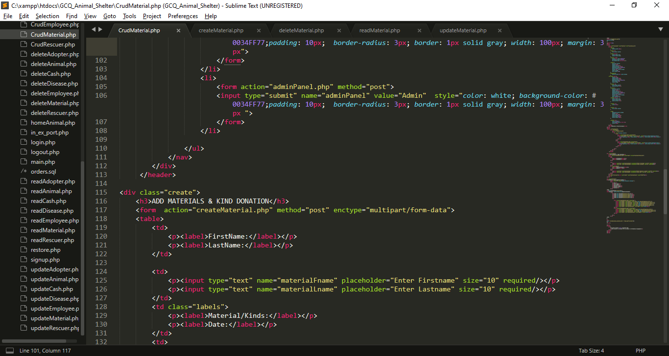

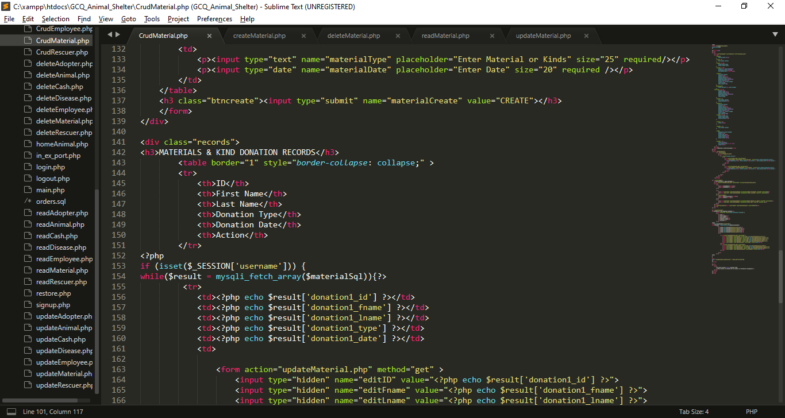

* I created a form inputs for the needed data, each input has name attribute which become a key for each value that users will input that will direct to createMaterial.php and it has a post method.
* At the end of the form I create submit button that has name attribute of materialCreate.

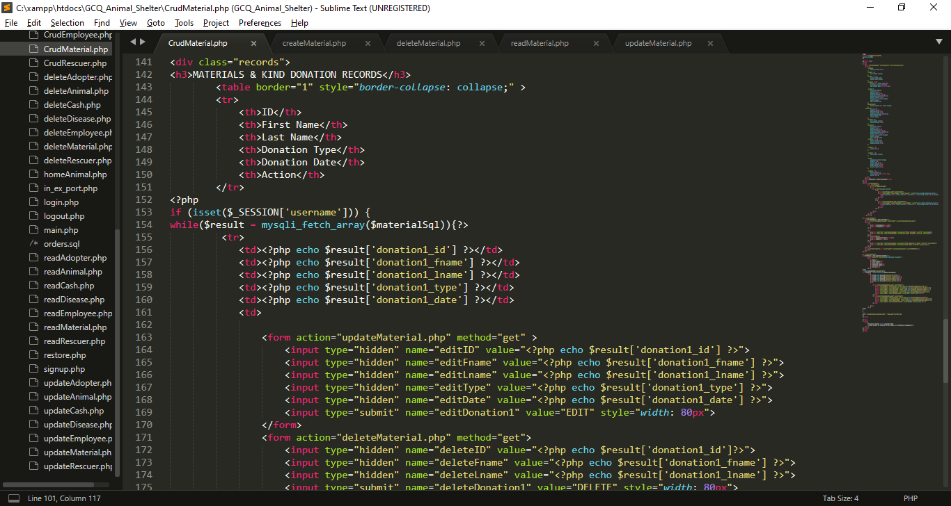

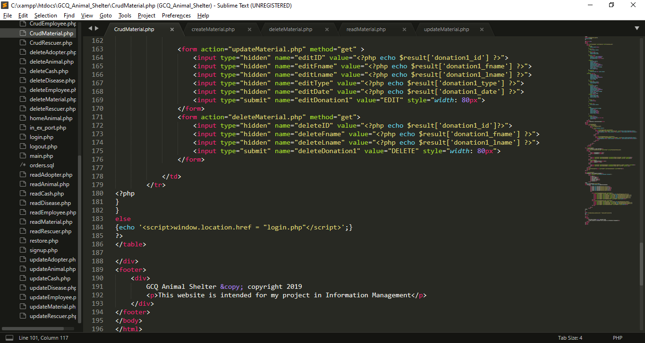

* I use If statement to check is the session username is already set.
* I use while loop to fetch all the data from $materialSql which imported from readMaterial.php, each row will stored in $result that contains material information, (the key is the column name and the value is the data that store in the specific column).
* I use hidden input type which get the result from results, this data will use for update
* I use hidden input type which get the result from results, this data will use for deletion

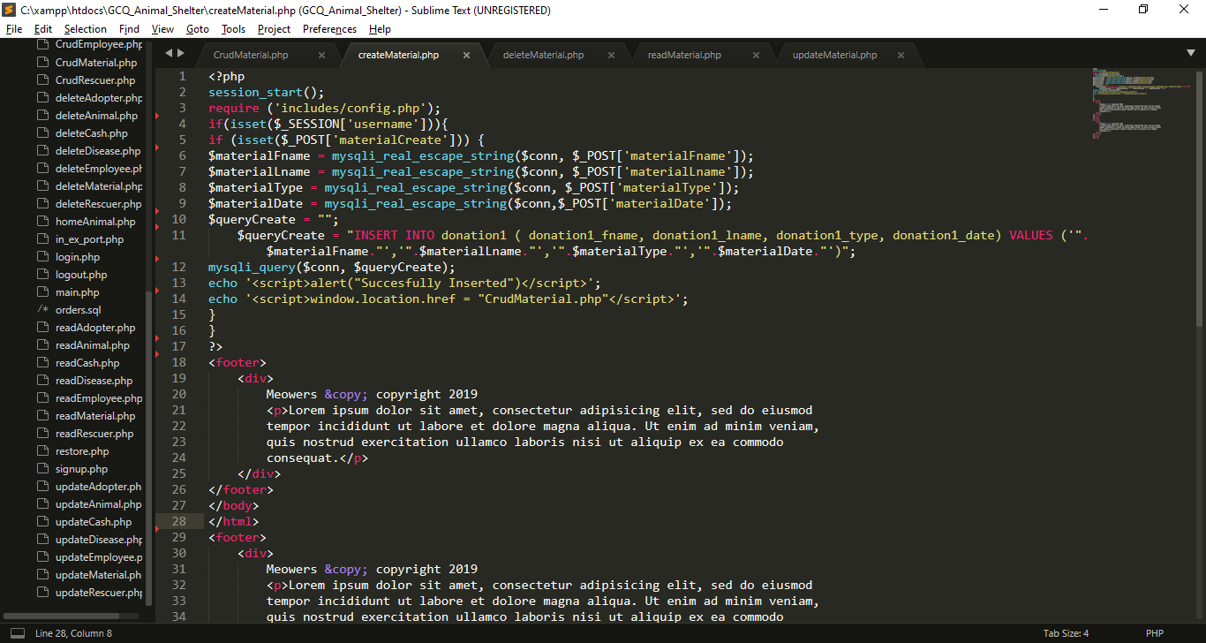

**I create createMaterial.php for inserting data in database**

* I import includes/config.php for database connection.
* I use If statement to check is the session username is already set.
* If materialCreate is set or click the insert process will begin
* I get all the data from post which set in previous page (CrudMaterial.php). And put it into variables, so that I can use for insertion query
* $queryCreate variable contain string or query for insertion of values in material table
* Using java script Success message will pop-up after the insertion, then it will back to CrudMaterial.php
* If the session username is not set insertion will not proceed.

**I create deleteCash.php for deleting data in database**

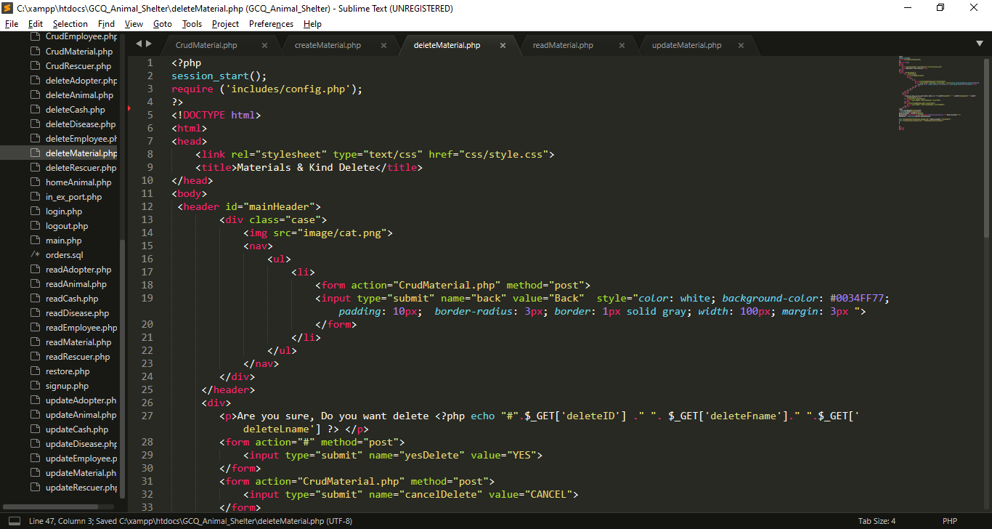

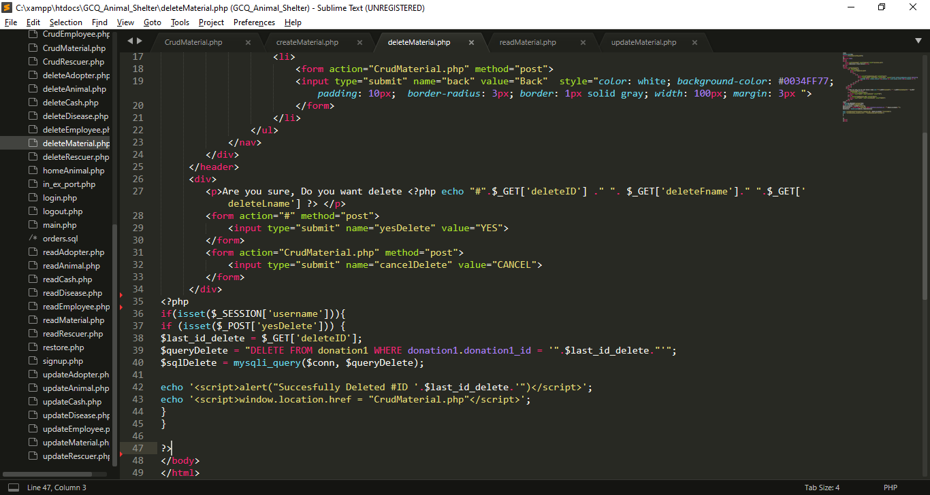

* I Include config.php for database connection
* If input submit named yesDelete is click the name yesDelete will set in $_POST, If this submit input named cancelDelete is click it will back in CrudMaterail.php
* If yesDelete is set query will execute for deletion

**I create readMaterial.php for reading data in database**

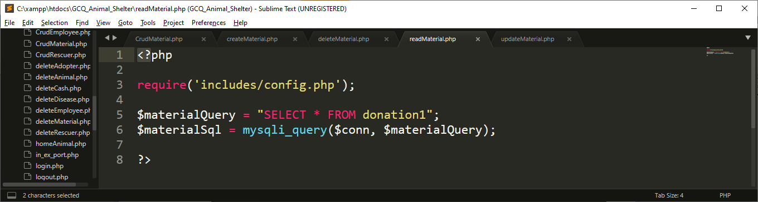

* Include config.php for database connection
* I create query called $materialQuery for selecting all the data from material , after that, I execute that query using mysqli_query() function, that has 2 parameter which is the connection and the query

**I create updateMaterial.php for update data in database**

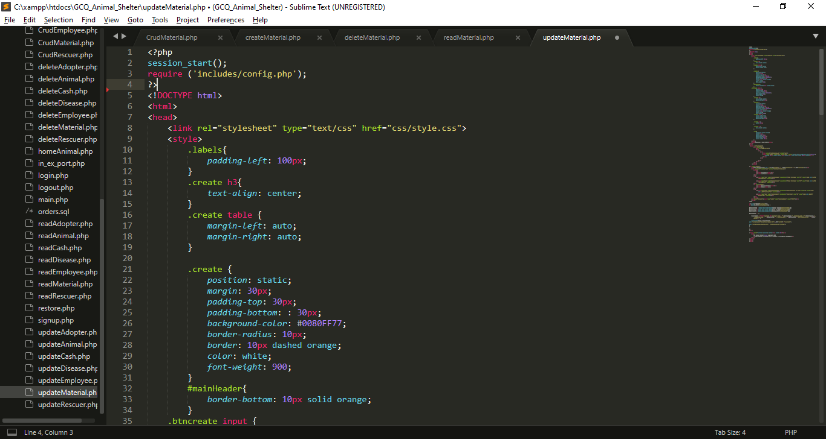

My External CSS

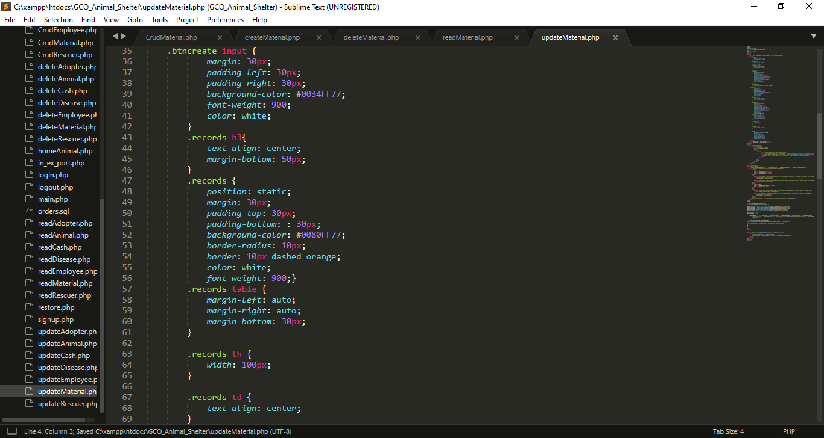

My Internal CSS

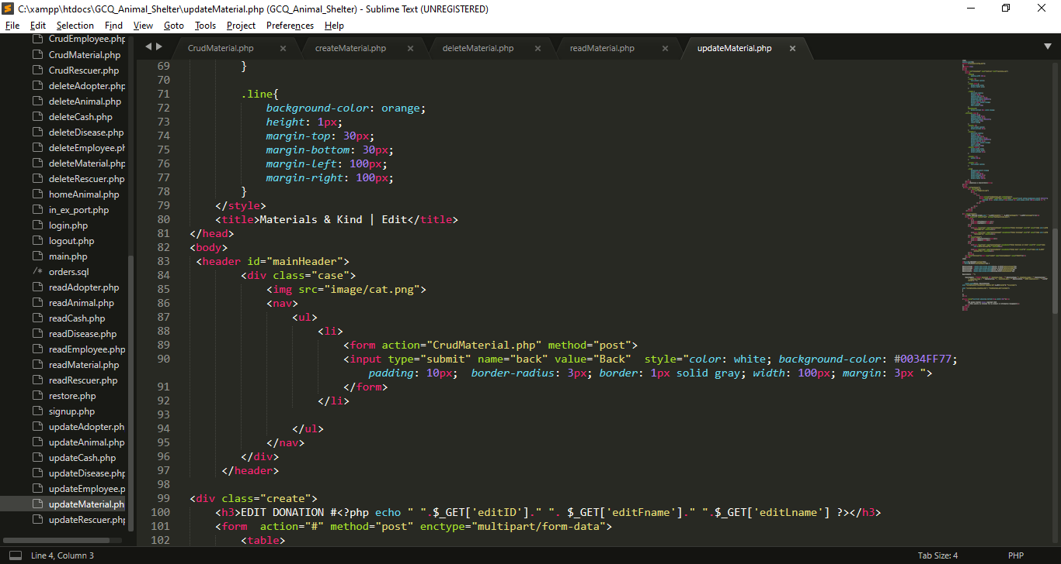

My Internal CSS

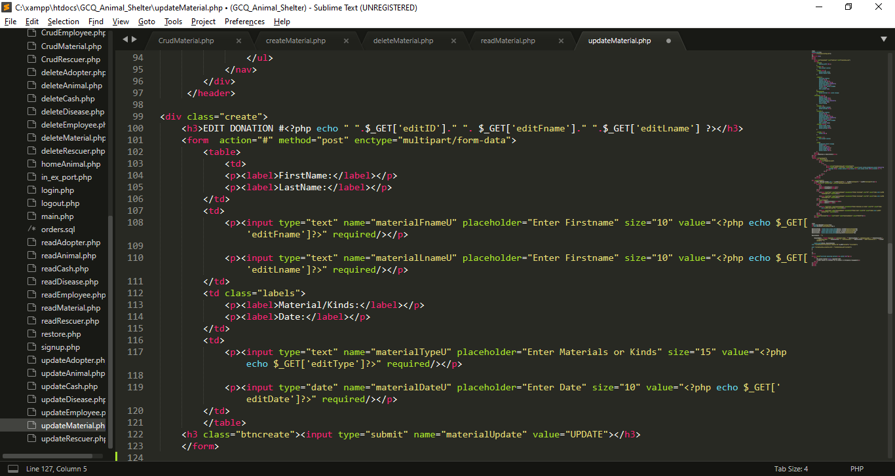

* I created inputs for the needed data, each input has name attribute which become a key for each value that users will input for update, I also get all the data from get method from CrudMaterial.php to show the current value while editing.

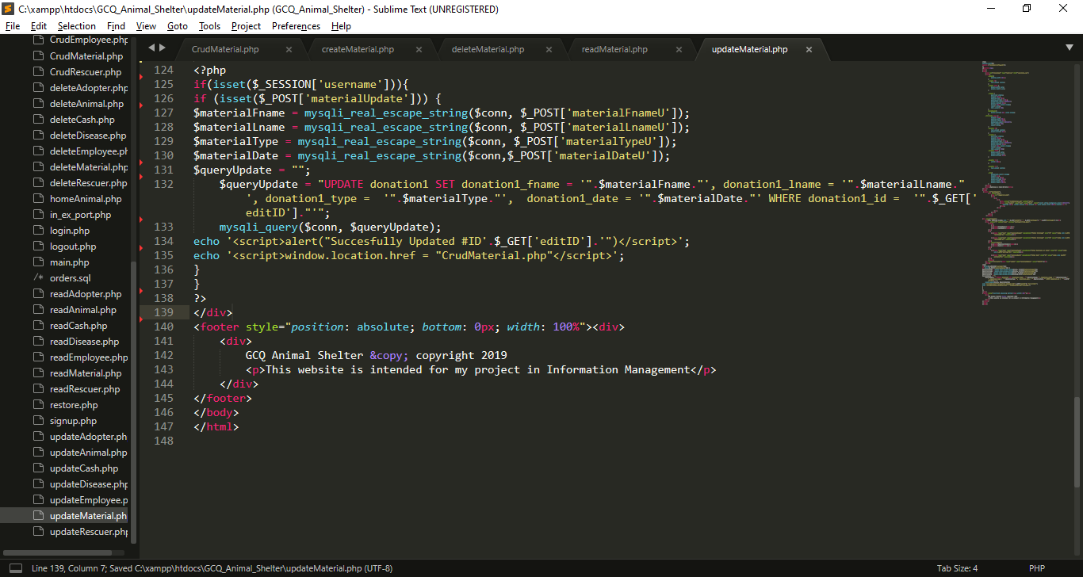

* I get all the data from post which set in from the top of this file, I put it into variables, so that I can use for updating query.
* After that , all query will be executed, if the updating is success alert will pop-up

**6. MP 4 CRUD Script For The Adopters**

**6.1 GUI For MP 4**

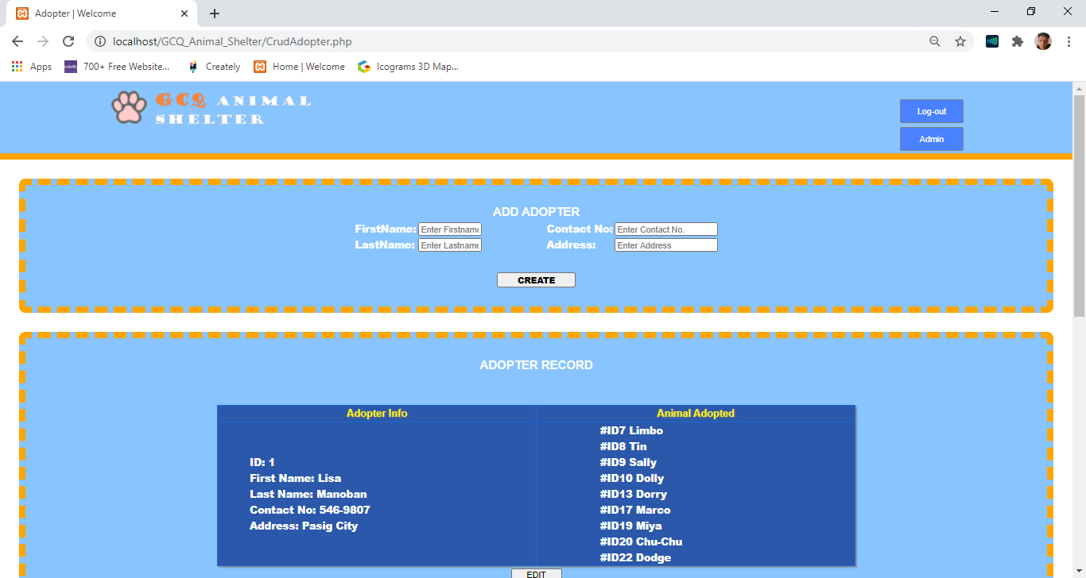

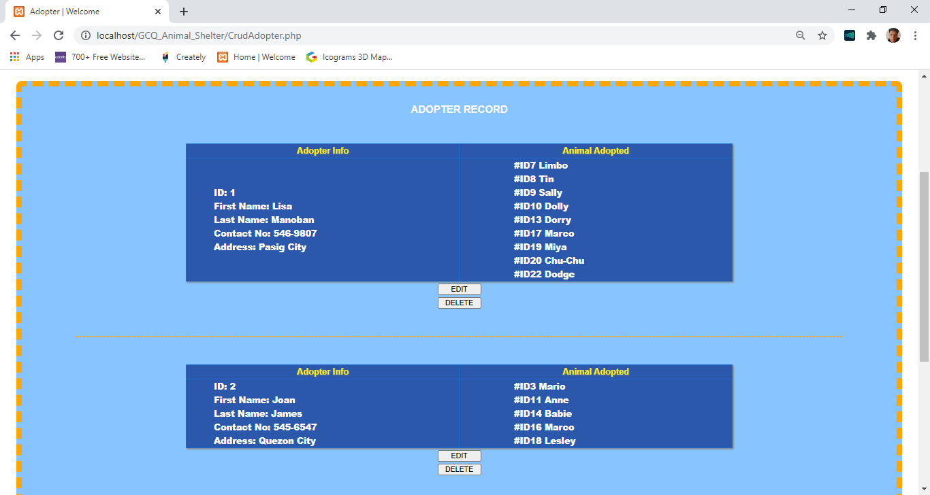

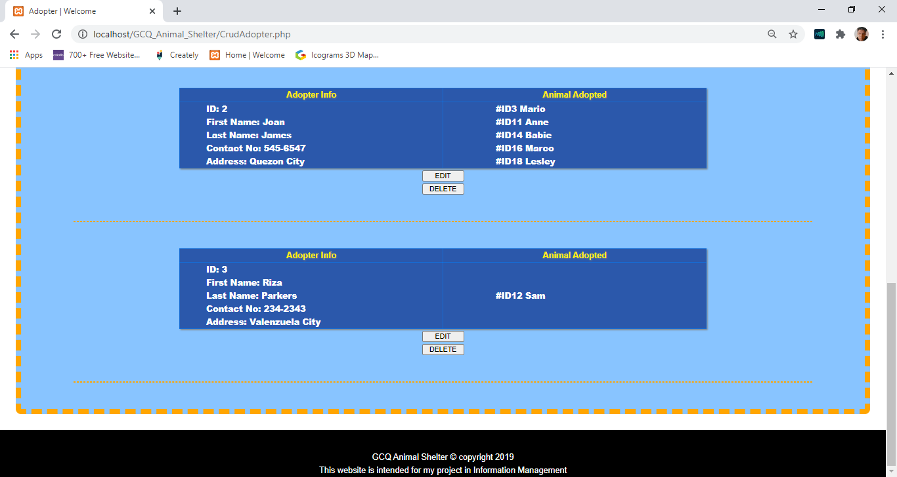

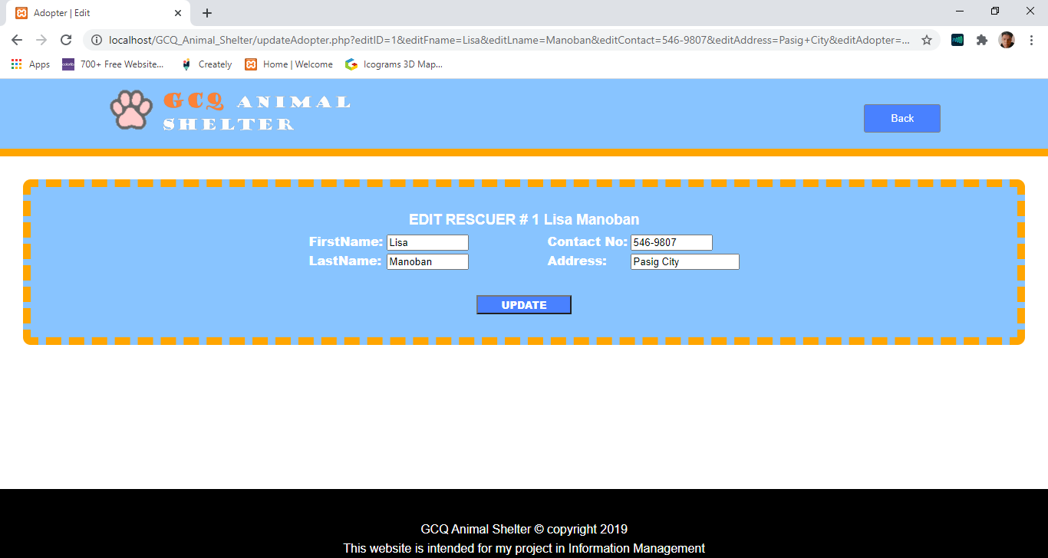

**6.2 Codes For MP 4**

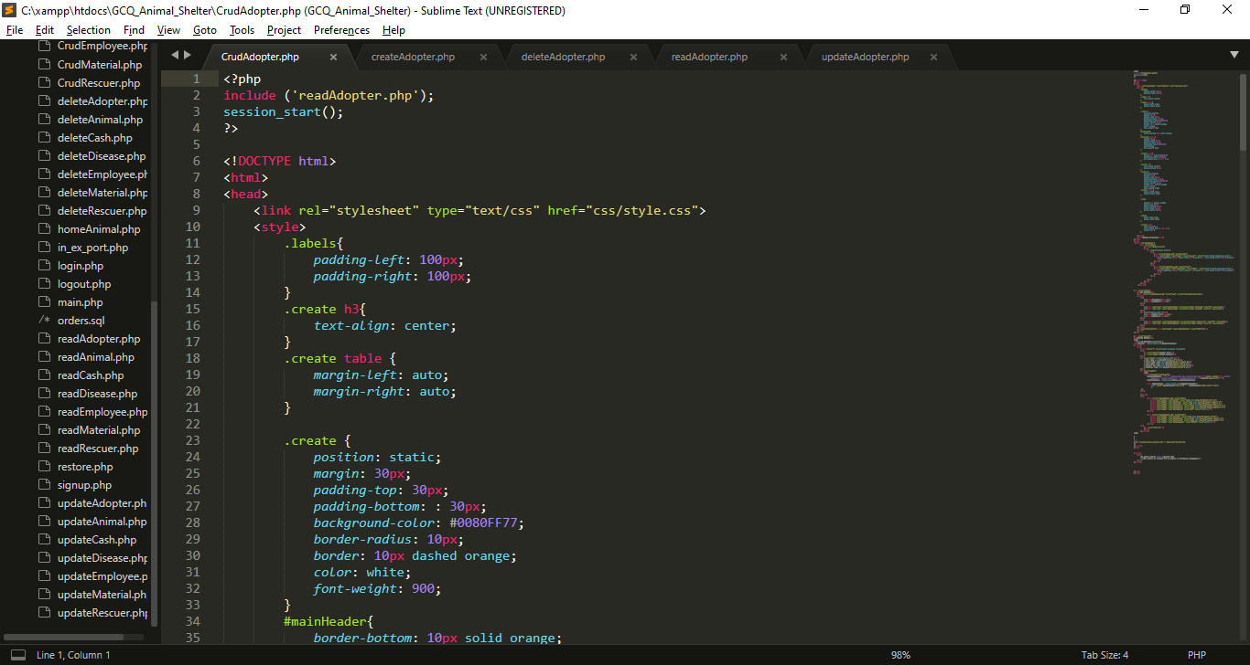

I import/include this reads file for displaying purpose

My External CSS

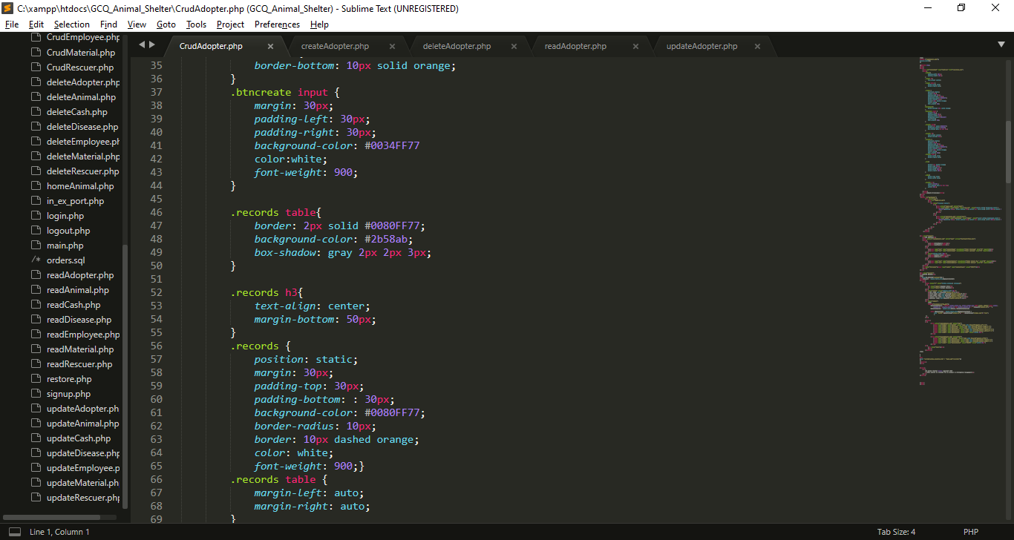

My Internal CSS

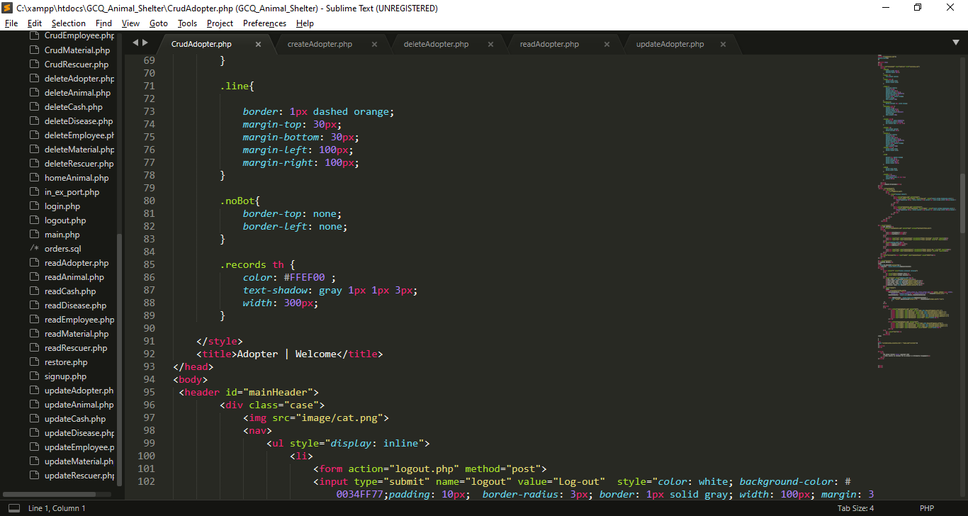

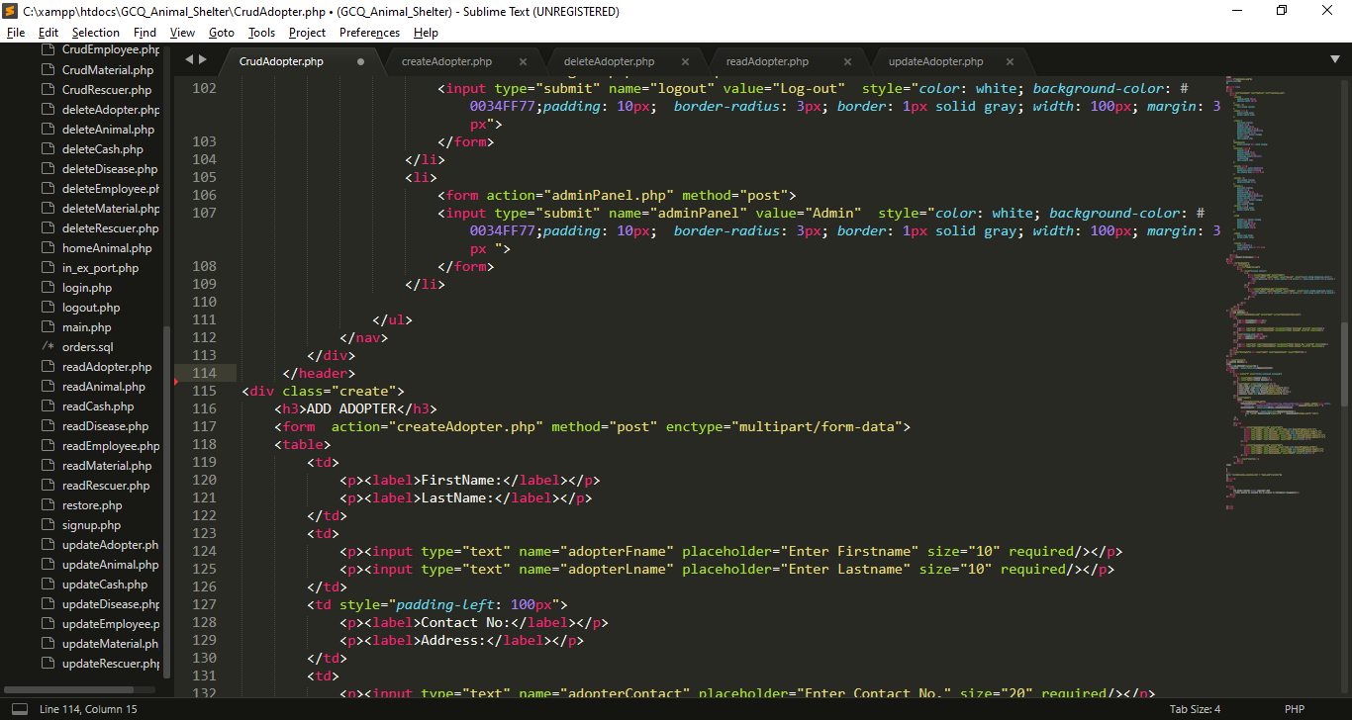

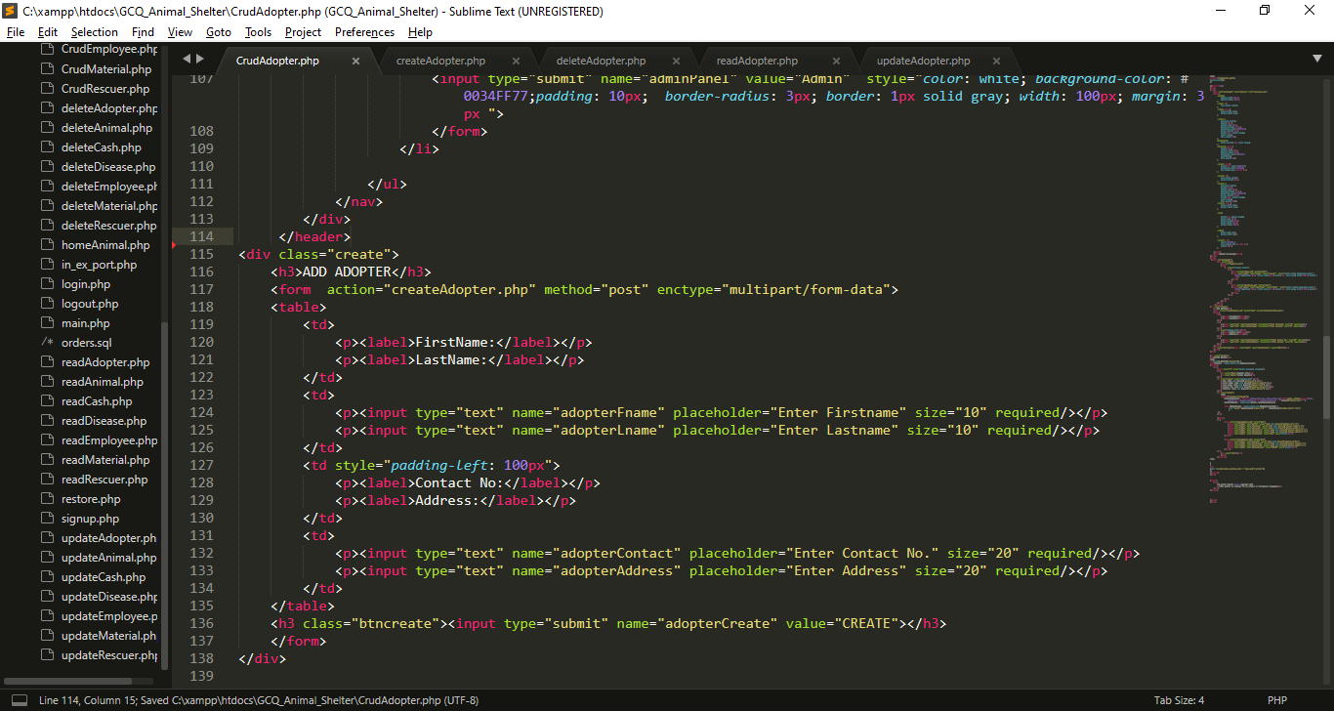

* I created a form inputs for the needed data, each input has name attribute which become a key for each value that users will input that will direct to createAdopter.php and it has a post method.
* At the end of the form I create submit button that has name attribute of adopterCreate.

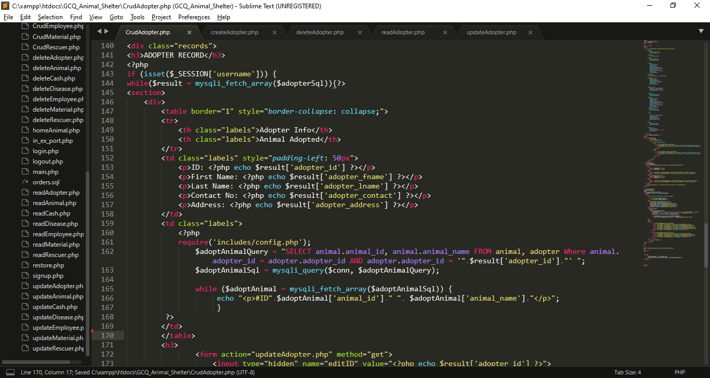

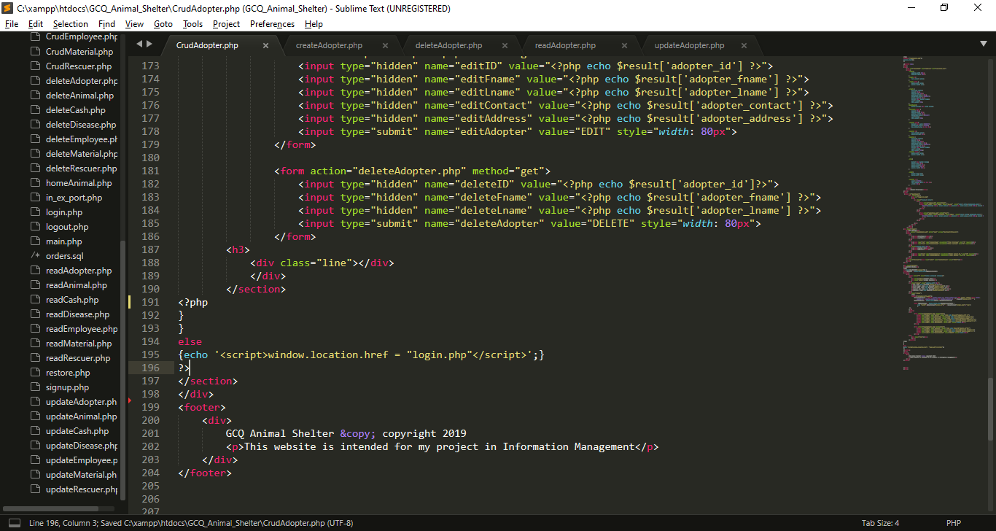

* I use If statement to check is the session username is already set.
* I use while loop to fetch all the data from $adopterSql which imported from readAdopter.php, each row will stored in $result that contains adopter information, (the key is the column name and the value is the data that store in the specific column).
* I use hidden input type which get the result from results, this data will use for update
* I use hidden input type which get the result from results, this data will use for deletion

**I create createAdopter.php for inserting data in database**

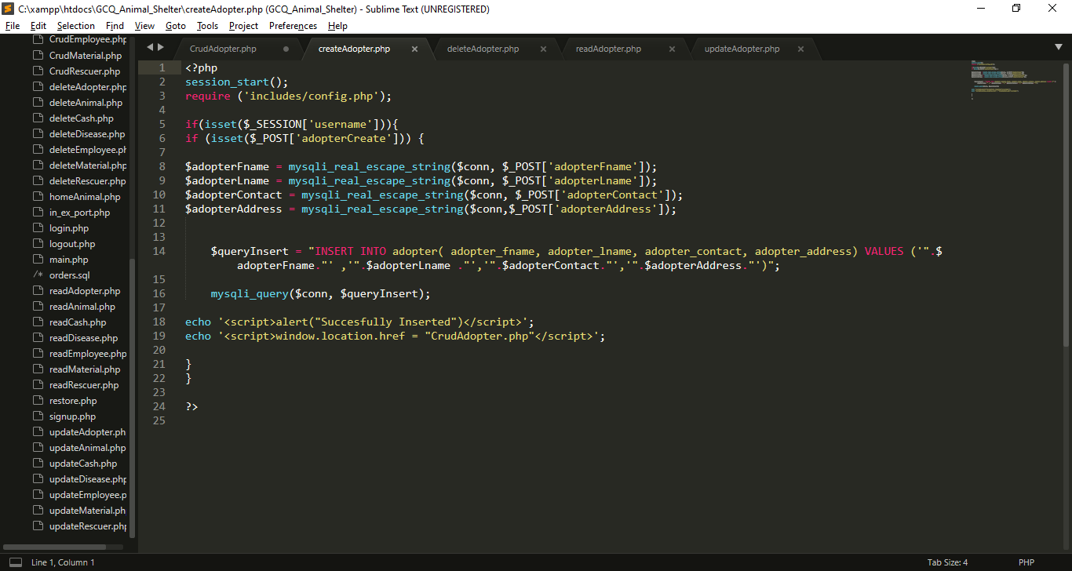

* I import includes/config.php for database connection.
* I use If statement to check is the session username is already set.
* If adopterCreate is set or click the insert process will begin
* I get all the data from post which set in previous page (CrudAdopter.php). And put it into variables, so that I can use for insertion query
* $queryCreate variable contain string or query for insertion of values in adopter table
* Using java script Success message will pop-up after the insertion, then it will back to CrudAdopter.php
* If the session username is not set insertion will not proceed.

**I create deleteAdopter.php for deleting data in database**

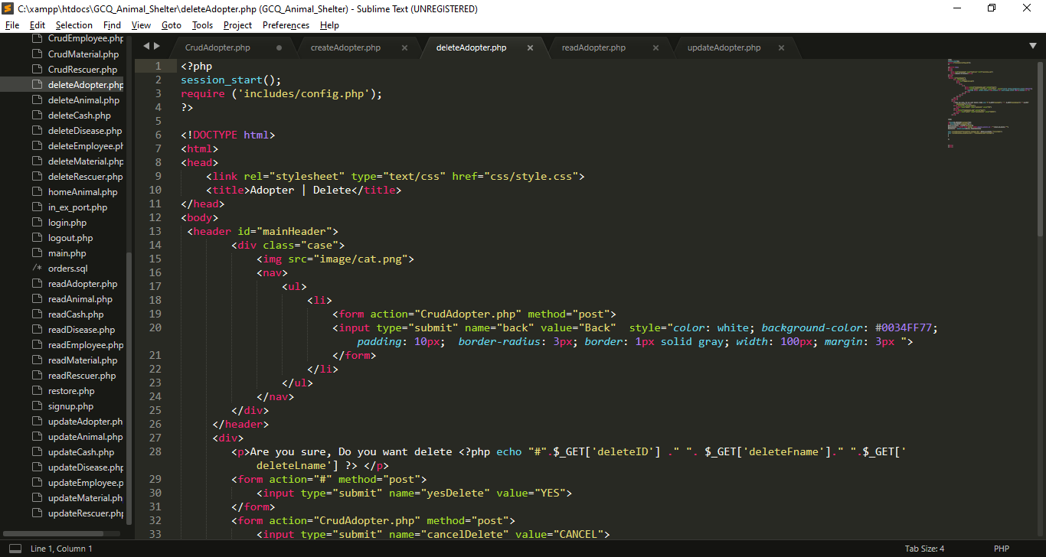

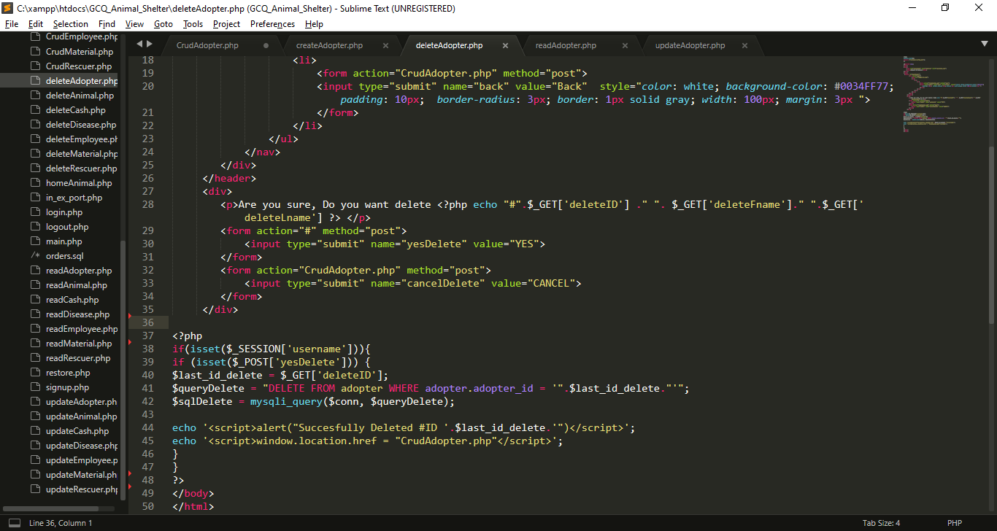

* I Include config.php for database connection
* If input submit named yesDelete is click the name yesDelete will set in $_POST, If this submit input named cancelDelete is click it will back in CrudAdopter.php
* If yesDelete is set query will execute for deletion

**I create readAdopter.php for reading data in database**

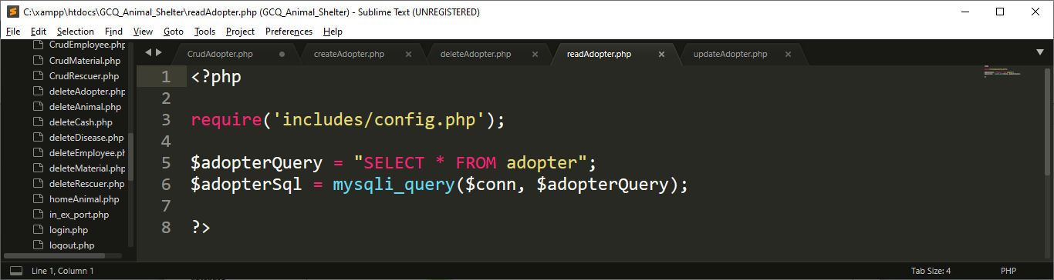

* Include config.php for database connection
* I create query called $adopterQuery for selecting all the data from adopter , after that, I execute that query using mysqli_query() function, that has 2 parameter which is the connection and the query

**I create updateMaterial.php for update data in database**

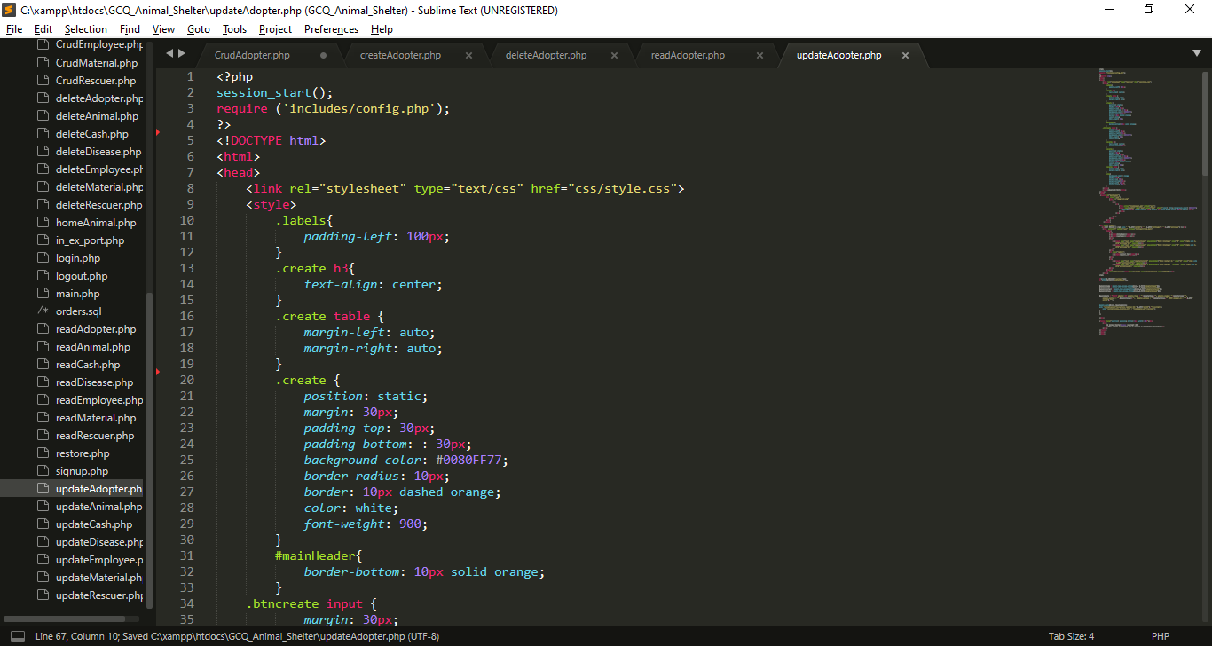

My External CSS

My Internal CSS

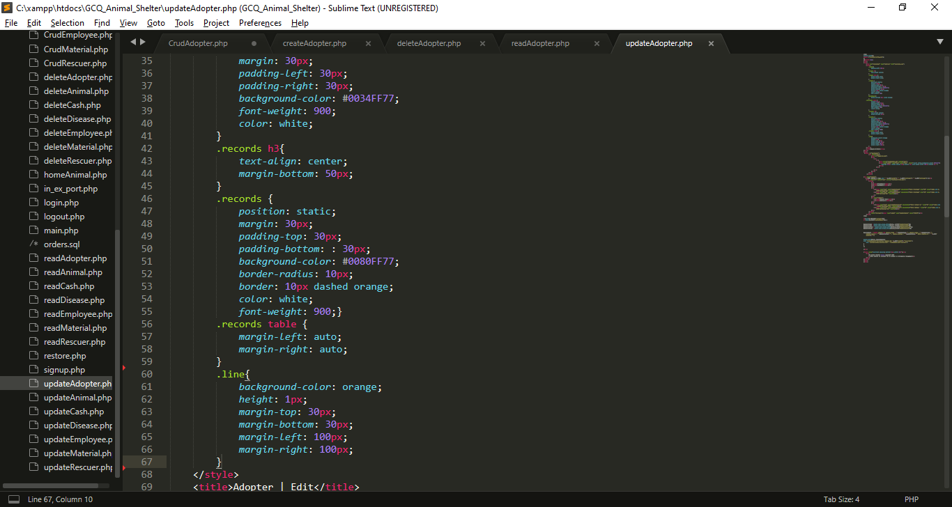

My Internal CSS

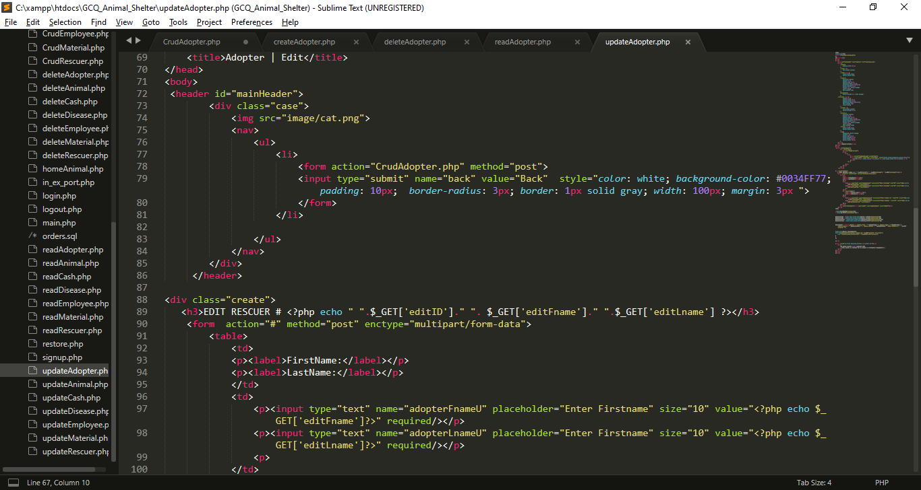

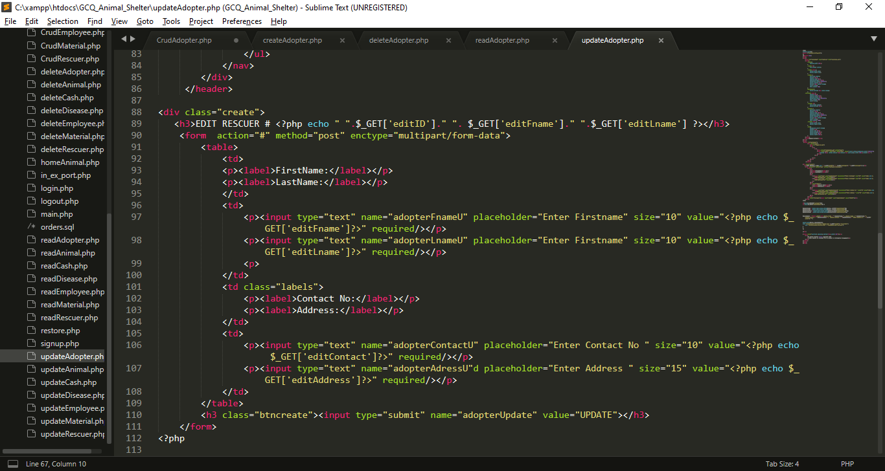

* I created inputs for the needed data, each input has name attribute which become a key for each value that users will input for update, I also get all the data from get method from CrudAdopter.php to show the current value while editing.

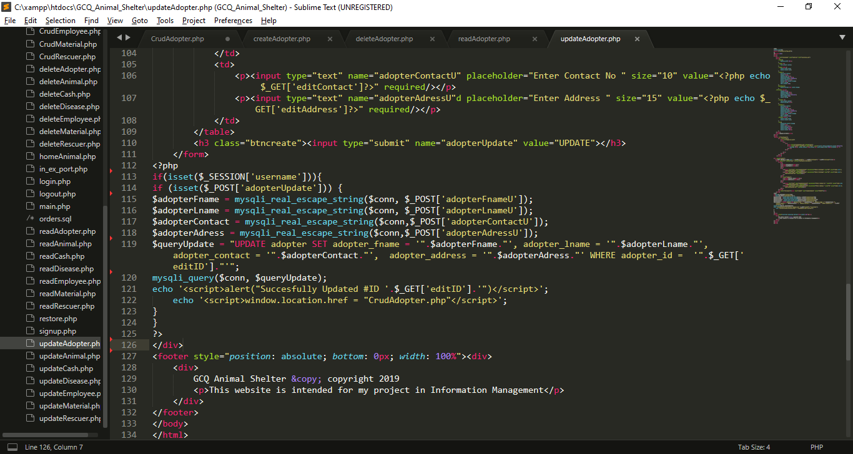

* I get all the data from post which set in from the top of this file, I put it into variables, so that I can use for updating query.
* After that , all query will be executed, if the updating is success alert will pop-up

**7. MP5 CRUD Script For The Common Animal Diseases/Injuries.**

**7.1 GUI For MP5**

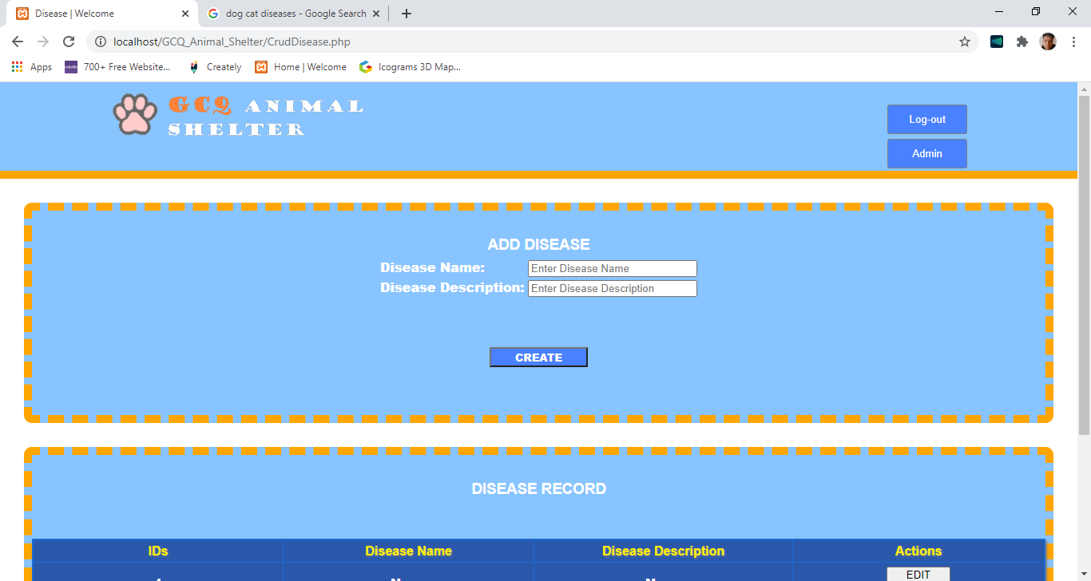

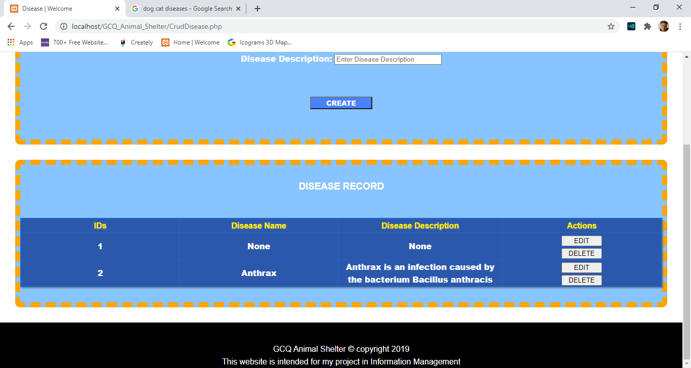

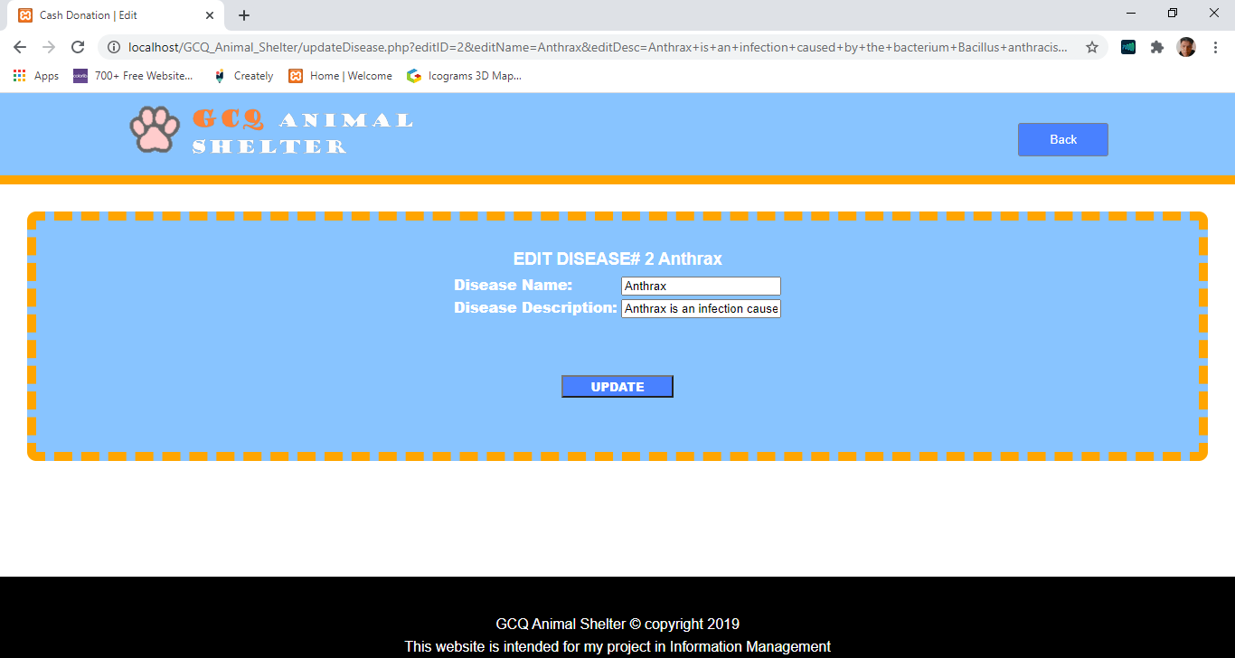

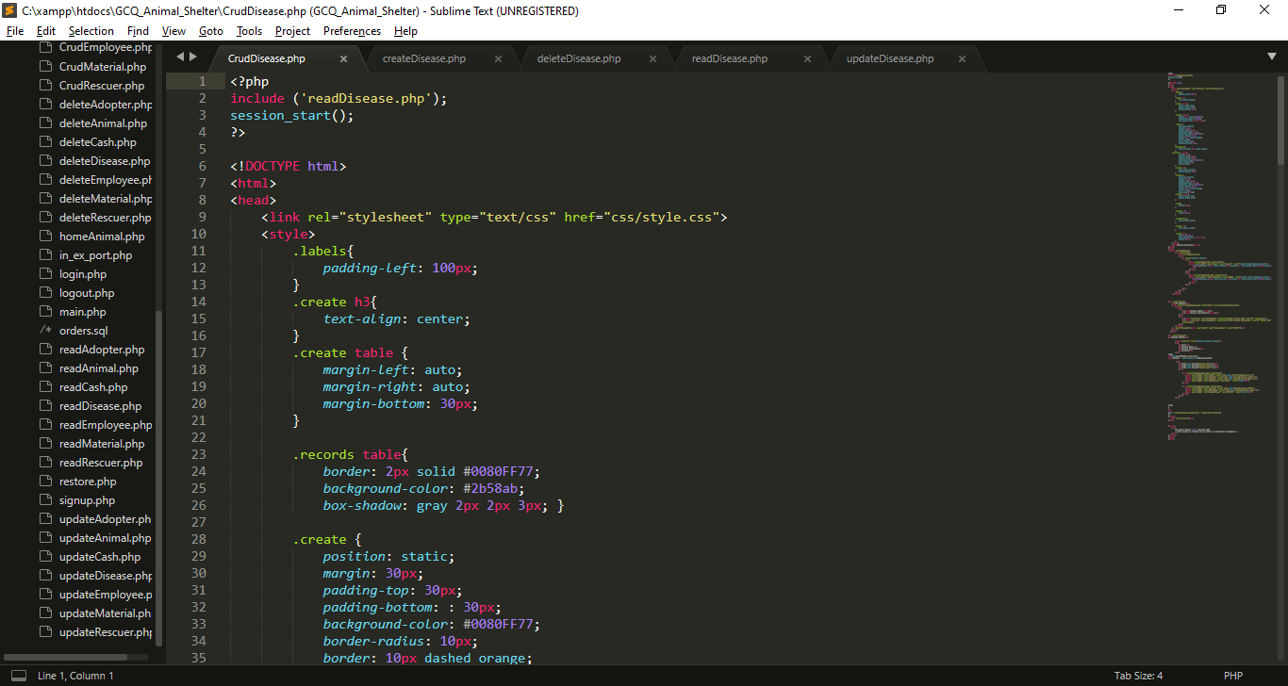 **7.2 Codes For MP5**

I import/include this reads file for displaying purpose

My External CSS

My Internal CSS

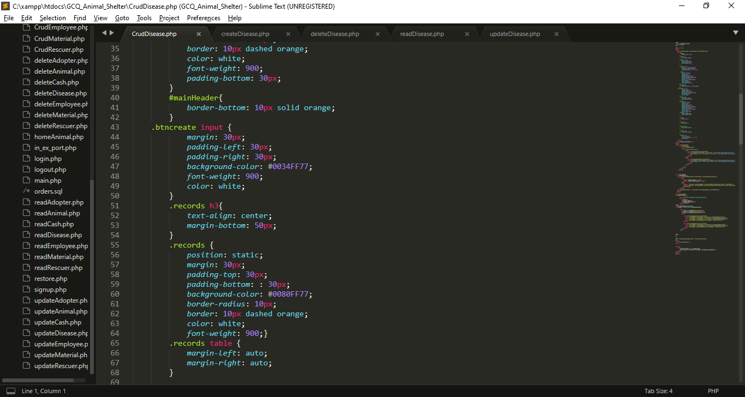

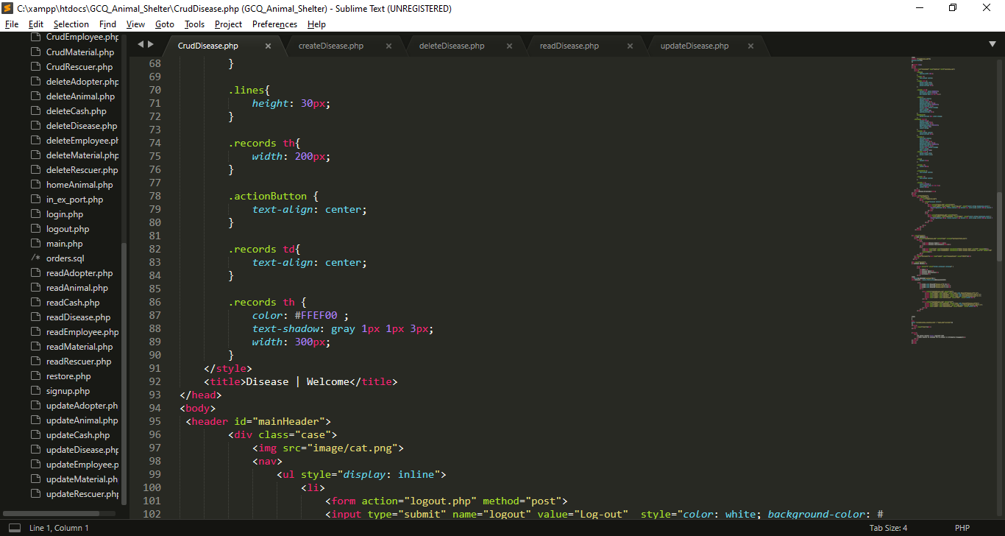

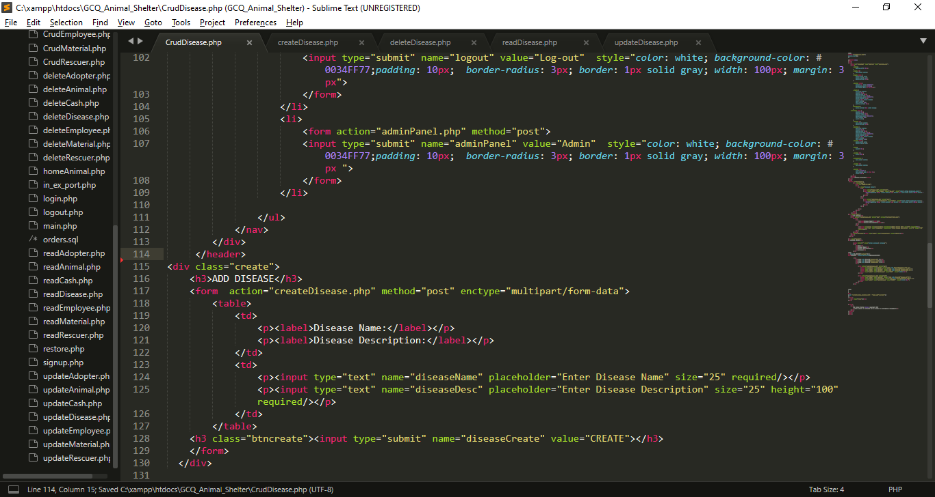

* I created a form inputs for the needed data, each input has name attribute which become a key for each value that users will input that will direct to createDisease.php and it has a post method.
* At the end of the form I create submit button that has name attribute of diseaseCreate.

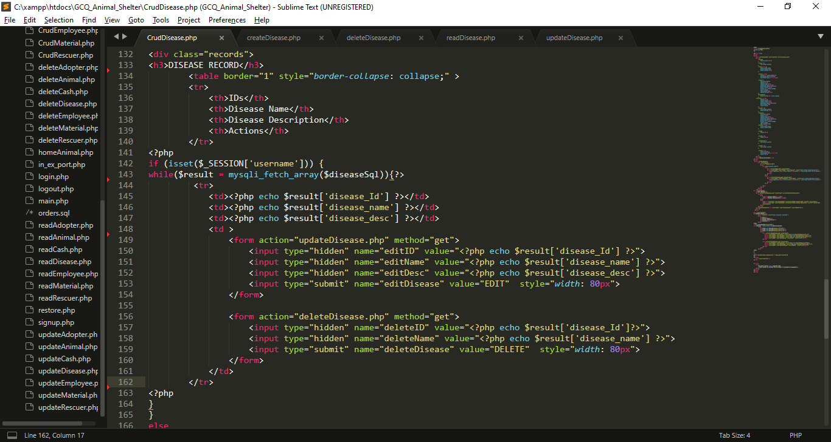

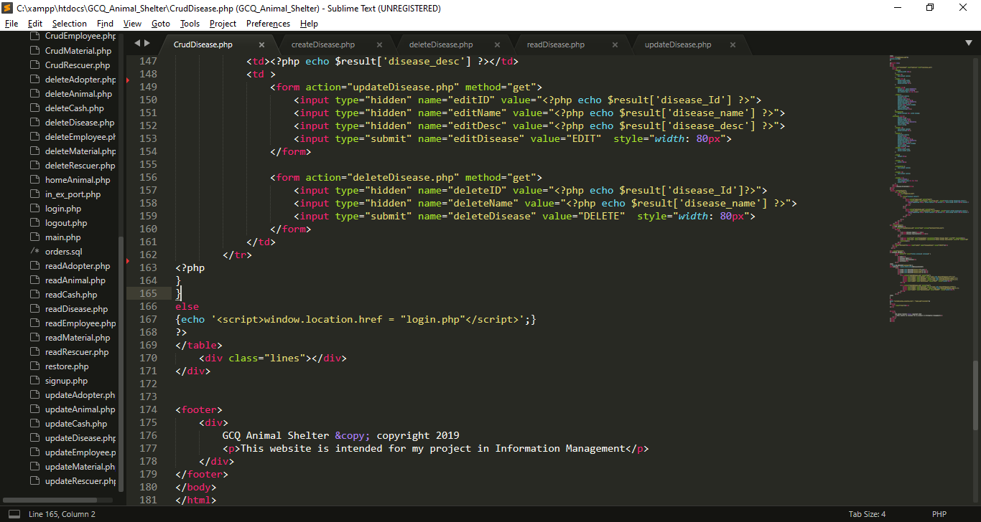

* I use If statement to check is the session username is already set.
* I use while loop to fetch all the data from $diseaseSql which imported from reaDisease.php, each row will stored in $result that contains disease information, (the key is the column name and the value is the data that store in the specific column).
* I use hidden input type which get the result from results, this data will use for update
* I use hidden input type which get the result from results, this data will use for deletion

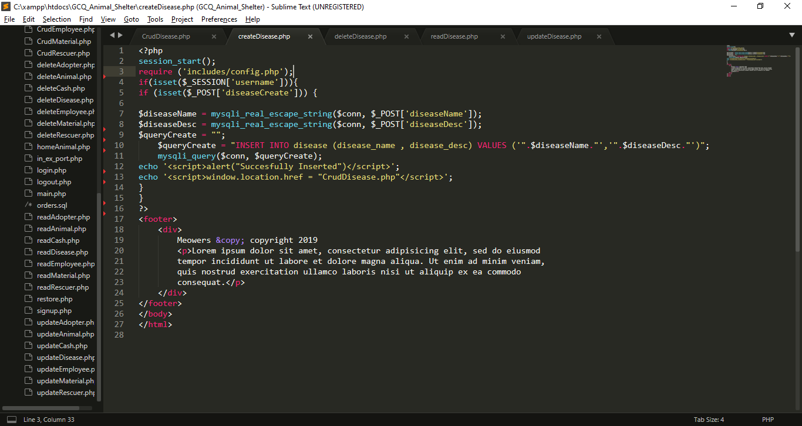

**I create createDiseases.php for inserting data in database**

* I import includes/config.php for database connection.
* I use If statement to check is the session username is already set.
* If diseaseCreate is set or click the insert process will begin
* I get all the data from post which set in previous page (CrudDisease.php). And put it into variables, so that I can use for insertion query
* $queryCreate variable contain string or query for insertion of values in disease table
* Using java script Success message will pop-up after the insertion, then it will back to CrudDisease.php
* If the session username is not set insertion will not proceed.

**I create deleteDisease.php for deleting data in database**

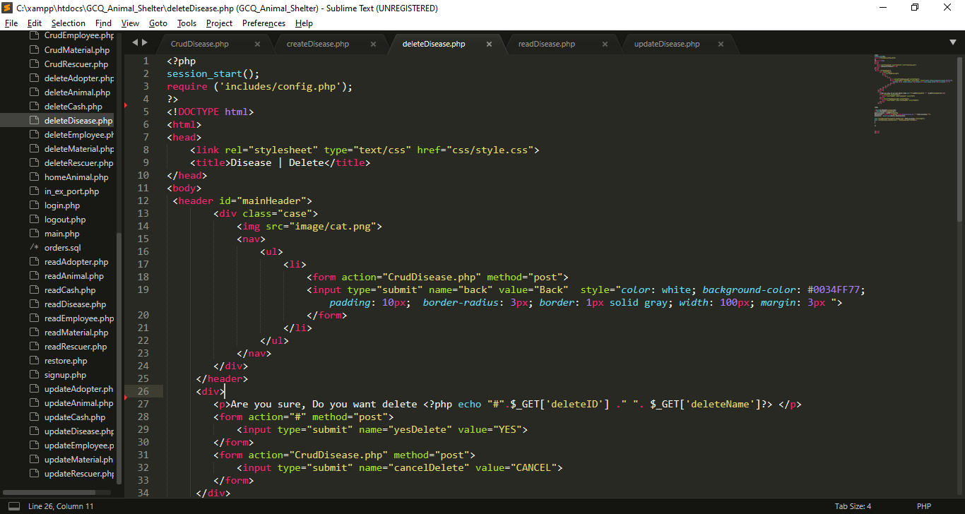

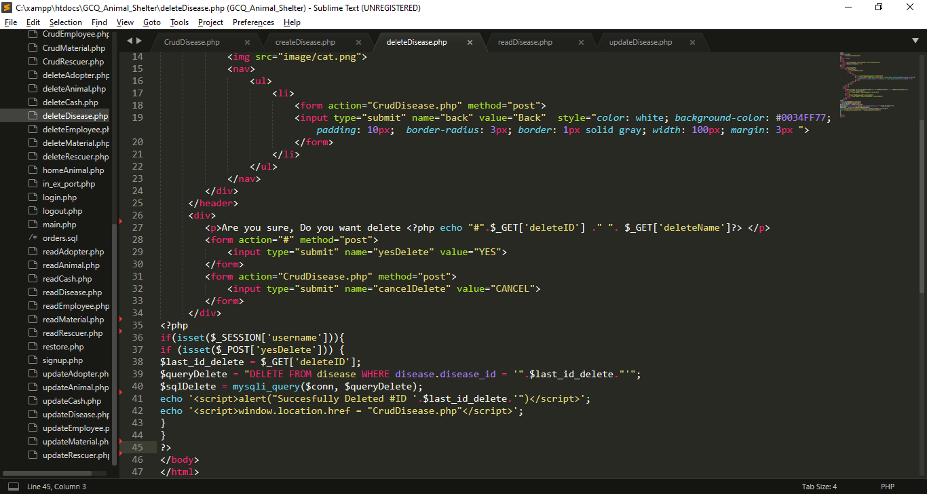

* I Include config.php for database connection
* If input submit named yesDelete is click the name yesDelete will set in $_POST, If this submit input named cancelDelete is click it will back in CrudDisease.php
* If yesDelete is set query will execute for deletion

**I create readDisease.php for reading data in database**

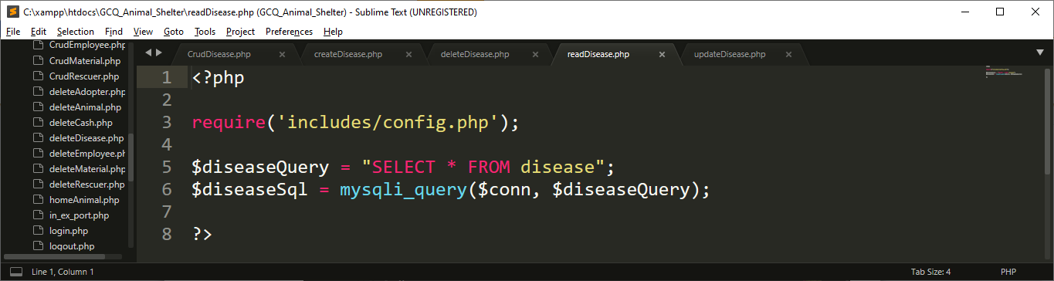

* Include config.php for database connection
* I create query called $diseaseQuery for selecting all the data from disease , after that, I execute that query using mysqli_query() function, that has 2 parameter which is the connection and the query

**I create updateDisease.php for update data in database**

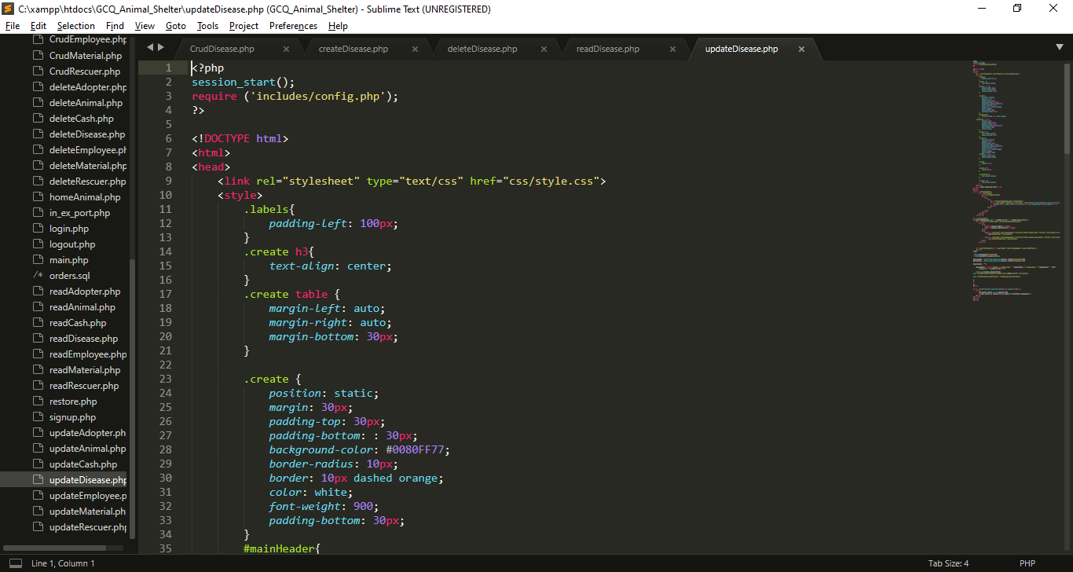

My External CSS

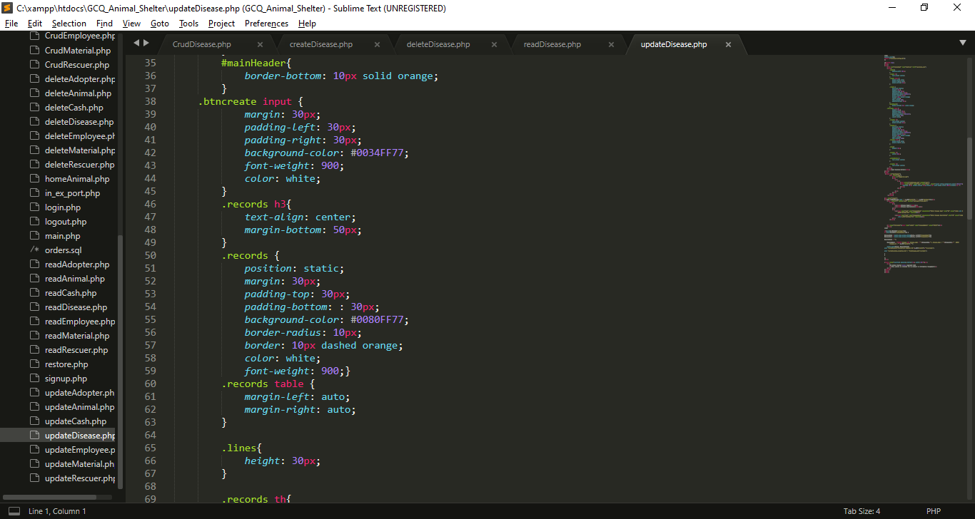

My Internal CSS

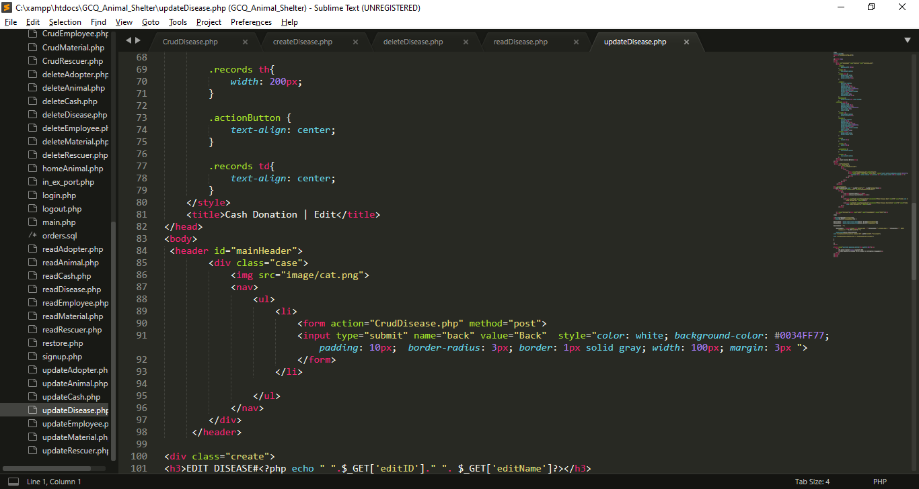

My Internal CSS

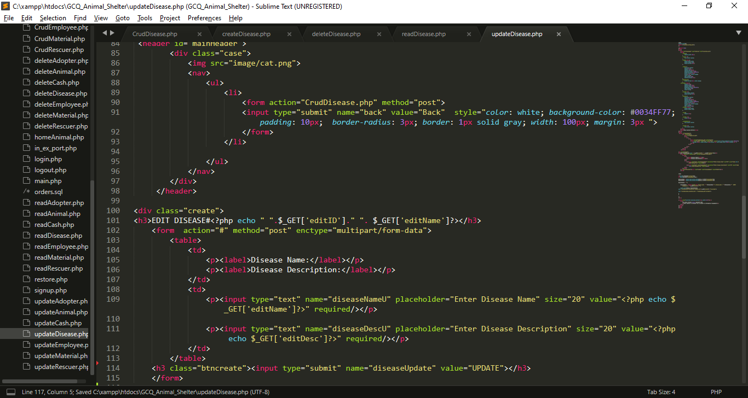

* I created inputs for the needed data, each input has name attribute which become a key for each value that users will input for update, I also get all the data from get method from CrudDisease.php to show the current value while editing.

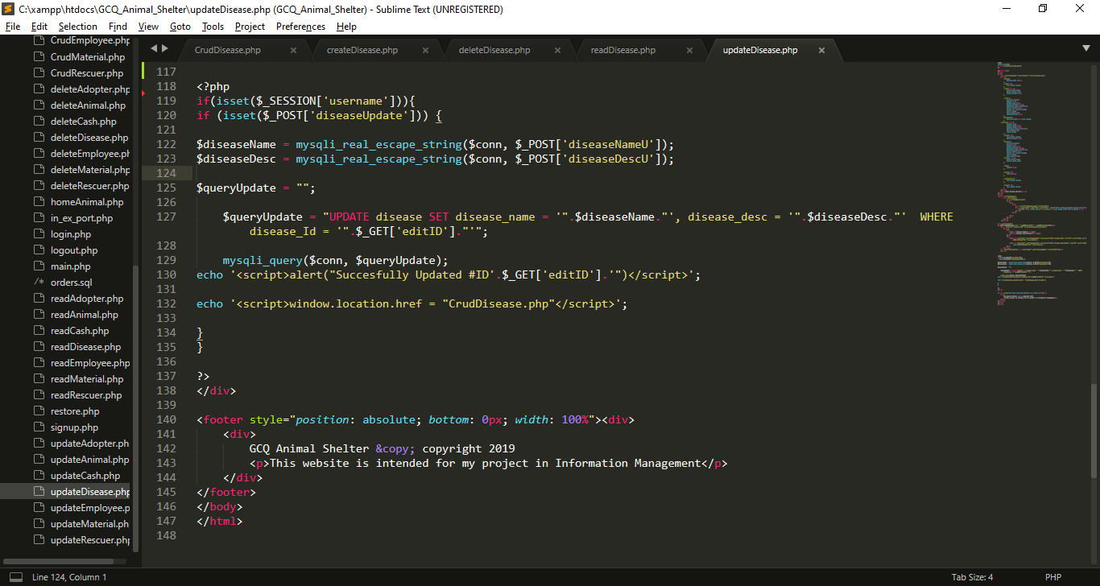

* I get all the data from post which set in from the top of this file, I put it into variables, so that I can use for updating query.
* After that , all query will be executed, if the updating is success alert will pop-up

**UNIT 2**

**8. The System Can Display The Information And Health Status Of Each Dog or Cat (With Photos)**

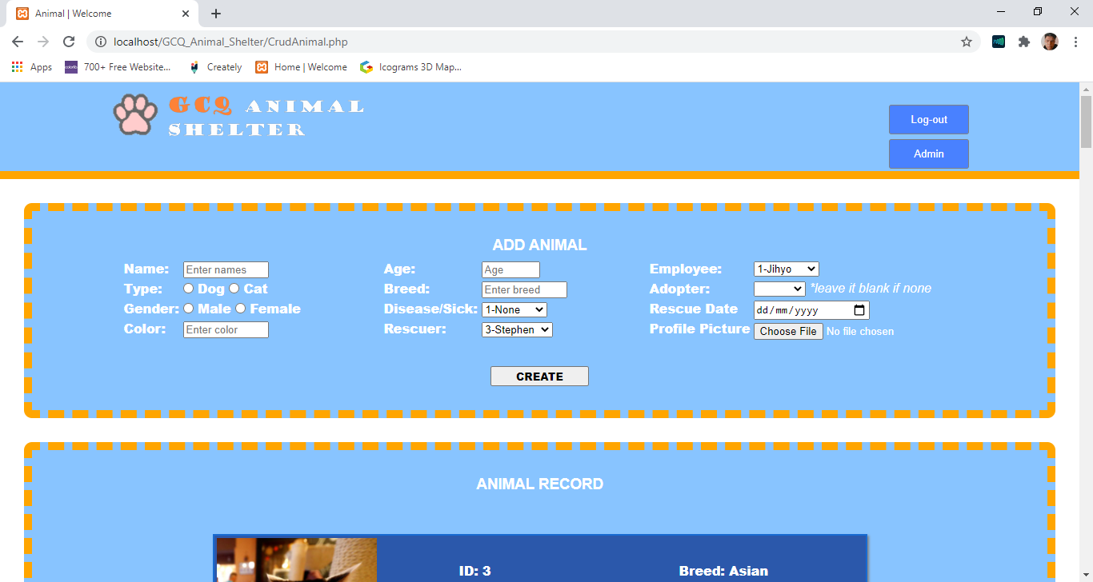

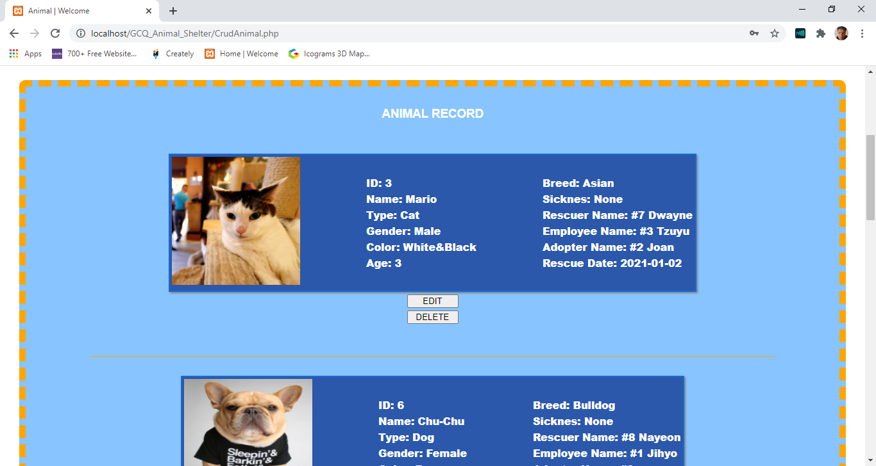

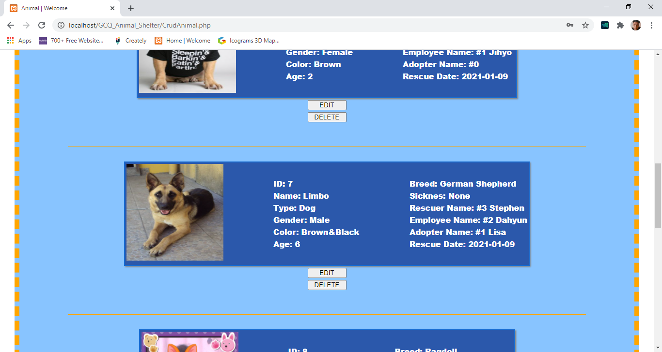

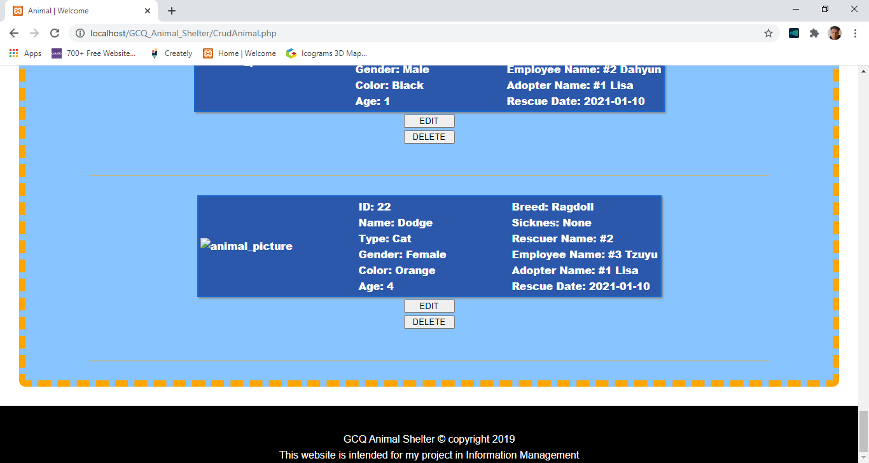

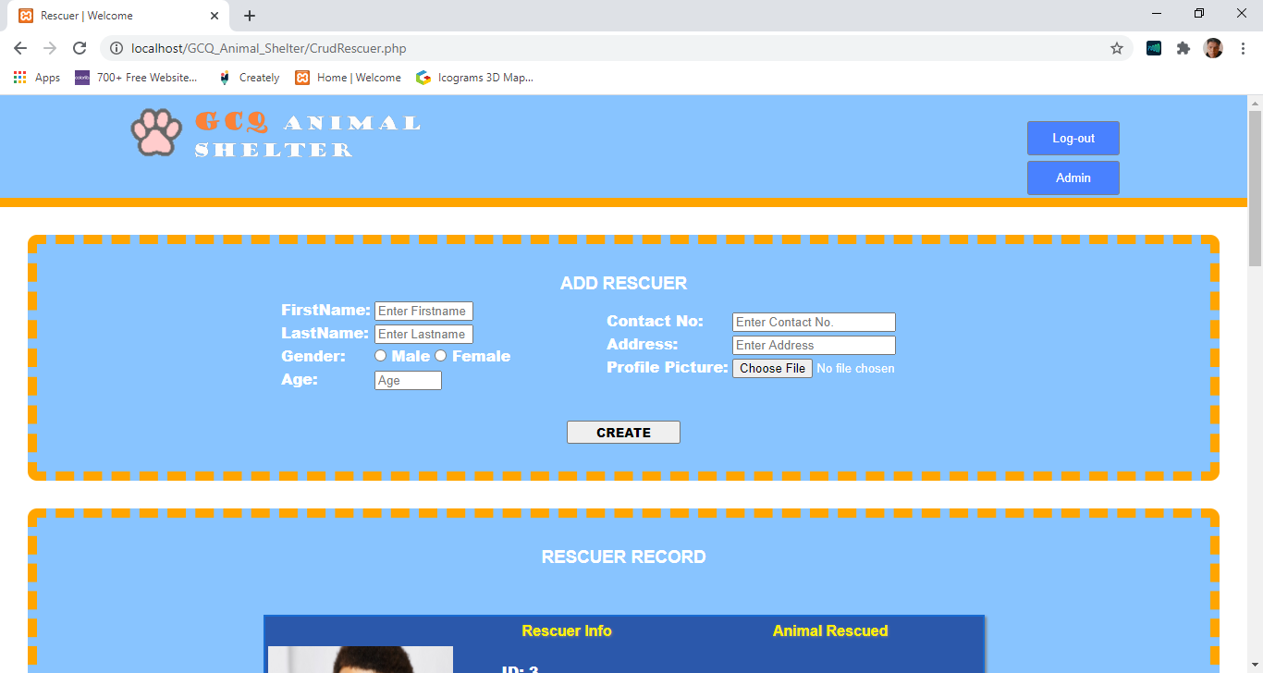**9. The System Can Display The Rescuer's Information Together With The Animal He/She Rescued.**

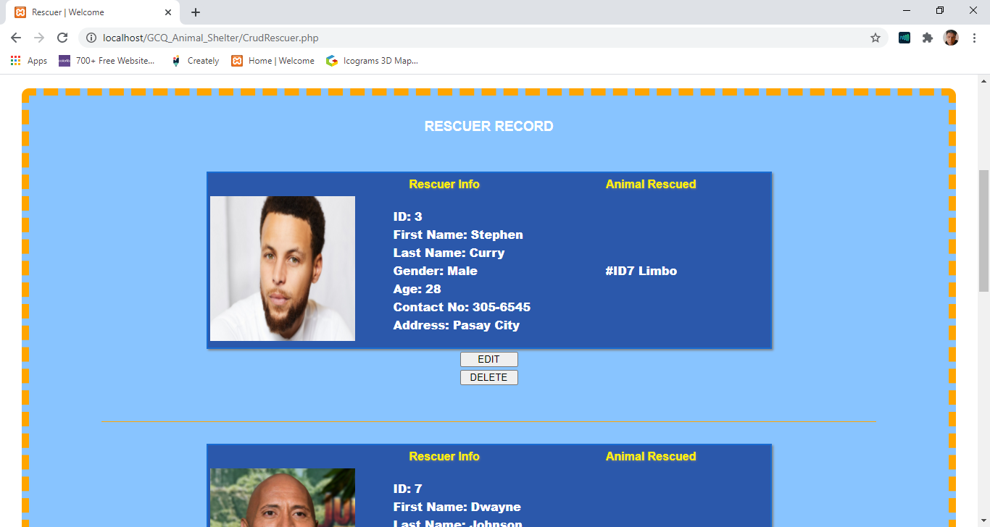

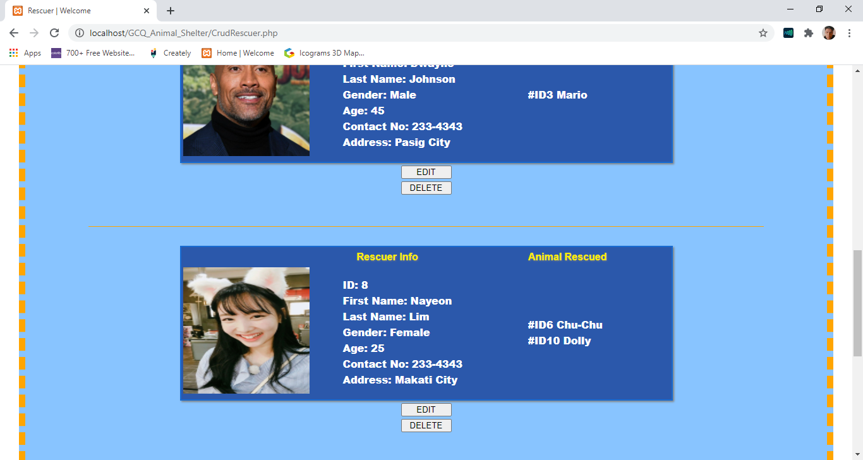

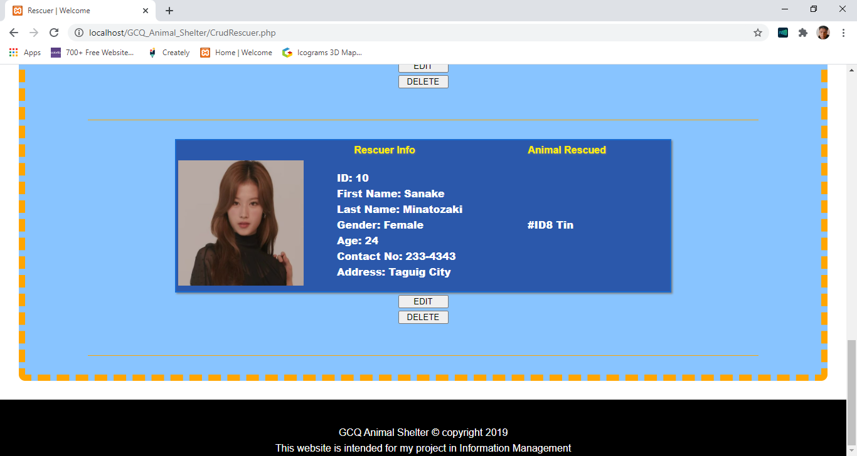

**10. The System Can Display The Adopters And The Animals They Adopted.**

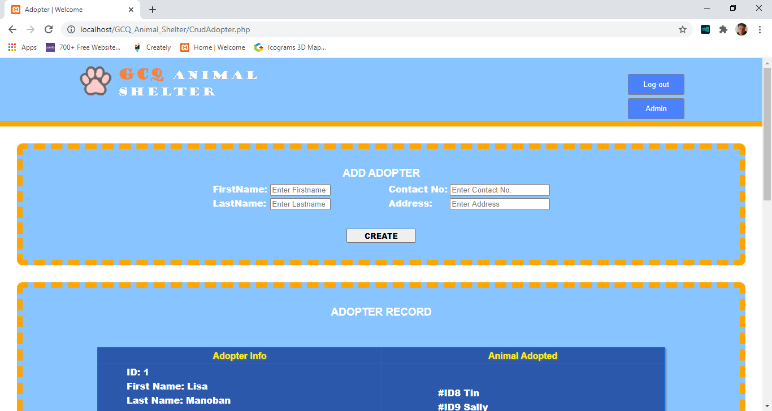

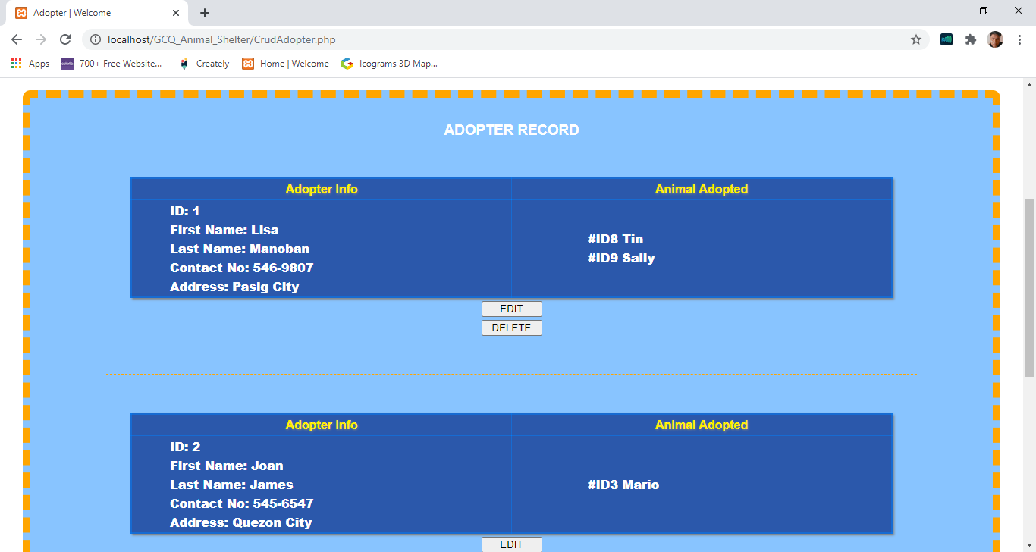

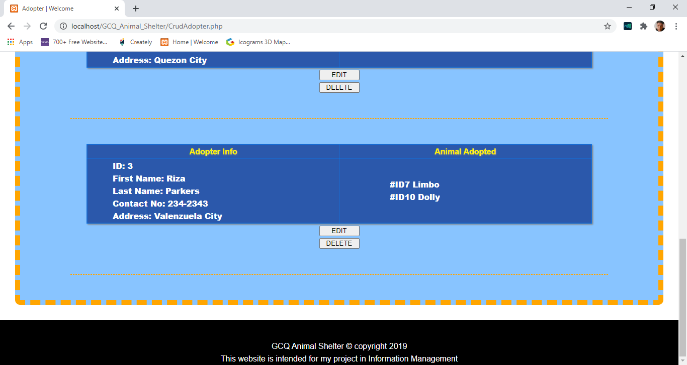

**11. Quiz 3 Create A Login Function Or The Employees. Only Authorized Employees Are Allowed To Enter Data.**

**11.1 GUI For Quiz 3**

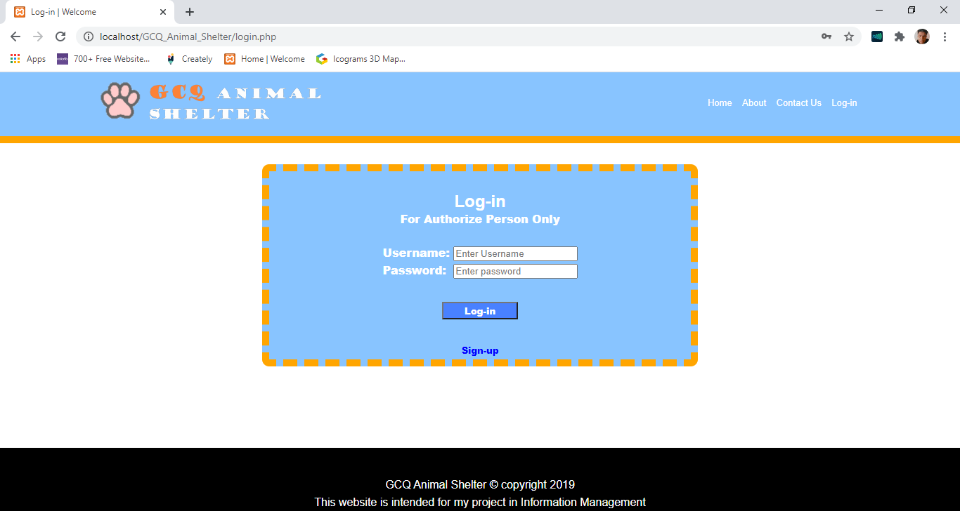

**11.2 Codes For Quiz 3**

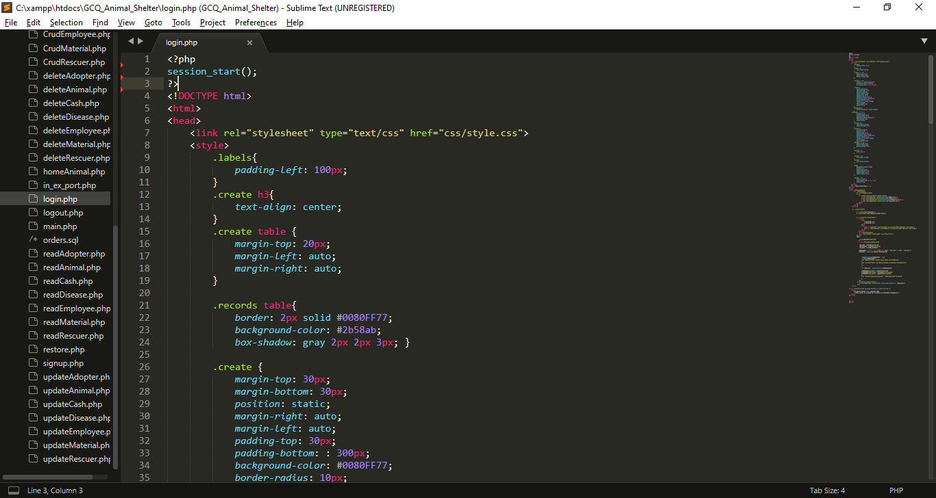

I start session

My external CSS

My Internal CSS

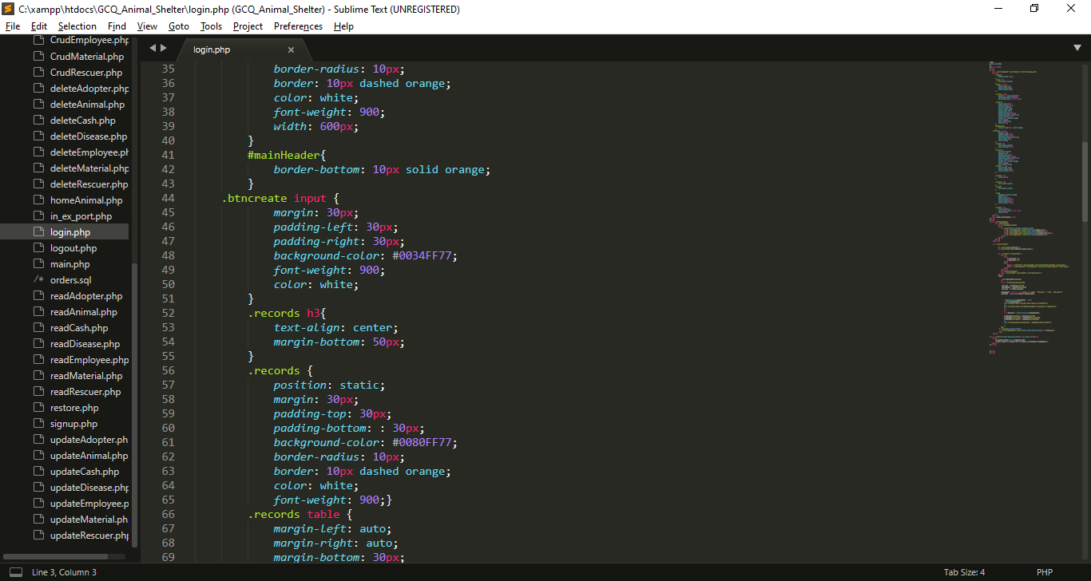

My Internal CSS

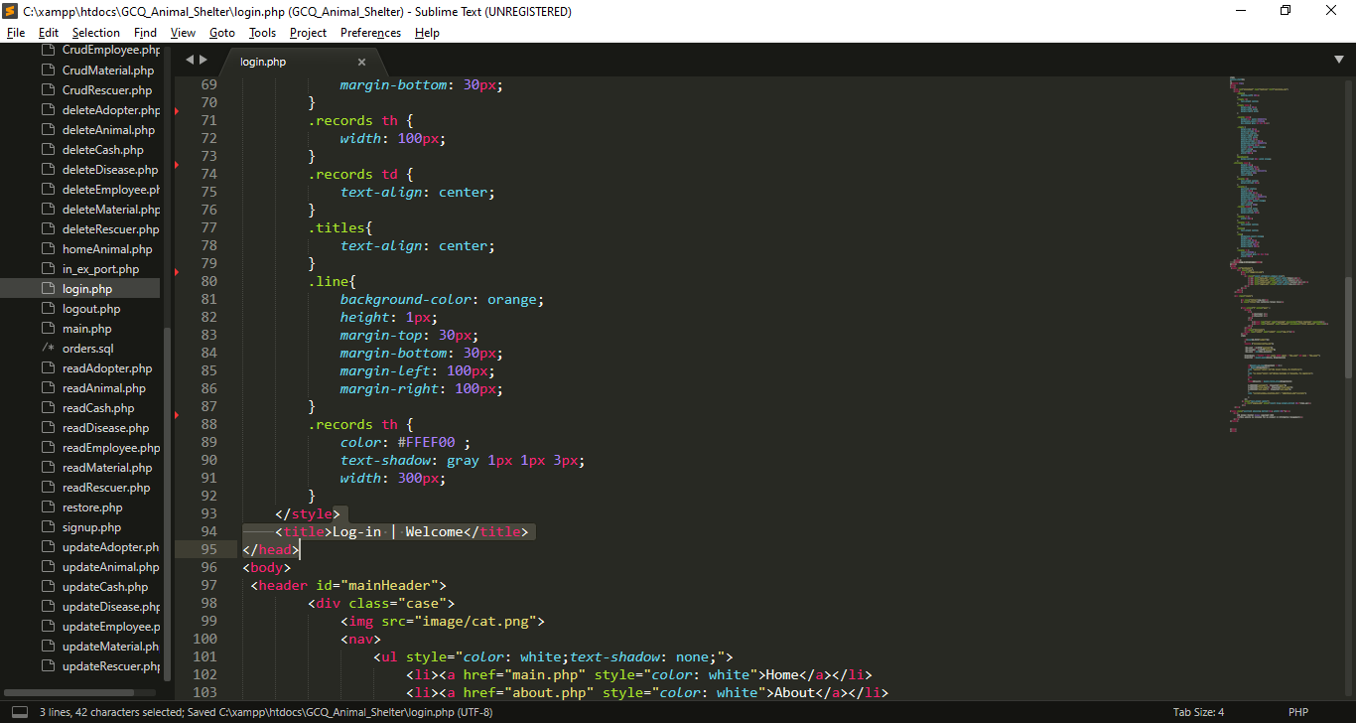

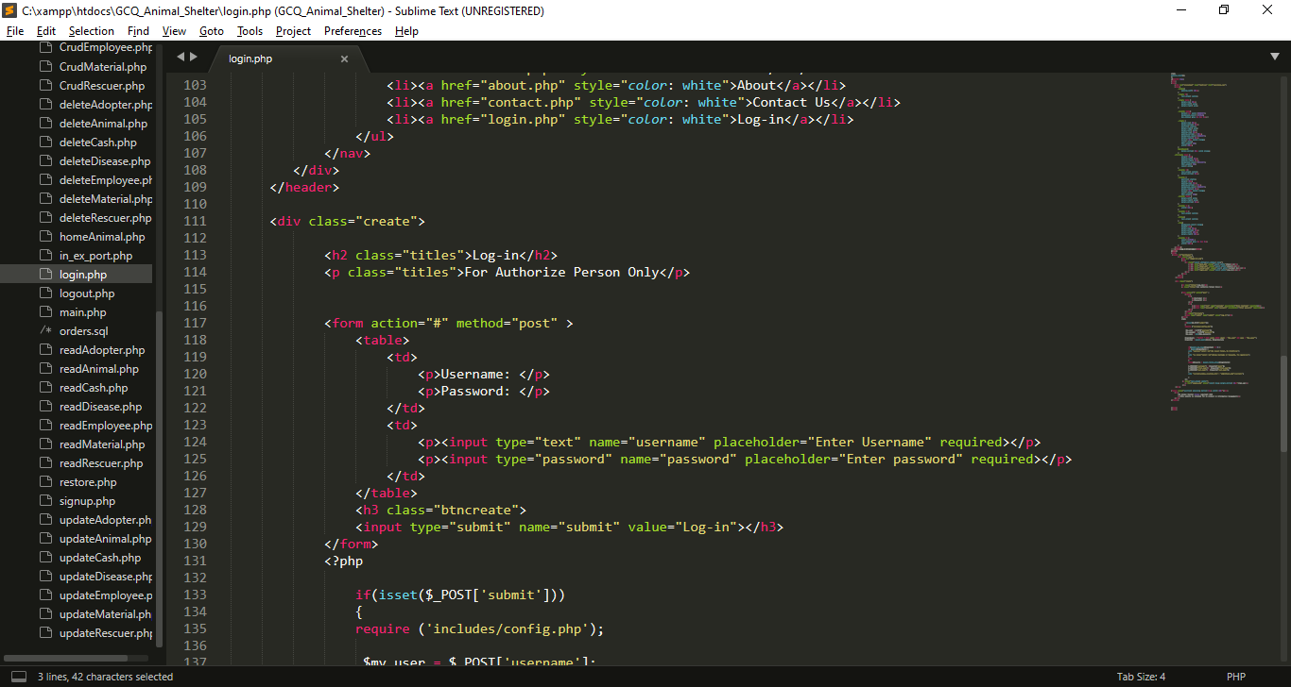

My Navigation Button

* I created a form that has a post method, which mean all the input of this form will be store in global variable $_POST.
* Inside of this for I created 2 inputs first in input that has a type of text and it has a name attribute called “username”. The second input has a type of password and it has name called “password”.
* At the end of this form I created a submit button that has a name of “submit”.

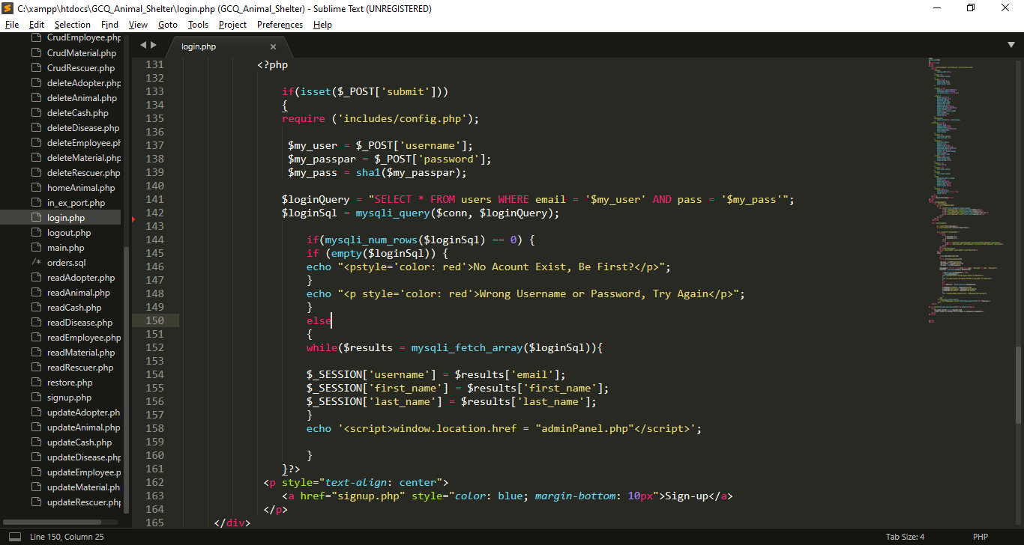

* If the “submit” input from the top is set process will proceed.
* First is, I create variable $loginQuery, for string query.
* Second is, I create $loginSql this variable execute the query above, this variable return all the date from users table in my database (is use mysqli_query() which has 2 parameters the connection to database and the query).
* I use mysqli_num_rows to get the number of rows from the result, if any.
* If the there is no result message will say “No Account Exist, Be First?” or “Wrong Username or Password, Try Again”.
* But if account is exist session will set and it will direct to admin panel page.

**12. MP6 The Front Page Of The Web App Should Display All Adoptable Animals.**

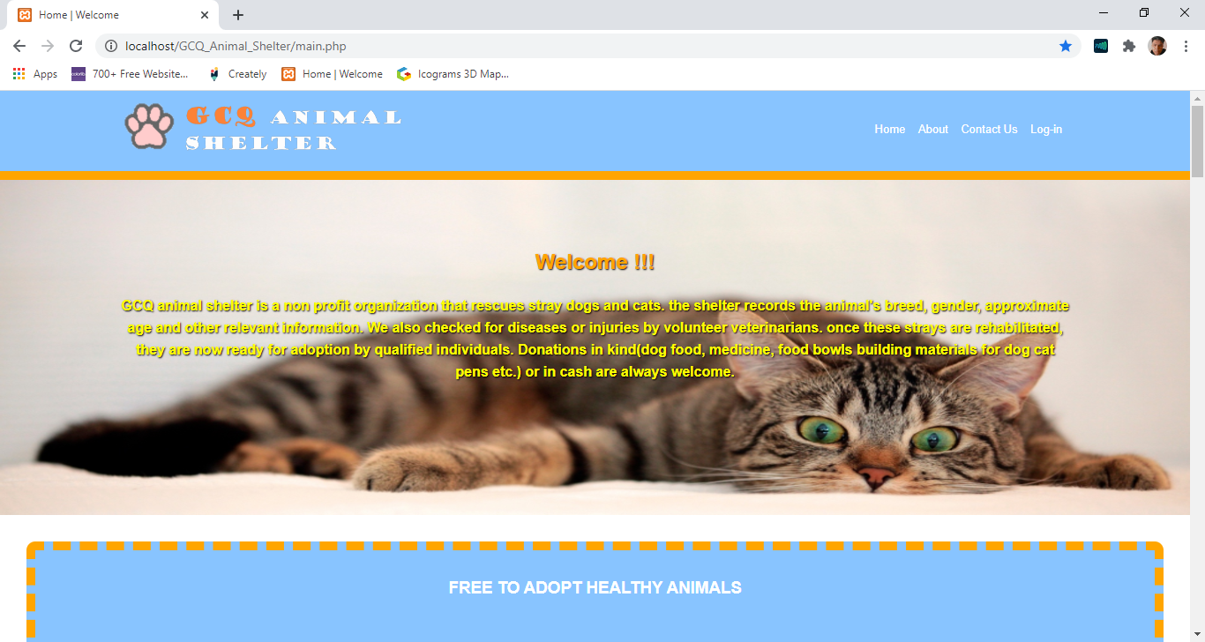**12.1 MP6 GUI For MP6**

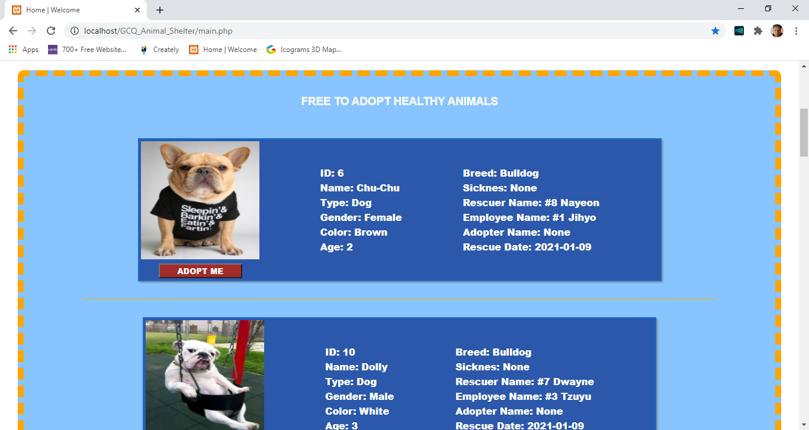

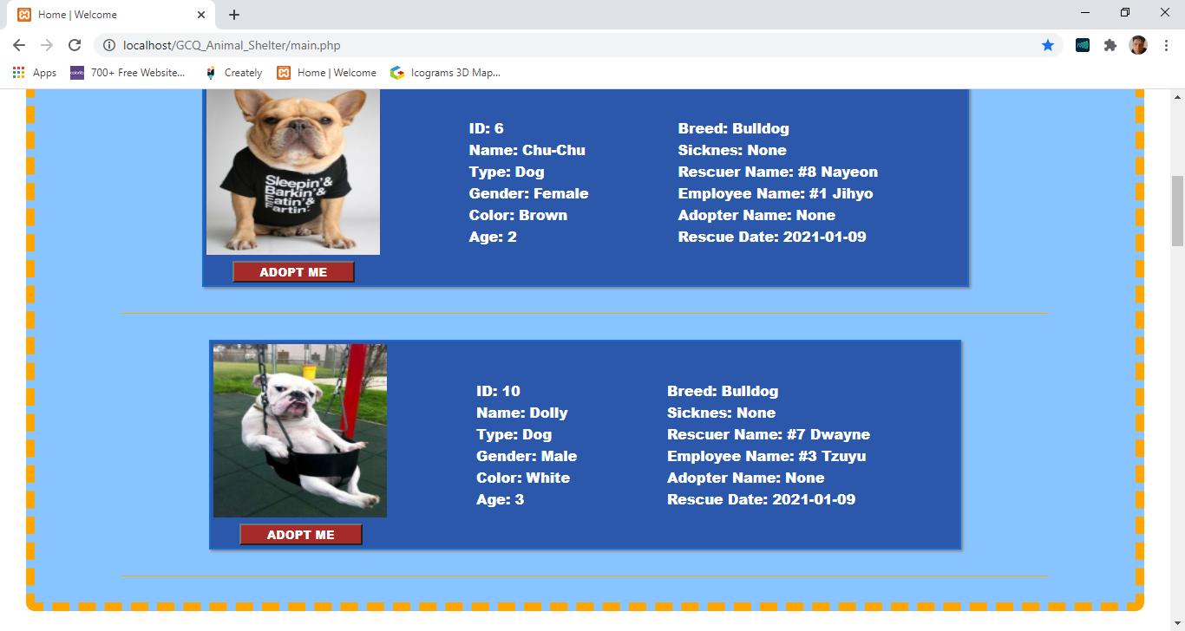

**12.2 Codes For MP6**

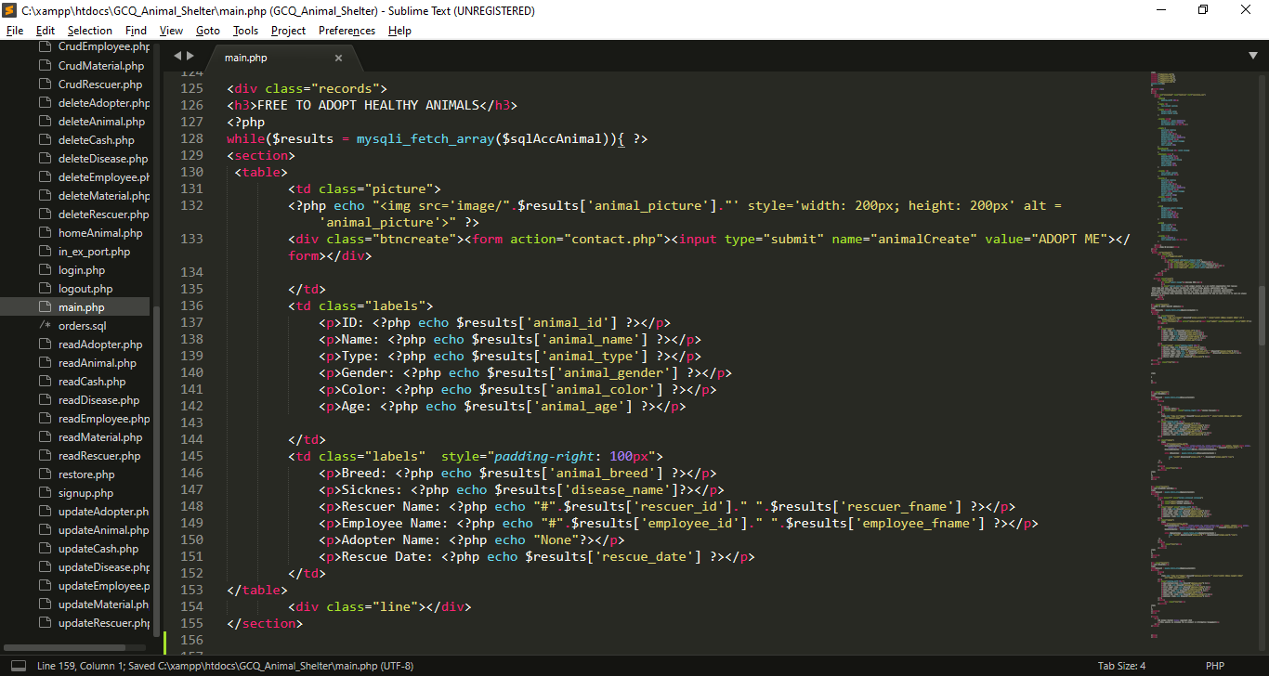

* I fetch all the result from $sqlAccAnimal using while loop, which imported from homeAnimal.php
* I use $results to store row for every loop, table column name serve as a key for every value.

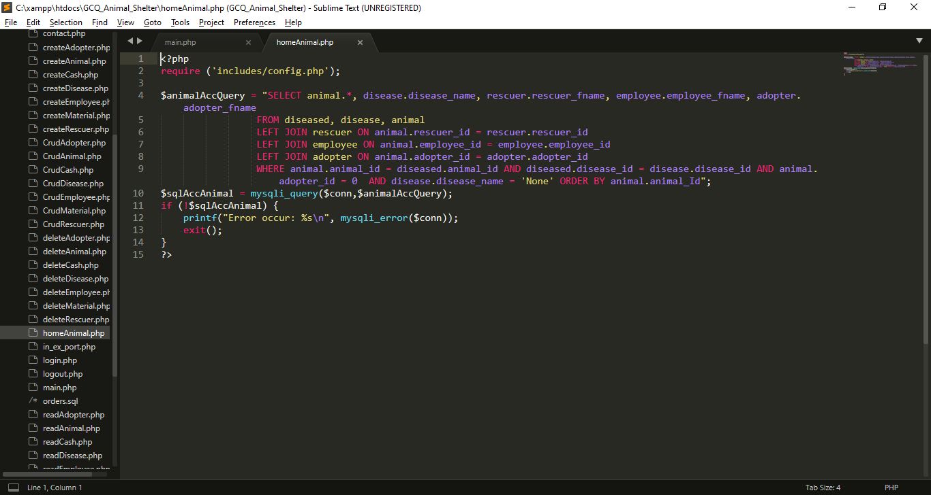

* I created homeAnimal.php, then I import config.php for database connection.
* I created query which returns all healthy and not adopted animals and also its other information.
* I executed the query using mysqli_query and the it will stored to $sqlAccAnimal which I used in main.php
* I use mysql_error function to show errors if occurs in connection.

**13. MP6 Create A Backup Restore Function**

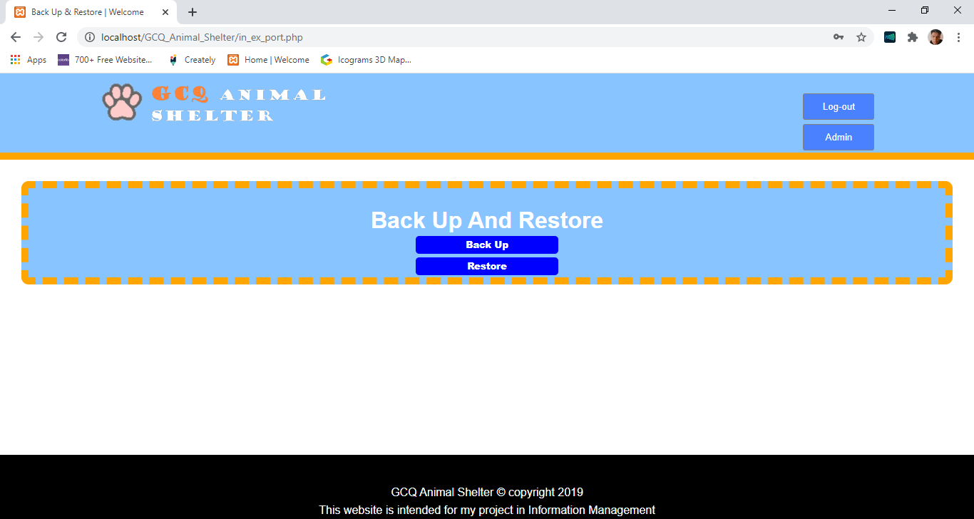 **13.1 GUI For MP6**

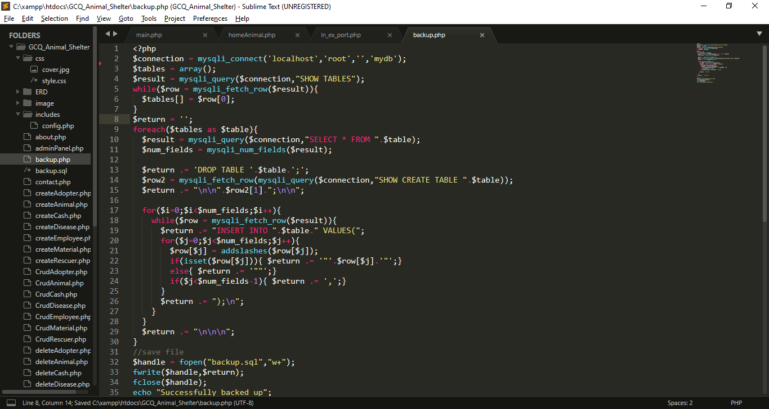 **13.2 Codes For MP6**

* I create backup.php for backuping my database
* First I create connection to database using mysqli_connect()function
* I use query to get all the tables name
* Then, I also get the data per table.
* I create $return to store the following query:
* First, I issue “SHOW CREATE TABLE”[table_name] to show the creation command of the table.
* I also create a insert query to transfer all data to the table.
* Finally I use fopen() function to open my file backup.sql, then I use fwrite() function to write my script to backup.sql, after I close the file using fclose() function.

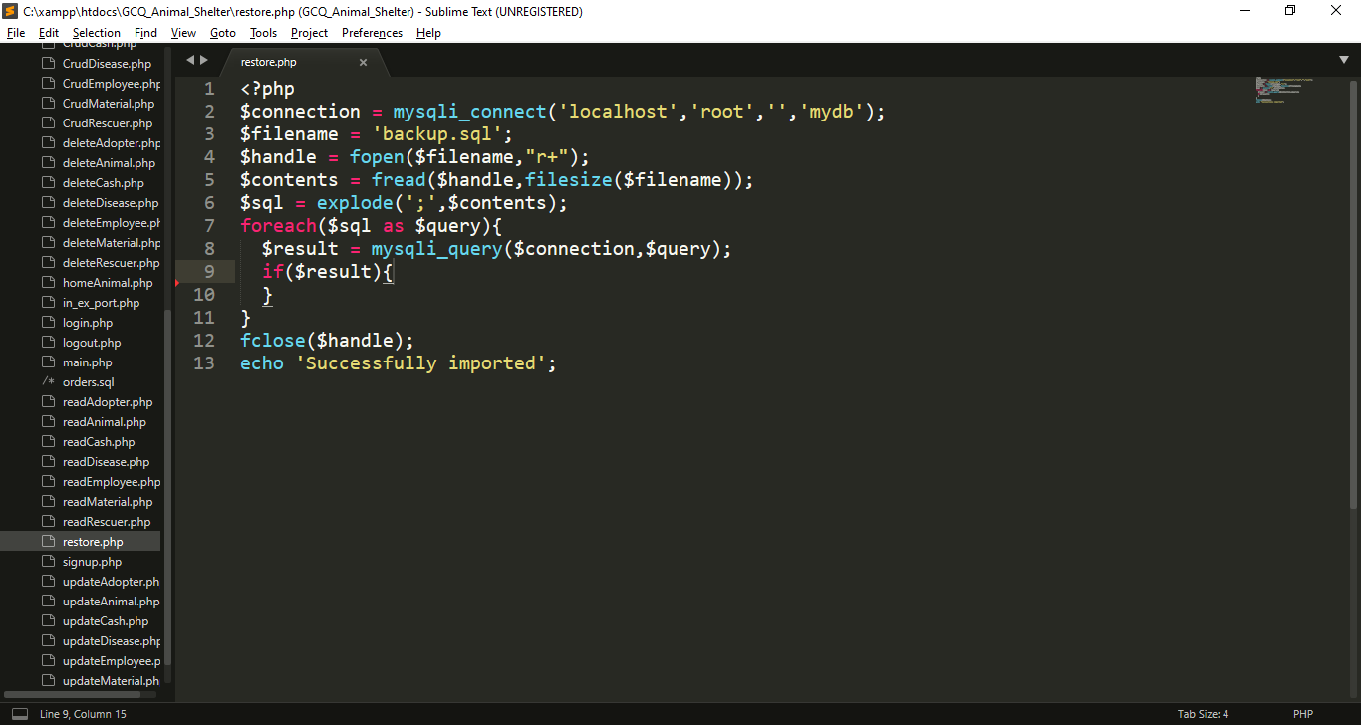

* I create restore.php for backuping my database
* First I create connection to database using mysqli_connect()function
* I use fopen() function to open my file backup.sql, then I use fread() function to read my script to backup.sql, then I use filesize() so that I can enter the lenght after I close the file using fclose() function.
* I use explode to split all the script separated by “;” so that I can convert into array
* Finally I execute that array;

**14. Added Features**

**14.1 Favicon –** Before I submit my project I decide to put favicon to my website

**Favicon**

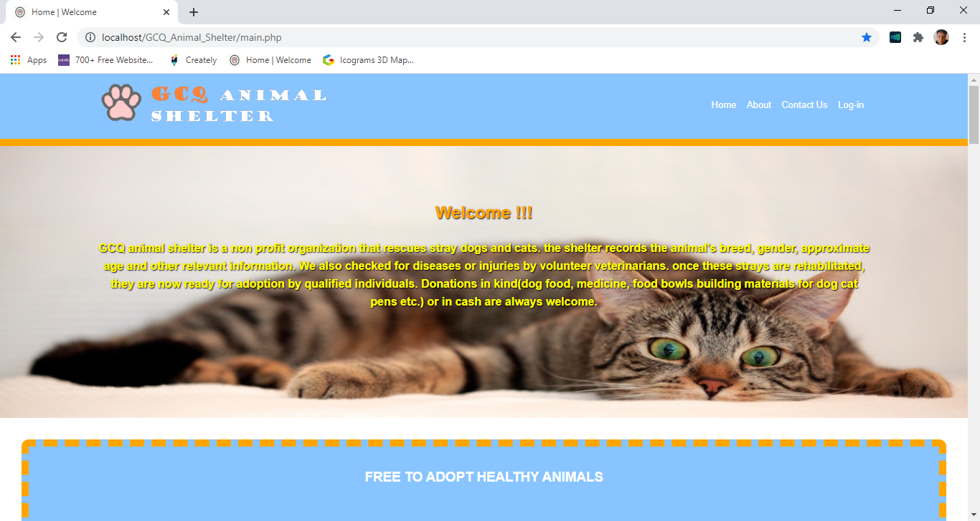

**14.2 About Tab**

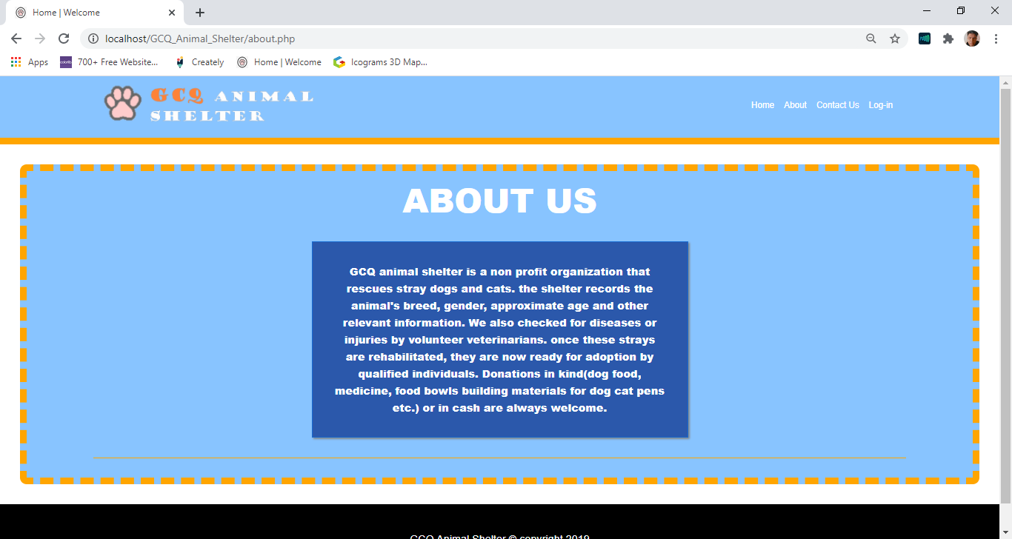

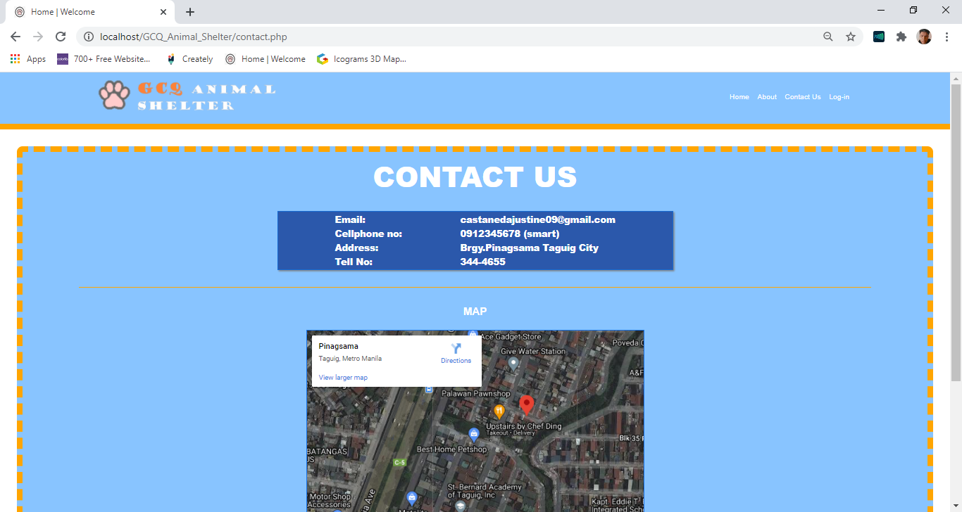 **14.3 Contact Us Tab With Embeeded Google Map**

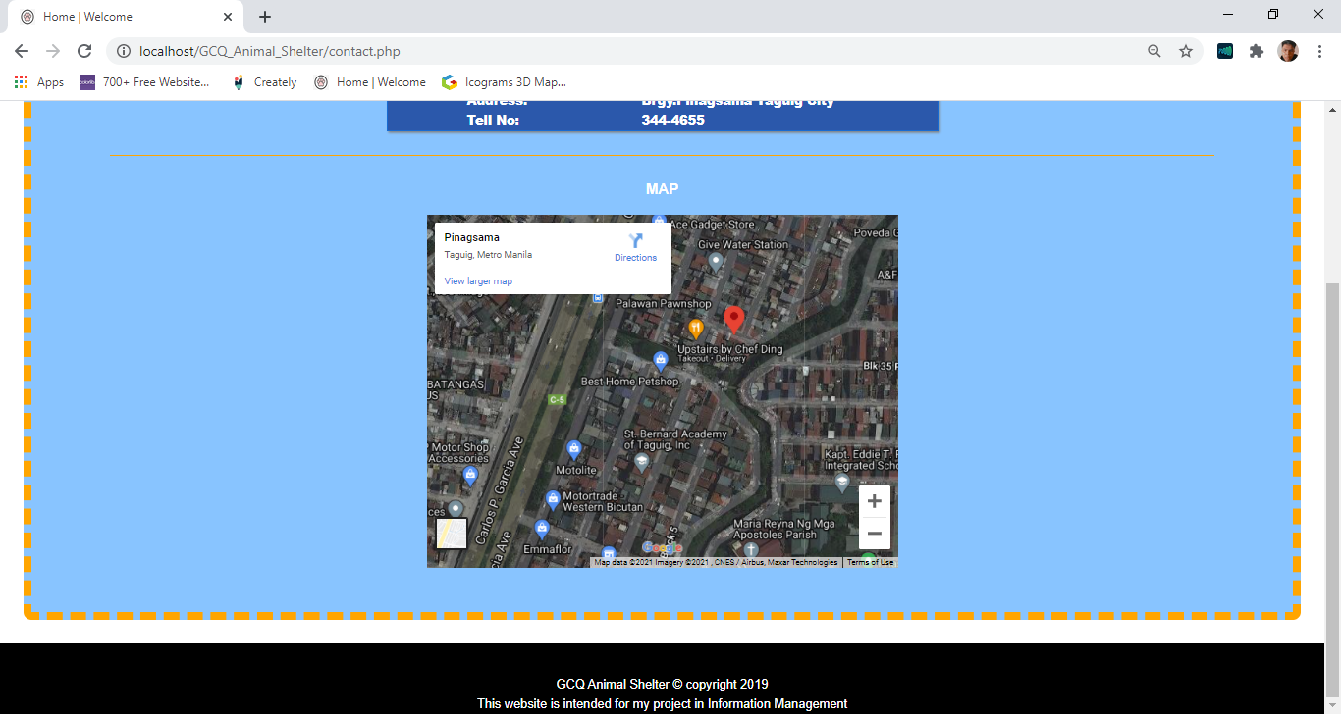

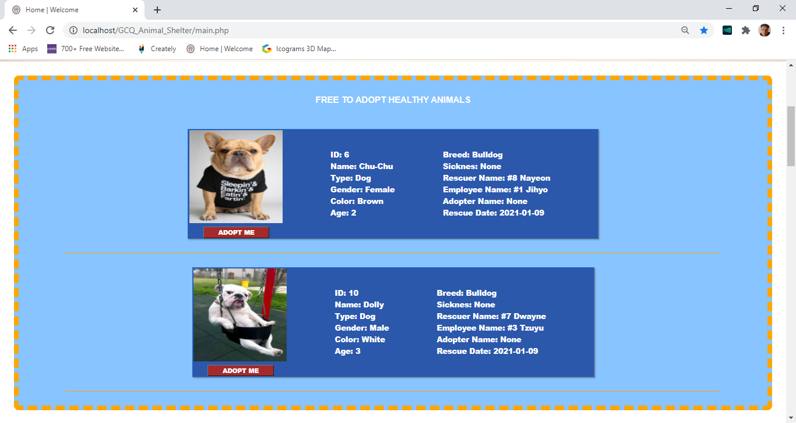 **14.4 “Adopt Me Button” –** this button will direct to contact us.

**Adopt Me Button in home page**

**14.5 Sign-Up Page**

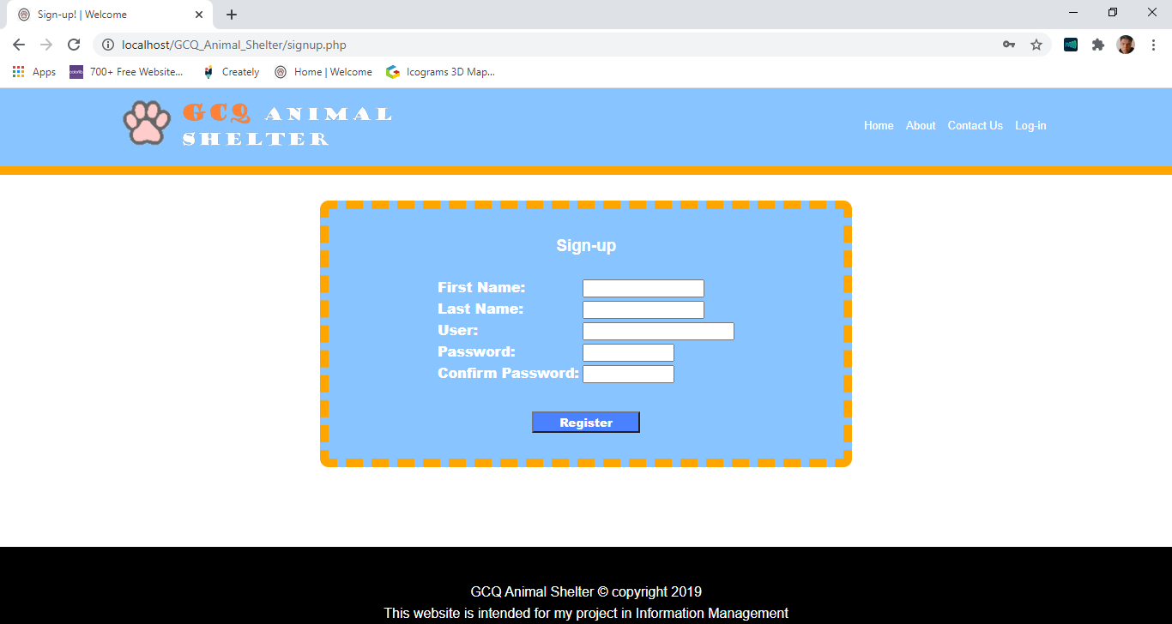

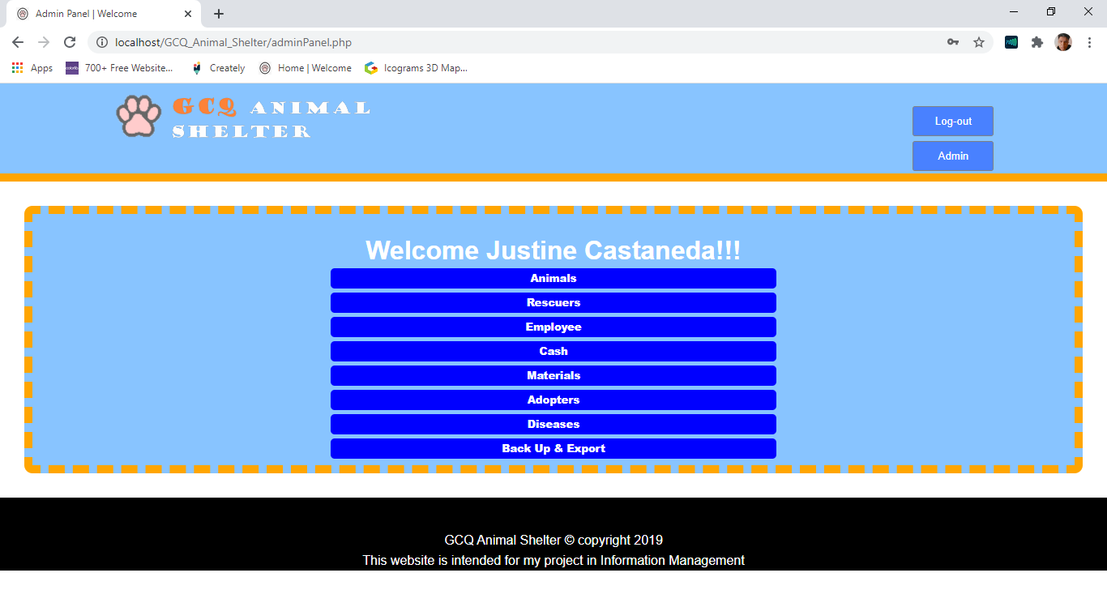 **14.6 Admin Panel**

**14.7 Recent values are already in the text box -** so that you don’t need to put all data again, just only the part that you want to edit/update.

